
Decentralized Crypto World Bank
A Blockchain-Based Lending Platform
with AI-Enhanced Security
Thesis ID: [P26101123]
by
Md. Bokhtiar Rahman Juboraz 20301138
Md. Mahir Ahnaf Ahmed
20301083
A pre-thesis 1 report submitted to the Department of Computer Science and Engineering in partial fulfillment of the requirements for the degree of
B.Sc. in Computer Science
Department of Computer Science and Engineering BRAC University
February 2026
© 2026. BRAC University — All rights reserved.

Declaration
It is hereby declared that
1.ThereportsubmittedisourownoriginalworkwhilecompletingdegreeatBRAC University.
2.The report does not contain material previously published or written by a third party, except where this is appropriately cited through full and accurate referencing.
3.The report does not contain material which has been accepted, or submitted, for any other degree or diploma at a university or other institution.
4.We have acknowledged all main sources of help.
Student’s Full Name & Signature:

Md. Bokhtiar Rahman Juboraz Md. Mahir Ahnaf Ahmed
20301138 20301083
2

Approval
Thepre-thesis1reportoffinalyearprojecttitled“DecentralizedCryptoWorldBank:A Blockchain-Based Lending Platform with AI-Enhanced Security” submitted by
1.Md. Bokhtiar Rahman Juboraz (20301138)
2.Md. Mahir Ahnaf Ahmed (20301083)
Of Spring, 2026 has been accepted as satisfactory in partial fulfillment of the requirement for the degree of B.Sc. in Computer Science on February 20, 2026.
Examining Committee:
Supervisor:
(Member)
Mr. Annajiat Alim Rasel
Senior Lecturer
Department of Computer Science and Engineering BRAC University
Project Coordinator:
(Member)
Dr. Md. Golam Rabiul Alam
Professor
Department of Computer Science and Engineering BRAC University
3

Head of Department:
(Chair)
Dr. Sadia Hamid Kazi
Chairperson and Associate Professor
Department of Computer Science and Engineering BRAC University

Ethics Statement
This project is designed to be functional on public blockchain testnets,with no intention formonetaryprofit,nortocreateinstitutionalleverageoverdecentralizedfinancing.No personal banking data, or private financial data, or codes of existing projects, are used in the development of the prototype platform and training AI/ML data. The full project prototype build is to be demonstrated in the final defence of the project; the platform is expected to bereadyfortestingandtroubleshootingbypre-thesis2.Allthedevelopmentworkflow canbetracedbytheofficialGitHubrepositoryfortheproject,andtheplanning,coding, testing, and usage of different dependencies for this project is considered open-source with MITlicensing,andwillbeopenforcontributionafterthesubmissionofthefinalbuild. ForthetrainingoftheAImodels,AI-assistedfinancialdecision-making,riskassessment, privacy features, on-chain and off-chain data processing and data storing, we acknowledge the ethical considerations while making decisions for the development of the project.
5

Abstract
In the modern world, global financing relies on institutional structures that are multilayered and complex that extend throughout the borders of nations, adapting complex protocols to maintain balance in the economy; however, these systems often struggle to maintain trans-parency and equal access to credit across the world. Decentralized financing has improved transparency in financing by adapting programmable infrastructures that can automate ex-changes or structured governance, but the existing models use mostly flat architecture that does not match with the traditional institutional hierarchies or governance that is well struc-turedbasedonglobaleconomiccontexts.Thiscreatesascopetostudyandexplorehow tier-based financial systems that mimic the functionalities, but in a decentralized environ-ment with the flexibility and adaptability. As an attempt to address this opportunity and to demonstrate what is possible, we present our research-based project Crypto World Bank, a formally specified prototype which is based on blockchain-based institutional finance, that includes coordinating capital allocation across multi-tiered hierarchical governance struc-tures. The primary focus of the project is a smart-contract that includes a hierarchy with a pipeline of oracle-based risk-analytics (Random Forest, Isolation Forest, SHAP, which will betrainedandbenchmarkedwithexistingsimilarsystems);anoptionalintelligentMCP agentasafeaturetointeractwiththeUIwithmorecomfort,whileallthecorebanking systemsremainintactbyusingwallets.Thebankingarchitectureincludesriskinterme-diation, liquidity management, deposit mobilization, credit allocation, payment settlement, and other adjacent financial services. The development workflow including frontend, smart contract, oracle integration and overall system architecture and design is specified in this paper; implementation and testnet deployment are planned across four phases in the final stages.The goal of this project paper is to illustrate how a hybrid system of design of de-centralized system can converge with institutional systems, to set a foundation for research on how a hierarchically governed crypto financial system can be developed.
Keywords: Blockchain,DecentralizedFinance,DepositMobilization,Explainable AI,FinancialSustainability,GroupLending,HierarchicalLending,InstitutionalDeFi, Multi-EntityCo-Lending,Oracle-MediatedRiskAnalytics,ReserveManagement,Smart Contracts
6

Dedication
Dedicated to our families for their unwavering support throughout our academic journey.
7

Acknowledgment
We would like to express our sincere gratitude to our panel members for their guidance and support throughout this project. We also thank our supervisor, Mr. Annajiat Alim Rasel, Se-nior Lecturer at the Department of Computer Science and Engineering, BRAC University, for his guidance and support.Finally, we thank the Department of Computer Science and Engineering at BRAC University for providing us with the resources and academic environ-ment to pursue this work.
8

Contents
Declaration  Approval  Ethics Statement  Abstract  Dedication  Acknowledgment |  |  |  |  |  |  |  |  |  | 2  3  5  6  7  8  1  2  3  4  5  5  7  7  8  9  9  9  9  9  10 10 10 10 10 10 13  14 14 15 16  37 37 38 39
1 | Introduction
1.1 |  | Background |  | ...................................
1.2 |  | Rationale and Motivation............................
1.3 |  | Problem Statement |  |  | ...............................
1.4 |  | Objectives |  | ....................................
1.5 |  | Proposed Solution................................
1.6 |  | Methodology in Brief..............................
1.7 |  | Scopes and Challenges |  |  |  | .............................
1.8 |  | Thesis Organization...............................
2 | Literature Review
2.1 |  | Preliminaries...................................
2.1.1 |  |  | Review Methodology (PRISMA-Style Frame).............
2.2 |  | Review of Existing Research..........................
2.2.1 |  |  | Decentralized Lending and DeFi Protocol Design..........
2.2.2 |  |  | Machine Learning, Explainable AI, and Extended AI Security |  |  |  |  |  | ...
2.2.3 |  |  | Hierarchical Distribution, Cross-Tier Flows, and Group Lending..
2.2.4 |  |  | Smart Contract Security and Layer 2 Scalability...........
2.2.5 |  |  | Monetary Policy, Tokenization, and Institutional Landscape....
2.2.6 |  |  | Graph ML, Federated Learning, Regulation, and Identity Primitives
2.2.7 |  |  | Oracle-Mediated ML and Optional LLM Interfaces |  |  |  |  | .........
2.3 |  | Summary of Key Findings ............................
3 | System Architecture and Design
3.1 |  | Prototype Scope and Stack...........................
3.2 |  | System Architecture...............................
3.3 |  | Architecture Diagrams (Full Set)........................
4 | Methodology
4.1 |  | MVT Checklist and Phase Plan.........................
4.2 |  | Design Decisions |  |  | ................................
4.3 |  | Methodology Diagrams (Full Set) |  |  |  |  | .......................
i

Crypto World Bank — Heavily Compressed |  |  |  |  |  |  | BRAC University
5 | Evaluation and Discussion |  |  |  |  |  |  | 48
5.1 |  | Performance Evaluation ............................. |  |  |  |  |  | 48
5.2 |  | Analysis of Design Solutions.......................... |  |  |  |  |  | 48
5.3 |  | Final Design Adjustment............................ |  |  |  |  |  | 48
5.4 |  | Feasibility Analysis............................... |  |  |  |  |  | 48
5.4.1 |  |  | Technical Feasibility.......................... |  |  |  |  | 48
5.4.2 |  |  | Economic Feasibility.......................... |  |  |  |  | 49
5.4.3 |  |  | Risk Feasibility............................. |  |  |  |  | 49
5.4.4 |  |  | Regulatory Feasibility |  | ......................... |  |  | 50
5.5 |  | Statistical Analysis |  | ............................... |  |  |  | 50
5.6 |  | Comparisons and Relationships |  |  |  | ........................ |  | 52
5.7 |  | Discussion.................................... |  |  |  |  |  | 53
6 | Conclusion |  |  |  |  |  |  | 54
6.1 |  | Future Work................................... |  |  |  |  |  | 54
References |  |  |  |  |  |  |  | 55
ii

List of Figures
1.1 | Crypto World Bank system overview...................... |  |  |  |  |  |  |  |  |  |  | 2
1.2 | Cross-tier lending flow directions........................ |  |  |  |  |  |  |  |  |  |  | 6
1.3 | Multi-entity co-funding mechanisms...................... |  |  |  |  |  |  |  |  |  |  | 7
2.1 | PRISMA-style literature screening flow..................... |  |  |  |  |  |  |  |  |  |  | 9
3.1 | CWB system architecture ............................. |  |  |  |  |  |  |  |  |  |  | 15
3.2 | Four-layer application architecture |  |  | ....................... |  |  |  |  |  |  |  | 16
3.3 | Component diagram (planning phase) ...................... |  |  |  |  |  |  |  |  |  |  | 16
3.4 | Layered blockchain and application stack.................... |  |  |  |  |  |  |  |  |  |  | 17
3.5 | Chainlink oracle architecture |  | .......................... |  |  |  |  |  |  |  |  | 18
3.6 | Core system entity graph............................. |  |  |  |  |  |  |  |  |  |  | 19
3.7 | Enhanced EER model............................... |  |  |  |  |  |  |  |  |  |  | 19
3.8 | Extended ERD entities | .............................. |  |  |  |  |  |  |  |  |  | 20
3.9 | On-chain versus off-chain data partitioning |  |  |  |  |  | .................. |  |  |  |  | 20
3.10 | Compliance and identity stack.......................... |  |  |  |  |  |  |  |  |  |  | 21
3.11 | Actor permission matrix (primary actions)................... |  |  |  |  |  |  |  |  |  |  | 21
3.12 | Client limits and bank-level syndication |  |  |  |  | .................... |  |  |  |  |  | 22
3.13 | Five-stage retail onboarding funnel....................... |  |  |  |  |  |  |  |  |  |  | 23
3.14 | Optional AI agent add-on (Phase III–IV, excluded from MVT) |  |  |  |  |  |  |  |  |  | ........ | 24
3.15 | LiquidationEngine tier models and lifecycle |  |  |  |  |  | .................. |  |  |  |  | 25
3.16 | SavingsVault and FixedDeposit closed loop................... |  |  |  |  |  |  |  |  |  |  | 25
3.17 | On-chain Credit Passport SBT lifecycle..................... |  |  |  |  |  |  |  |  |  |  | 26
3.18 | Chainlink CCIP cross-chain hierarchy invariant................ |  |  |  |  |  |  |  |  |  |  | 27
3.19 | Multi-entity and cross-tier capital operations.................. |  |  |  |  |  |  |  |  |  |  | 28
3.20 | Use-case diagram (nine-actor taxonomy).................... |  |  |  |  |  |  |  |  |  |  | 28
3.21 | USDC loan lifecycle activity flow |  |  | ........................ |  |  |  |  |  |  |  | 29
3.22 | Retail onboarding and identity activity flow |  |  |  |  |  |  | .................. |  |  |  | 29
3.23 | Client banking session activity flow....................... |  |  |  |  |  |  |  |  |  |  | 29
3.24 | Data-flow diagrams................................ |  |  |  |  |  |  |  |  |  |  | 30
3.25 | Loan approval sequence diagram |  |  | ........................ |  |  |  |  |  |  |  | 30
3.26 | Sequence diagrams................................ |  |  |  |  |  |  |  |  |  |  | 31
3.27 | Sequence diagrams................................ |  |  |  |  |  |  |  |  |  |  | 32
3.28 | Sequence diagrams................................ |  |  |  |  |  |  |  |  |  |  | 33
3.29 | Four-tier hierarchical capital flow........................ |  |  |  |  |  |  |  |  |  |  | 34
3.30 | Governance dual-path | .............................. |  |  |  |  |  |  |  |  |  | 34
3.31 | SAR and AML compliance workflow |  |  |  | ...................... |  |  |  |  |  |  | 35
3.32 | Five-layer defense-in-depth security architecture |  |  |  |  |  |  |  | ............... |  |  | 35
3.33 | Smart-contract security controls......................... |  |  |  |  |  |  |  |  |  |  | 36
4.1 | Agile / Scrum development process....................... |  |  |  |  |  |  |  |  |  |  | 39
4.2 | AI/ML pipeline wiring | .............................. |  |  |  |  |  |  |  |  |  | 40
4.3 | Planned ML evaluation layout (post pre-thesis 2) |  |  |  |  |  |  |  | ............... |  |  | 41
4.4 | Explainability and anomaly-detection flow................... |  |  |  |  |  |  |  |  |  |  | 42
4.5 | Real-time dashboard and runtime monitoring pipeline |  |  |  |  |  |  |  |  | ............ |  | 43
iii

Crypto World Bank — Heavily Compressed |  | BRAC University
4.6 | Transaction state machine of the loan lifecycle................. |  |  | 44
4.7 | Four-phase roadmap with SDLC mapping and progress............ |  |  | 45
4.8 | Development effort by implementation phase | ................. |  | 45
4.9 | Optional conversational agent add-on...................... |  |  | 46
4.10 | Planned development and verification toolchain................ |  |  | 46
4.11 | Key design decisions and alternatives considered |  | ............... | 47
5.1 | Annual revenue projection (10-year maturity)................. |  |  | 51
5.2 | Hierarchical interest-rate spread (APR)..................... |  |  | 52
iv

List of Tables
2.1 | Literature review summary (Part 1 of 2).................... |  |  |  | 11
2.2 | Literature review summary (Part 2 of 2).................... |  |  |  | 12
2.3 | Protocol comparison on eleven architectural dimensions |  |  | .......... | 13
3.1 | Prototype scope (summary)........................... |  |  |  | 14
4.1 | Four-phase implementation summary..................... |  |  |  | 37
4.2 | Core vs. optional capabilities.......................... |  |  |  | 37
4.3 | Design decisions (selected)........................... |  |  |  | 38
5.1 | Technical feasibility assessment........................ |  |  |  | 49
5.2 | Economic feasibility — zero-cost prototype.................. |  |  |  | 49
5.3 | Risk taxonomy and mitigation......................... |  |  |  | 50
5.4 | Regulatory design controls (selected) |  | ..................... |  | 50
5.5 | Revenue projection assumptions........................ |  |  |  | 51
5.6 | ETH-price sensitivity of spread revenue.................... |  |  |  | 51
5.7 | Default-rate sensitivity............................. |  |  |  | 51
5.8 | Market segments with supporting data.................... |  |  |  | 52
5.9 | Target customer segment profile........................ |  |  |  | 52
5.10 | Partner categories and roles | .......................... |  |  | 52
v

Chapter 1
Introduction
The Crypto World Bankis a research-based project for exploring how blockchain technol-ogy can be shaped to fit into institutional financial systems with all the added benefits that comewithadecentralizedfinancingsystem.Basedonourfindingsthathadsimilarmo-tivationtoourstudy,existingDeFiprotocolsshowisolatedfunctionalities,suchasAave for lending, Uniswap for exchange, and MakerDAO for stablecoins. This project specifies a tier-based, hierarchically governed platform that includes a mixture of institutional financ-ing with DeFi, accommodating deposit mobilization, credit allocation, interbank liquidity, installment repayment, FX facilitation, solidarity group lending, reserve enforcement, syn-dicatedco-lending,andrisk-basedgovernancecoveringallfourtiersthatsystematically mirrorsreal-worldinstitutionalfinancing.Atthetop,Tier1representstheWorldBank reserve; the core banking hierarchy is specified in Solidity and being improved until final deployment. Another significant feature—the multi-entity contract suite—is fully specified in Chapter 3, which is scheduled for practical development in Phases II–III.
Thesystemisdesignedforthreecategoriesofparticipant:aprogrammableWorldBank reserveasTier1,nationalandlocaldevelopmentbanksservinginTiers2–3,andretail clients in Tier 4.Retail clients get access to savings, group loans, and installment lending features. This hierarchical structure in this project was motivated by unbanked and MSME financing gaps [9, 11]. The project is not built with any motivation to deploy only in regions with access to advanced technologies;rather, proper distribution of access to finance and fairnessistheleadingcauseofthisattempttofindsuitablegroundtoadaptDeFiamong thegeneralpopulation.Thewholeprojectisopensourceandavailableinour.Theaddedbenefitsofblockchain:itprovidesstatevisibility,tamper-evident audittrails,andprogrammableruleenforcementamonginstitutionshavingcompetition, as demonstrated by the renowned World Bank FundsChain programme [27] and JPMorgan Kinexys[28].Fromthestudyofinstitutions,openledgerinfrastructureandinstitutional hierarchy are not mutually exclusive.
1

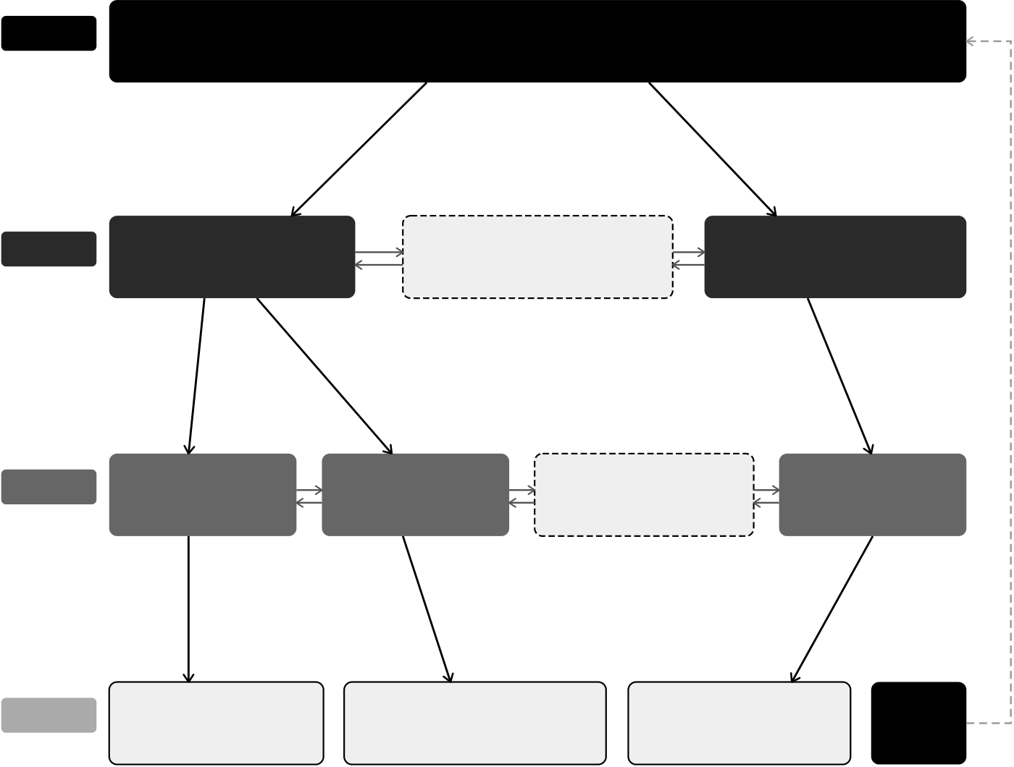
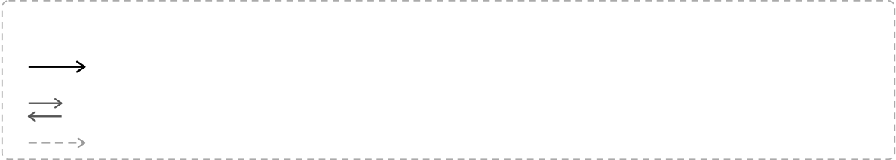
Crypto World Bank — Heavily Compressed |  |  |  | BRAC University
Tier1 | WorldBankReserve—Tier1 |  | NationalBankB
Global | Reserveauthority·Capitalissuer·Proofofreserve
Tier2 | NationalBankA | InterBankLendingPool

National | Reserveratioenforced | National-tierliquidity | Reserveratioenforced
Upward
surplus
repatriat
Tier3 | LocalBankA | LocalBankB | InterBankLendingPool | LocalBankC
Local | Retaillending | Retaillending | Local-tierliquidity | Retaillending
Tier4
 | Individualborrower | Groupborrowers | SME/business | Credit

Client | Savings·installmentloan | GroupLendingPool·jointliability | Syndicatedco-lending | Passport
Sixbankingfunctionsenforcedon-chain:
Depositmobilization | Creditallocation | Payment&settlement
Riskintermediation | Liquiditymanagement |  | Ancillaryservices
Technologystack:
L4 | React18/TypeScriptUI·walletsigning·optionalMCPagent(Qwen3-8B,17bankingtools)
L3 | Express.js+FastAPI·scikit-learnfrauddetection·SHAPexplainability·ChainlinkFunctionsoracle
L2 | Solidity0.8.20smartcontracts·ERC-4337Paymaster·ZKPidentity(Circom2.0/Groth16)·RBAC
L1 | PolygonzkEVMCardona·EthereumSepolia·PostgreSQL(19entities)·IPFS
Flowkey:
allocateCapital—downwardcapitalallocation(Tier1→2→3→4)
InterBankLendingPool—same-tierliquidity(dashedborder)
UpwardDepositFacility—surplusrepatriationtoparenttier
Figure 1.1: Crypto World Bank system overview
1.1Background
Local lenders, or our target users, for this aspect of lending through layered institutions—supranationalbodiesthatisprovidedbydevelopmentfinancechannelshavestructural costs.Idle capital is usually locked by correspondent banking in pre-funded nostro/vostro accounts [14], cross-border transactions that take around two to five days cost roughly $45 pertransaction[15],chargesforremittancecorridorsaverage6.49%,whichisabovethe UN SDG target of 3% [16]. Due to unequal access to traditional banking systems, 1.4 billion adults remain unbanked [9] and MSMEs face a $4.5 trillion annual financing gap [11].
In decentralized financing,lending,collateral,and interest can be automated by enabling
2

Crypto World Bank — Heavily Compressed | BRAC University
ruleson-chaintransparently.However,institutionslikeAavev3thatholds$26.3billion TVL [17] and the broader DeFi lending market exceeds $55 billion [8], use flat pool design that ignore institutional hierarchy, inter-tier exchange, and accessing clients via local bank lend path which is more generalized for normal people with less knowledge about DeFi.
Contributionofsmart-contractandblockchain. Smart-contractscandeveloplend-ing rules as immutable, atomic, with auditable on-chain logic. This technology replaces the bilateral ledger reconciliation with a system of shared record, when a local bank initiates aloan,theWorldBank’sreserveratioupdatesonthesametransactionstatus[27].DeFi extends this feature to financial services without licensed custodians.Here in The Crypto World Bankadds three dimensional feature that is missing from the existing institutional protocols:institutional hierarchy (four-tier capital flows), multi-entity operations (solidar-ity groups, syndicated loans, tranched pools), and a connection to the evolving development finance framework identified as absent in the literature [1].
Optionalconversationalinterface. Everyuserinteractswiththissystemprimarily through the React UI and wallet credential signing. For development purposes and demon-stration, a locally hosted agent (Qwen3-8B + MCP, 17 banking tools) provides an alternate path to get the essential tasks done, including all the customer services that require system interaction information guidance and assistance in acquiring a loan or exchange finances withthesystem.InthefinalbuilditisplannedtobereplacedwithsecuredAPI-based services.
Technical foundations. Consensus.The chain is an append-only ledger:nodes agree on history, and no one can rewrite past blocks without controlling most of the network [50].
EVM execution [41]. Loan logic runs as deterministic bytecode on Ethereum-compatible chains. Storage writes are the main cost driver (Section 5.1).
State machines. Each loan moves through clear stages—PENDING →APPROVED →ACTIVE→REPAYING→COMPLETED/DEFAULTED—withonlyauthorisedrolesallowedtoadvance it.
Oracles [45, 76]. Contracts cannot read off-chain data on their own. ML risk scores reach the chain via a commit-reveal oracle (Section 3.2); Chainlink Feeds, Automation, and Proof of Reserve handle prices,due-date checks,and reserve attestation.Live ML wiring starts after pre-thesis 2.
Polygon zkEVM. We deploy on Cardona testnet (Section 3.2) for low fees and L1-backed validity proofs.
1.2Rationale and Motivation
Real development finance depends on layered institutions, yet settlement friction, opaque reserves, and correspondent-banking idle capital leave both intermediaries and unbanked clients underserved [16, 90]. Flat DeFi protocols automate lending at scale but ignore insti-tutional hierarchy, cross-tier flows, and the Local-Bank-to-client path that microfinance and development banks use in practice [1]. This study is motivated by the opportunity to encode that hierarchy on a programmable ledger—with enforced reserves, role-based governance,
3

Crypto World Bank — Heavily Compressed | BRAC University
and auditable capital movement—while supporting (not replacing) human credit judgment through lightweight analytics and an optional conversational interface. The thesis specifies a reusable architecture; it does not claim a particular national deployment target.
1.3Problem Statement
Threeprimaryforcesofmotivationforthisstudy:development-financehasrestricting transparencyandsettlement;theabsenceofmulti-tieredbankingfunctionsinDeFi(de-posits, solidarity and lending); the keen interest in combining blockchain auditability with MLcomputationalanalytics.Therearesixstructuralinefficienciesnoticeableindevelop-ment finance routes for individual borrowers from national and local banks:
1.Lackoftransparency:thereisverylittlechanceofthelowertieruserstoverify capital management, reserve levels or lending decisions are made by the higher tiers, very less transparency on how money flows through the different levels of systems.
Onlythetoptiersgettheinformationandrecordsofreservesandauditedatmost quarterly.
2.Sluggishsettlementsandidlecapital: cross-bordertransactionsarequite expensive, average $45 per transaction [15], and time consuming taking two to five days [21].
3.Inconsistent risk evaluation: fraud and credit assessment are completely relied on human judgement,borrowers are generally re-evaluated at each tier or institutions based on information available at that tier, no unified credit history.
4.Accessandtrustbarriers:thecostofinter-institutionaltrustisquiteexpensive forlegalandauditprocess.Itcreatescongestionsindevelopingcountrieswhere investors earn returns roughly 3% below compared to developed markets [18].
5.No programmable savings: depositors in developing economies have no real-time access to visibility into how savings are processed and deployed.
6.No on-chain group credit:without individual collateral, borrowers cannot access programmable on-chain mutual group lending with shared responsibility. Real-world organizations like BRAC exist but does not function like DeFi.
DeFienabledautomaticlendingtransparencyatscalesuchasAavev3with$26.3billion TVL, $17.7 billion borrows [17], Compound v3 ($1.4 billion) [19], MakerDAO with $10.5 bil-lion stablecoin issuance [20].Despite large market coverage they exhibit four limitations for institutional development finance:
•Flatlendingmodels.Aave/Compoundusesoneprotocolformanyassetpools (USDC, ETH, etc.). There is no cross-tier allocation, no institutional hierarchy, no dif-ference in role-based governance.Here our CWB models institutional relationships that go deep into what kind of services to provide to what kind of roles/institutions to increase liquidity in overall lending and exchange situations.
•No AI risk analytics.DeFi relies on collateral ratio, utilization curves.There is no behavioral fraud detection or explainable credit support system.
•No tiered governance. DeFi protocol treats tokens as a measurement of voting, not based on what is the role of the client or user or institution in the bigger to smaller picture as it lacks relation to a deeper level like institutions.
•Single-level institutional DeFi. Maple & Goldfinch [51] with $2.6–3.8 billion TVL and$680millionoriginationsin18+countriesrespectivelyserveinstitutions,but
4

Crypto World Bank — Heavily Compressed | BRAC University
none models a full multi-tier banking system with interbank flows, lack hierarchical capital flows.
1.4Objectives
The objectives of this project are:
1.Design and specify all features and constraints of a four-tier lending architecture on an EVM-compatible blockchain and complete a full testnet deployment (World Bank→National Bank →Local Bank →Client). The whole development cycle is planned for Phases I–IV.
2.Design not only pool lending, but specify an extended banking product suite on the hierarchical system (deposits, savings, and solidarity group lending).
3.Investigate a lightweight off-chain analytics layer using ML, training and testing the models in practical testnet for fraud detection, anomaly detection, explainable review, and an optional MCP-based conversational interactive agent for ease of use.
4.Specifyprogrammableon-chainlendingwithborrowinglimitsbasedonfinancial behaviour analysis,installments,and role-based access control and information via smart contracts.
5.Plan and execute testnet deployment using Polygon zkEVM Cardona, Ethereum Se- polia, and evaluate hierarchical controls in the final thesis phase.
6.Documentgovernanceforfutureimprovements,securityanalysisandfeatureim-provements,role-basedregulatoryconsiderations,andacontrolledrollouttoward sandbox piloting.
1.5Proposed Solution
The Crypto World Bank will implement a four-tier on-chain lending model:Tier 1 World Bankreservecustodian→Tier2NationalBanks→Tier3LocalBanksprocessingretail loans →Tier 4 clients building on-chain credit history (Figure 1.1), with six standard bank-ing functions enforced on-chain—deposit mobilization, credit allocation, payment and set-tlement, risk intermediation, liquidity management, and ancillary services—rather than dis-cretionary audit alone.Banks also borrow from peers, park surplus with parent tiers, and syndicate large loans; the platform replicates four-tier downward flow, same-tier pools, up-ward deposits, and multi-bank co-funding on-chain (Figure 1.2).
5

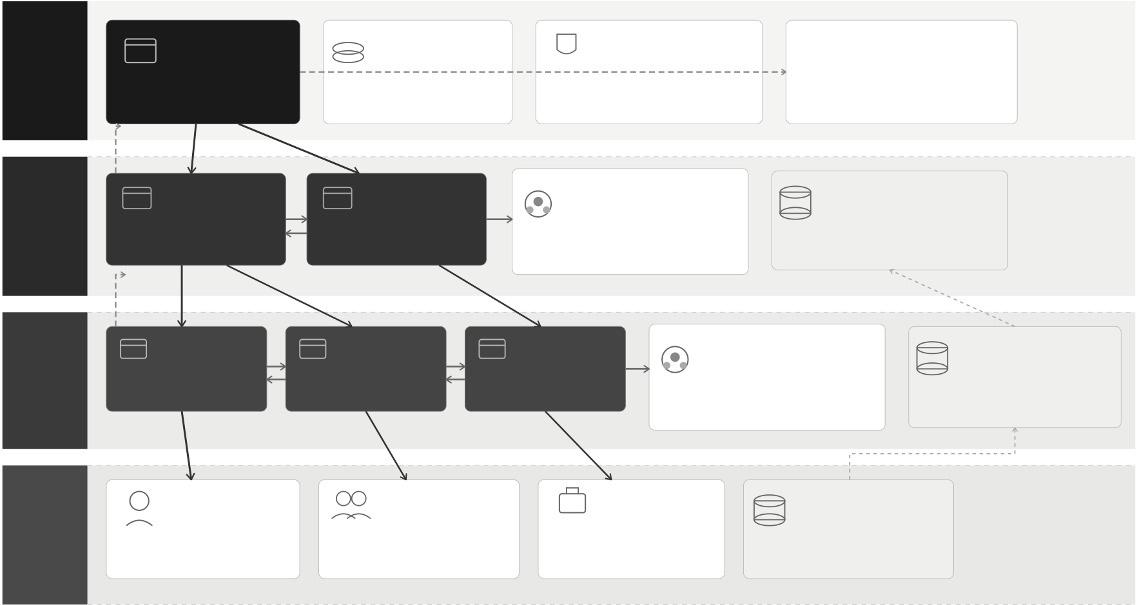
Crypto World Bank — Heavily Compressed | BRAC University
Cross-TierCapitalFlowSystemArchitecture
Multi-directionalcapitalflowsencodedason-chaincontractsacrossfourinstitutionaltiers
TIER1 | WorldBank | GlobalCapital | GlobalPolicy& | UpwardDeposit
 |  |  |  | Facility
 | Reserve | Pool | Governance
Global | ReserveAuthority | ReserveFunds | CapitalPolicies | Surplusrepatriationupward
Reserve | CapitalIssuer | LiquidityBuffer | RiskStandards | toparentinstitution
(Global) | NationalBankA | NationalBankB | InterBankLending | §3.14.2
 |  |  |  | NationalDataHub
TIER2 | CountryReserve | CountryReserve | Pool(National) | Aggregatedreporting
 | LendingAuthority | LendingAuthority | Same-tierliquiditysharing | Loanperformancedata
National
Banks |  |  | SOFR/SONIAbenchmarks
 |  |  | §3.14.1(PhaseII)
(Country)
TIER3 | LocalBankA | LocalBankB | LocalBankC |  | InterBankLending | LocalDataHub
 | Regionallending | Regionallending | Regionallending |  | Pool(Local) | Localdatacollection
 | Clientonboarding | Clientonboarding | Clientonboarding |  | Same-tierliquiditysharing | Loanperformance
Local
Banks | Individual | Group | SME/ |  | Peerliquiditybalance | CreditPassportfeed
 |  |  |  |  | §3.14.1
(Regional)
 |  |  |  |  | ClientData
TIER4 | Borrower | Borrowers | Business |  | Vault
End | Personalloans | Solidarity/GroupLendingPool |  | Businessloans | KYC/CreditPassport§3.12
Clients | Microloans | Mutualliability§3.17.3 | Workingcapital |  | Transactionhistory
(User)
MULTI-ENTITYCO-FUNDINGCONTRACTS |  |  |  | TranchedPool |  | UpwardDepositFacility
SyndicatedLoan |  | GroupLendingPool |  |  |  |  |  | ClientPath
Institutionalco-lending |  | Solidarity/mutualliability |  | Senior/juniorco-funding |  | Surplusrepatriationupward |  | KYC§3.8.2·Credit
Largeexposuresharing§3.14.3 |  | Retailco-borrowing§3.17.3 |  | Risk-tieredcapital§3.14.4 |  | Ratetermstructure§3.14.2 |  | Passport§3.12
 | Downwardcapitalallocation |  | Same-tierinterbankflow |  | Upwardsurplusrepatriation |  | Dataflow
Figure 1.2: Cross-tier lending flow directions
Canagroupofentitieslendorfundtogether? Syndicatedloans,solidaritygroups, tranched pools, and upward surplus deposits (Figure 1.3; Section 3.2) coexist with same-tier peer liquidity pools (Section 3.2); retail clients enter through Local Banks via KYC, Credit Passport, and borrowing limits, with syndication reserved for large loans.
6

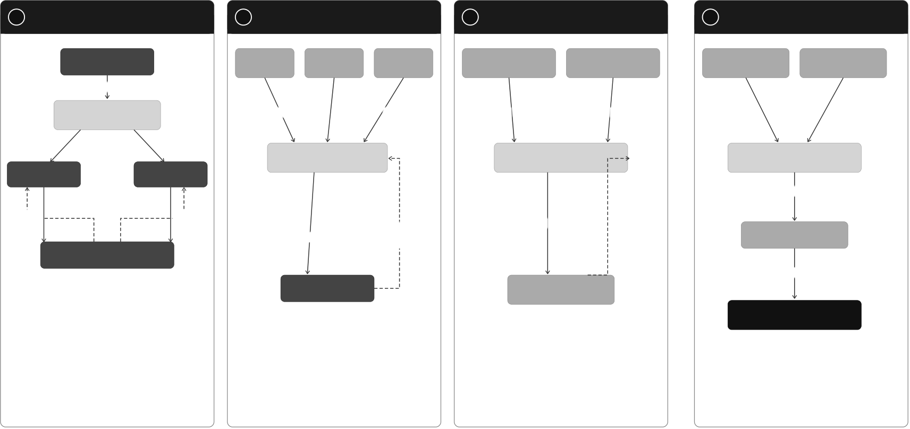
Crypto World Bank — Heavily Compressed | BRAC University
Multi-EntityCo-FundingMechanisms
FourCo-FundingPatternsEnablingCapitalatScaleAcrosstheCryptoWorldBankEcosystem
1 | SyndicatedLoan | 2 | SolidarityGroupLoan |  | Group | 3 | TranchedPool | SeniorTranche | 4 | UpwardDepositFacility
 | InstitutionalCo-Lending |  | RetailCo-Borrowing |  |  |  | Senior/JuniorCo-Funding |  |  | SurplusRepatriation
 | LeadArranger |  | Group | Group |  |  | JuniorTranche |  |  | Surplus | Surplus
 | Bank |  | Member1 | Member2 | Member3 |  | (First-Loss) | (Protected) |  | LocalBankA | LocalBankB
structure+fee
SyndicatedLoan | collateral | collateral | collateral | juniorcapital | seniorcapital
Contract
Co-LenderA | Co-LenderB | GroupLendingPool | TranchedPool | UpwardDepositFacility
 |  | (MutualLiability) | Contract | Contract
consolidatedsurplus
deposits
capitalshare | capitalshare | grouploan | cover | funding | senior-priority | Parent
 |  |  |  |  | repayment
 |  |  | shortfall |  | (interest&
 |  | (disbursement) | (mutual |  | principal)
 |  |  | liability) |  |  | NationalBank
Corporate/Project
Borrower furtherrepatriation (toWorldBankReserve
pro-ratainterest | LocalBank | LoanPool | ifapplicable)
 |  | (Borrowers)
&principalrepayment
WorldBankReserve
(Tier1)
LEGEND
 | CapitalCommitment/Disbursement(FlowofFunds) |  | Entities(DarkGray)
 | Repayment/Yield/MutualLiabilityCover(ReturnFlow) |  | SmartContracts/Pools(LightGray)
Figure 1.3: Multi-entity co-funding mechanisms:syndicated loan, solidarity group, tranched pool, and upward deposit
1.6Methodology in Brief
TherearefourAgilephasestothismethodologyforthisproject.Thisreportisdesigned withthearchitecturespecification.ThedevelopmentphasewillstartfromPhaseIIafter pre-thesis 1.In this report there is architecture, contracts, database, and ML pipeline.The Phase II development phase will demonstrate the loan cycle.Phase III will start the imple-mentationofMLscoringandtheChainlinkoracle(Section3.2).PhaseIVwillshowthe evaluation,metrics,andtheoverallfeasibilityoftheprojectintherealworld.Stack:So-lidity,React,Express/FastAPI,scikit-learnonPolygonzkEVMCardona.Thereisalsoan AI chat agent that will be built as an optional feature that will run alongside the project to help the clients navigate better with the system.
1.7Scopes and Challenges
Inscopenow.Inourdevelopment phases,we havecalculated that wecan implement a limited amount of our full vision: the four-tier lending architecture, loan lifecycle workflow, borrowing limits for the clients and the banks, the design of Oracle fraud analytics, and the training and the live demonstration of the AI/ML workflow.It can be shown to a limited amount on the prototype builds only.
Out of scope for now. Mainnet deployment, live retail payments in the real world, produc-tion KYC/AML at the banking level and client interaction, stress testing the whole project, and providing an MVT checklist before the product is ready is not quite possible yet.
Main risks. There are a couple of risks that we have noticed for our project, starting with thefraudlabelsmaynotbecompletelyaccuratebasedonthelimitedamountofdatawe have for our system architecture.We need more synthetic data that will be collected over
7

Crypto World Bank — Heavily Compressed | BRAC University
time.If regulations have changed—mitigated by testnet-only builds—then we might have to change the architectural elements.The gas toll on micro-loans may not be sustainable. The ML layer with SHAP may keep borrowers in the loop in the system since it is not 100% accurate and accuracy of the system depends on the training process. Rest of the economics and trade-offs are discussed in Chapter 5.
Economicsustainability. OnCardona,10–15txsonatypicalloancostunder$0.15—small next to interest earned. Mainnet micro-loans would need tighter gas work.
Institutional capture. Another huge issue that needs to be addressed is that Tier 1 and the National Banks, which have huge reserves and influence over the rates, reserves, and who gets credit, might influence the overall system and cost-to-performance ratio. It might temper the trust and relationship with the retail customers and smaller banks.
Stablecoin-first lending. Retail clients are not to be carrying high-priced positions like ETH,sincethepricesofEthereummightfluctuate.MiCAandtheU.S.GENIUSActsup-porttheideathatstablecoinsshouldbemoregeneralizedforauthorizedcryptocurrency. There are many settlement projects like mBridgeand Agora [64, 65],moving the value of cryptocurrencies across borders, but it is not a replacement for our lending system. The ar-chitectural system for stablecoin pools and L2 deployment (Section 3.2) gives the liquidity move fluidly from the top tier to the bottom, and the surplus to go up from the bottom.
1.8Thesis Organization
•Ch. 1 — Introduction: problem, objectives, approach (CO1).
•Ch. 2 — Literature: PRISMA review and protocol comparison (CO9).
•Ch.3—Architecture:tiers,contracts,datamodel,identity,products,security (CO2–4, CO12).
•Ch. 4 — Methodology:build phases, MVT scope, ML oracle, optional agent (CO5, CO10).
•Ch. 5 — Evaluation: feasibility, benchmarks, limits (CO6–7, CO11).
•Ch. 6 — Conclusion: contributions and future work; appendices hold contracts and deployment notes.
8

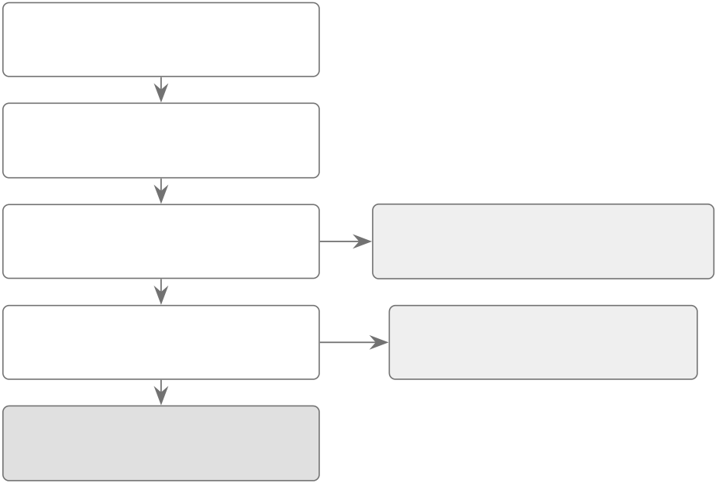
Chapter 2
Literature Review
2.1Preliminaries
Importantterms—XAI,PoS,CBDC,solidarity/grouplending,DeFi,smartcontracts,over-collateralization, ALM, flash loans, ZKP, and Health Factor—have been introduced in Glos-sary appendix. This section has been expanded in appendix D that will be presented in the final versions of the complete project file.
2.1.1Review Methodology (PRISMA-Style Frame)
Wedidourresearchtofindtheappropriatepapersandhighlyqualifiedpapersthatgoes without project from ACM, IEEE, Elsevier, MDPI, arXiv, and BIS/World Bank (2017–2026) with PRISMA-style screening [52].Primary topics for this search:DeFi lending, fraud ML, tiered finance, and smart-contract security.
Records identified
(892 from 6 databases)
After duplicate removal
(614 unique records)
Title / abstract screened Excluded at screening
(614 records) (500: out of scope / low quality)
Full-text assessed Excluded at full-text
(126 records) (0: all met inclusion criteria)
Included in synthesis
(95 numbered references)
Figure 2.1: PRISMA-style literature screening flow
2.2Review of Existing Research
Weexplainourliteraturereview,andourfindingsfromthepapersandtheworkofthe authors, in the subsections shown below.
2.2.1Decentralized Lending and DeFi Protocol Design
Forabigpicture,Werneretal.[1]showthatDeFilendersuseflatpoolswithnobank-style tiers; we have found a gap that can be filled by introducing our project. According to Bastankhah et al. [2], adaptive borrow rates work better than Aave-style curves for financial flows, which we introduced in our kinked-rate module. Dao et al. [43] show how on-chain limits can get off-chain credit scores that in general are applied at our Local Bank level.
9

Crypto World Bank — Heavily Compressed | BRAC University
2.2.2Machine Learning, Explainable AI, and Extended AI Security
Forfrauddetection,Palaiokrassasetal.[3]engineerbehavioralfeaturesthatdoareally good job in DeFi transaction fraud detection, not just hashes. We plan to use Random Forest in Phase III that will further strengthen the fraud detection level with the mixture of hash functions that is built into the DeFi protocol.Moreover, for the situations when the fraud detection level is scarce, we will use Liu et al. [6] Isolation Forest.We also studied a very in-depth comparison of SHAP versus LIME by Adom et al. [4], which shows a significant advantage by using SHAP for loan detection; approvers in bank and authority level will see SHAP screening results before signing.
2.2.3Hierarchical Distribution, Cross-Tier Flows, and Group Lending
Tan [5] demonstrated how CBDC flows in bank-to-bank and bank-to-client financial trans-actions.Weextendedthisideainourprojectbyshowingtier-basedreservechecks.For layeredreservecontracts,ProjectPine[79]hasshownaprototypethatissimilartoour InterBankLendingPool and the syndicated-style loan flow. We also integrated the style of microcredit admin cost with smart contracts based on the study of Asaduzzaman et al. [38]. ThestructureofGroupLendingPoolfunctionistheon-chainversion,withoutclaiming that we are trying to replace BRAC-style social microfinancing enforcement.
2.2.4Smart Contract Security and Layer 2 Scalability
To improve the security system of the project, we are following Atzei et al. [7], which lists themainEthereumcontractattacks.Sincethetier-basedsystemisverycomplex,many transactions on Cardona might be triggered. Gas prices can be cut to 30–50% by transaction batching [13], with further DeFi gas optimisation [39].
2.2.5Monetary Policy, Tokenization, and Institutional Landscape
Very large institutions like World Bank FundsChain [27] and similar institutions show that development finance is already moving on-chain for auditability; we are further improving this by encoding rules, not just managing disbursement logs.
2.2.6Graph ML, Federated Learning, Regulation, and Identity Primitives
Wenoticedtheusabilityandriseofstablecoinandwentfurtherdeepintoitandtryto explore how stablecoin pools for retail clients can be strengthened by using MiCA and the U.S. GENIUS Act [61, 63].For our project, soulbound tokens will be used that fit into our Credit Passport idea, which was extended by the idea of Buterin et al. [55]. This introduces asecuredidentityon-chain,aportablereputation,withoutthefearofexposingpersonal data.
2.2.7Oracle-Mediated ML and Optional LLM Interfaces
Lastly, for an optional feature to our project, future studies can be made and features can be added to the system. Caldarelli [76] describes how ML scores still have some issues that go beyond price oracles; we focus on this part and extend our commit-reveal or Chainlink path targets.We collected some reputable databases,and more to be added such as the BCCC fraud dataset [71] that goes with our system.This section will be continued and extended after pre-thesis 2.
10

Crypto World Bank — Heavily Compressed | BRAC University
Table 2.1: Literature review summary (Part 1 of 2)
Author & Focus | Methodology | What they found & how we use it
Palaiokrassas et al. | XGBoost, NN on | We plan to use behavioural features in Phase II
(2024) [3] · DeFi | 54M+ txs | for Random Forest, as it lifted F1 to 0.76–0.85

fraud | LIME / SHAP | Approvers get a SHAP brief before signing, as
Adom et al. (2025)
[4] · XAI lending | comparison | it gives a clearer result than LIME on loan data
Tan (2023) [5] · | Developing- | CBDC backs the four-tier layout and works as
CBDC hierarchy | nation model | a bank-to-user tier
Liu et al. (2008) [6] · | Isolation Forest | Flags odd wallets without many labels; backup
Anomaly detection |  | when fraud data is thin
Atzei et al. (2017) [7] | SoK of Ethereum | Lists re-entrancy and access-control risks;
· SC security | attacks | guides OpenZeppelin guards
Werner et al. (2022) | Survey of 12+ | Main gap CWB targets is DeFi lending having
[1] · DeFi SoK | protocol types | no bank hierarchy
Bastankhah et al. | Dual fast/slow | Dynamic rates support our kinked-rate
(2024) [2] · Adaptive | control | modules as it beats static curves

lending | Smart-contract | Gas is cut in on-chain P2P, which is a minor
Hartmann & Hasan
(2021) [32] · P2P | origination | input for loan-facing clients
lending
Hasan et al. (2022) | FL on encrypted | Lack of raw-data sharing features by banks
[33] · Federated | features | leaves future cross-bank options

fraud | ML on bytecode | Common bytecode bugs spotting by ML helps
Wang et al. (2020)
[34] · SC |  | provide extra security over manual audit
vulnerabilities
Liao et al. (2019) [35] | Classification + | Workflow idea for Phase V is inspired from ML
· Audit automation | fuzzing | prioritizing fuzzing speed
11

Crypto World Bank — Heavily Compressed | BRAC University
Table 2.2: Literature review summary (Part 2 of 2)
Author & Focus | Methodology | What they found & how we use it
BIS et al. (2020) [37] | Retail distribution | Standard CBDC two-tier is extended to
· CBDC design | analysis | four-tier with on-chain reserves
Kiff et al. (2020) [82] | IMF architecture | Matching National/Local roles; retail CBDC
· CBDC models | survey | flow implemented through supervised banks
Bindseil (2020) [81] · | ECB tiered | Upward deposit spread idea inspired from
CBDC rates | remuneration | tiered rates that protect bank intermediation
Dong et al. (2023) | Three-tier game | Capital can move down a chain, parallel to
[80] · Supply-chain | model | World Bank →client allocation
finance
Project Pine (2025) | NY Fed / BIS | IBLP and syndicated loans used on-chain
[79] · Hierarchical | prototype | layered reserve contracts prototype

SCs | Nostro/vostro | Tiered on-chain flow is better than legacy
CPMI/FSB [14, 21] ·
Cross-border | cost analysis | settlement as it is slow and costly
settlement
World Bank (2025) | 13-project pilot | Programmable lending rules added with
[27] · Dev. finance |  | dev-banks system

blockchain | Cross-chain | Scaling by splitting loads throughout chain is
Chen et al. (2024)
[30] · Multi-chain | design | later option, not for Phase I
lending
Yang & Cui (2023) | Quantitative risk | Gives utilisation and liquidation benchmarks
[31] · Protocol | metrics | for health checks tier

evaluation | Smart-contract | Model for GroupLendingPool is smart
Asaduzzaman et al.
(2020) [38] · Smart | MFI | contracts, which cuts the admin costs in
micro-credit |  | Bangladesh
Wang et al. (2021) | iBatch | Per call saved 15–59% in gas price by which we
[13] · Tx batching | middleware | deploy on Cardona L2
Kim & Kim (2024) | DeFi parameter | ∼18% gas cut on Ethereum pools helps our L2
[39] · Gas | tuning | deployment
optimisation
Yuan (2024) [40] · | RF, GBM + SHAP | Deploying on Cardona L2 as batching saved
SHAP credit default |  | 30–50% gas; SHAP is also used for our decline

path
12

Crypto World Bank — Heavily Compressed |  |  |  |  |  | BRAC University
Feature |  | Aave | Comp. | Maker | Maple | Gfinch | CWB
Institutional hierarchy |  | p | p | p | p | p | ○
 |  |  |  | p | p | p | Ý
Cross-tier capital flow |  | p | p
 |  |  |  | p | p | p | Ý
Same-tier | interbank | p | p

lending | p | p | p | Part. | Part. | Ý
Syndicated / co-lending
 | p | p | p |  |  | Ý
Upward capital repatria- |  |  |  | p | p

tion | p | p | p | p | Part. | ○
Solidaritygrouplend-

ing |  |  | p | p | p | Man. | Man. | ○
AI/ML fraud detection
 |  |  | p | p | p |  |  | ○
SHAP explainability |  |  |  |  |  | p | p
 |  |  | p | p | p | p | p | ○
ZKP KYC compliance
Kinked | interest | rate | ✓ | ✓ | Gov. | ✓ | p | Ý

curve | Part. | Part. | Gov. | ✓ | Part. | ○
Role-basedaccesscon-

trol | p | p | p | ✓ | Part. | ○
Institutional / L2 focus
TVL / Status (2026) | $26B | $1.4B | $10B | $2.6B | $680M | Planning
Table 2.3: Protocol comparison on eleven architectural dimensions
2.3Summary of Key Findings
Four points stand out after reviewing and Table 2.3:
•Flat DeFi vs. tiers. Large pool lenders [1, 8] have no hierarchical bank currently, and it opens a door to explore how a hierarchical system would behave with DeFi. CBDC andProjectPinework[5,79]provethatnobodycombinesafourreserve-enforced tier with group lending and cross-tier financial flows and an ML oracle in a singular architecture.
•ML and security. ML and security layers combined with behavioural fraud features andSHAP[3,4,6]furtherextendtheusability,feasibility,andadaptabilityofour project. Based on these literature reviews, we further improve our Phase III pipeline; contractattackcatalogues[7]andL2gasbatching[13,39]justifyOpenZeppelin guards to be added to our project.
•Groups and institutions. We explored smart-contract microcredit in Bangladesh [38] and World Bank on-chain pilots [27] that gave us the idea and improved the imple-mentation ofGroupLendingPool function and institutional lending system.
•Regulation. For regulation improvement and securities, MiCA and GENIUS [61, 63] areacceptedbystablecoin-firstpools.Soulboundcredittokens[55]fittheCredit Passport without putting KYC on-chain.
13

Chapter 3
System Architecture and Design
3.1Prototype Scope and Stack
Table 3.1: Prototype scope (summary)
Feature | Status
Four-tier RBAC (World / National / Local / Client) | Specified (Phase I)
Loan lifecycle + installments | Specified / Phase II
SavingsVault, GroupLendingPool, IBLP | Specified / Phase II
RF + IF + SHAP oracle pipeline | Planned (Phase III)
ZKP KYC, testnet deploy, Foundry sim | Planned (Phase IV)
Optional MCP agent (17 tools) | Optional (Phase III–IV)
14

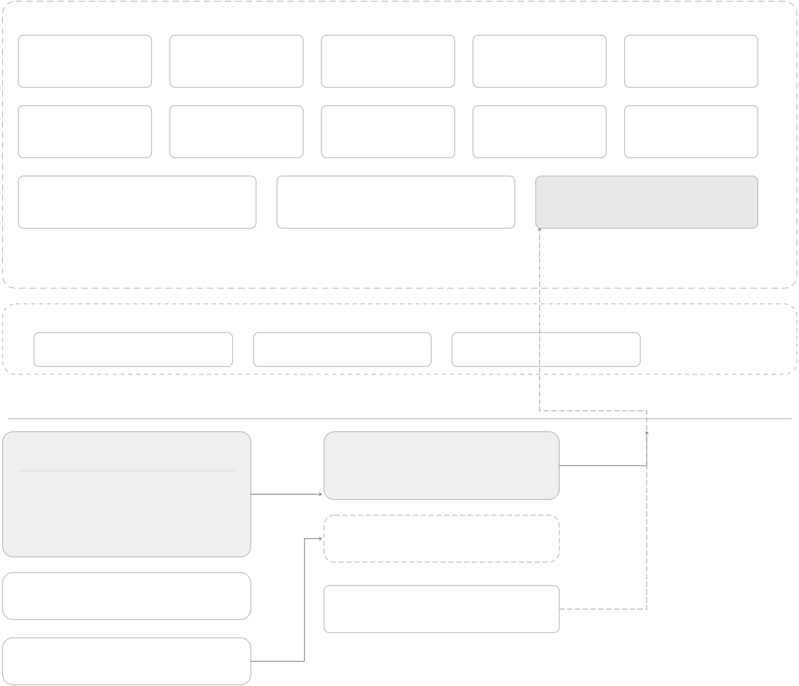

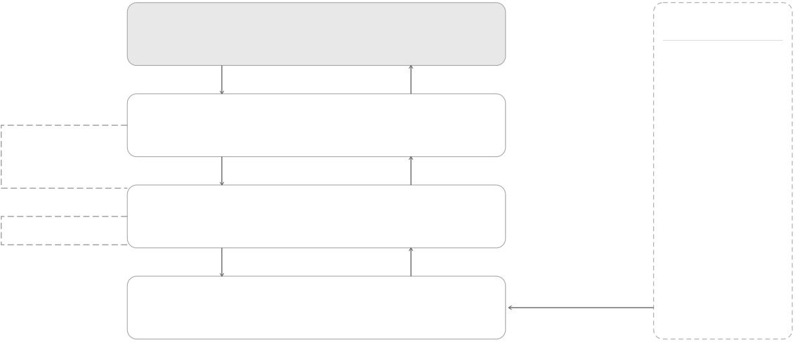
Crypto World Bank — Heavily Compressed | BRAC University
3.2System Architecture
Contractarchitecture
PhaseI–II
WorldBankReserve NationalBank LocalBank SavingsVault FixedDeposit
GroupLendingPool FXModule InsuranceFund CurrentAccount TreasurySwap
InterBankLendingPool UpwardDepositFacility LoanController
PhaseIIIstretch
SyndicatedLoan | TranchedPool | NettingEngine
Oracle&MLintegration
Off-chainML | scores | ChainlinkFunctions | SCORE_REVEALED
 |  | primaryoracle
RandomForest
IsolationForest
Compositeriskscores | overdue | Commit-revealrelay
SHAPexplanations |  | PriceFeeds
ChainlinkAutomation
Datamodel&partitioning
On-chain | sync | Off-chain(PostgreSQL·20entities·3NF)
·Balances,RBAC,reserveratios |  | ·PII,KYCdocuments
·Loanstatemachine |  | ·SHAPJSONauditlogs
·Committedriskscores |  | ·MLmodeloutputs&history
·CreditPassportSBT(zk-KYC) |  | ·Installments,marketdata
·ZKPidentity(Circom/Groth16) |  | ·Agentsessionlogs(optional)
·ERC-4337Paymaster(gas-freeT4) |  | ·Indexedchainevents
Cross-tiercapitalflows
InterBank | allocateCapital | WorldBankReserve | UpwardDepositFacility | Retail
 |  | Tier1 |  | Savings
 |  | NationalBanks |  | Fixeddeposits
 |  |  |  | Installmentloans
 |  | Tier2
 |  |  |  | FXdisplay
LendingPool | allocateCapital | LocalBanks | UpwardDepositFacility
 |  |  |  | Insurancebuffer
 |  |  |  | Grouplending
same-tier | allocateCapital | Tier3 | UpwardDepositFacility | Syndication
EndClients
Tier4·zero-gasviaPaymaster
Figure 3.1: CWBsystemarchitecture—contracts,oracle/MLintegration,datapartitioning,and
cross-tier operations
15

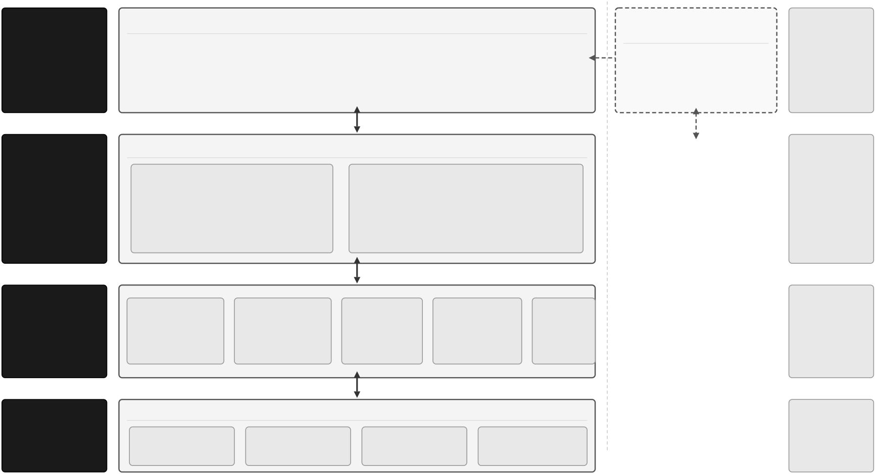
Crypto World Bank — Heavily Compressed | BRAC University
3.3Architecture Diagrams (Full Set)
1 | COREPLATFORM |  |  |  |  | Event | OPTIONALADD-ON | KEYTECHNOLOGIES
 | React18+TypeScriptWebApplication |  |  |  |  |  | AIAgentInterface | React18,TypeScript,
 |  |  |  |  |  |  | (Qwen3-8B) | Wagmi,Viem,
PRESENTATION | Pages•Components•StateManagement |  |  |  |  |  |  | Ethers.js
 |  |  |  |  |  |  | MCPToolServer
LAYER | Wagmi/Viem•WalletIntegration |  |  |  |  |  |  | Solidity^0.8.x
 |  |  |  |  |  |  | (17BankingTools)
(UserInterface)
 | 15ModularSmartContracts(Solidity)
2
 |  |  |  |  |  |  |  | OpenZeppelin,
SMART-CONTRACT | CoreFour-TierHierarchy |  | 12PlannedModules |  |  |  |  | EVM(zkEVM)
LAYER | WorldBankReserve(Tier1) |  | •Loans,SavingsVault,FixedDeposit |  |  |  |  | Node.js,Express.js,
(On-Chain–EVM) | ↓ |  | •GroupLendingPool,InterBankPool
 | NationalBanks(Tier2) |  | •CreditPassport,Compliance(ZKP-KYC)
 | ↓ |  | •FraudDetection,Oracles,Automation
 | LocalBanks(Tier3) |  | •andothers
3 | Express.js | PostgreSQL |  | FastAPI | Chainlink |  |  | PostgreSQL,FastAPI,
OFF-CHAIN | RESTAPI | Relational | MLScoring |  | Oracle | Listener |  | Redis,WebSockets
SERVICESLAYER | (Node.js) | Database | Service |  | Integration | (Indexer)
(Backend&Data
Services)
4 | Chainlink | ChainlinkDecentralizedOracleServices |  | Chainlink | ChainlinkFunctions,
 |  |  |  |  | Automation,Price
CHAINLINK |  | Chainlink | Chainlink |  | Feeds,Proofof
INFRASTRUCTURE | Functions | Automation | PriceFeeds | ProofofReserve | Reserve
(Oracle&Automation) | (Off-ChainCompute) | (ScheduledTasks) | (MarketData) | (ReserveVerification)
Figure 3.2: Four-layer application architecture
ComponentArchitecture(Specified—PlanningPhase)
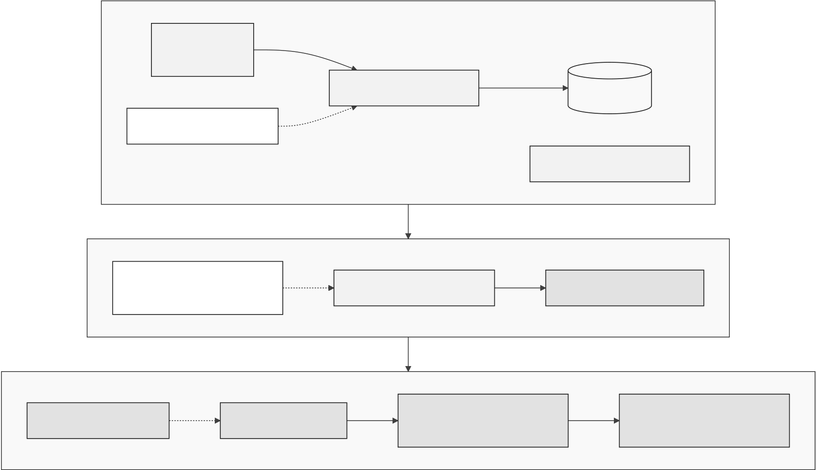
Figure 3.3: Component diagram (planning phase)
16

Crypto World Bank — Heavily Compressed | BRAC University
BlockchainandApplicationStack

Figure 3.4: Layered blockchain and application stack
17

Crypto World Bank — Heavily Compressed | BRAC University
ChainlinkOracleArchitecture-Off-ChainAItoOn-ChainDecision
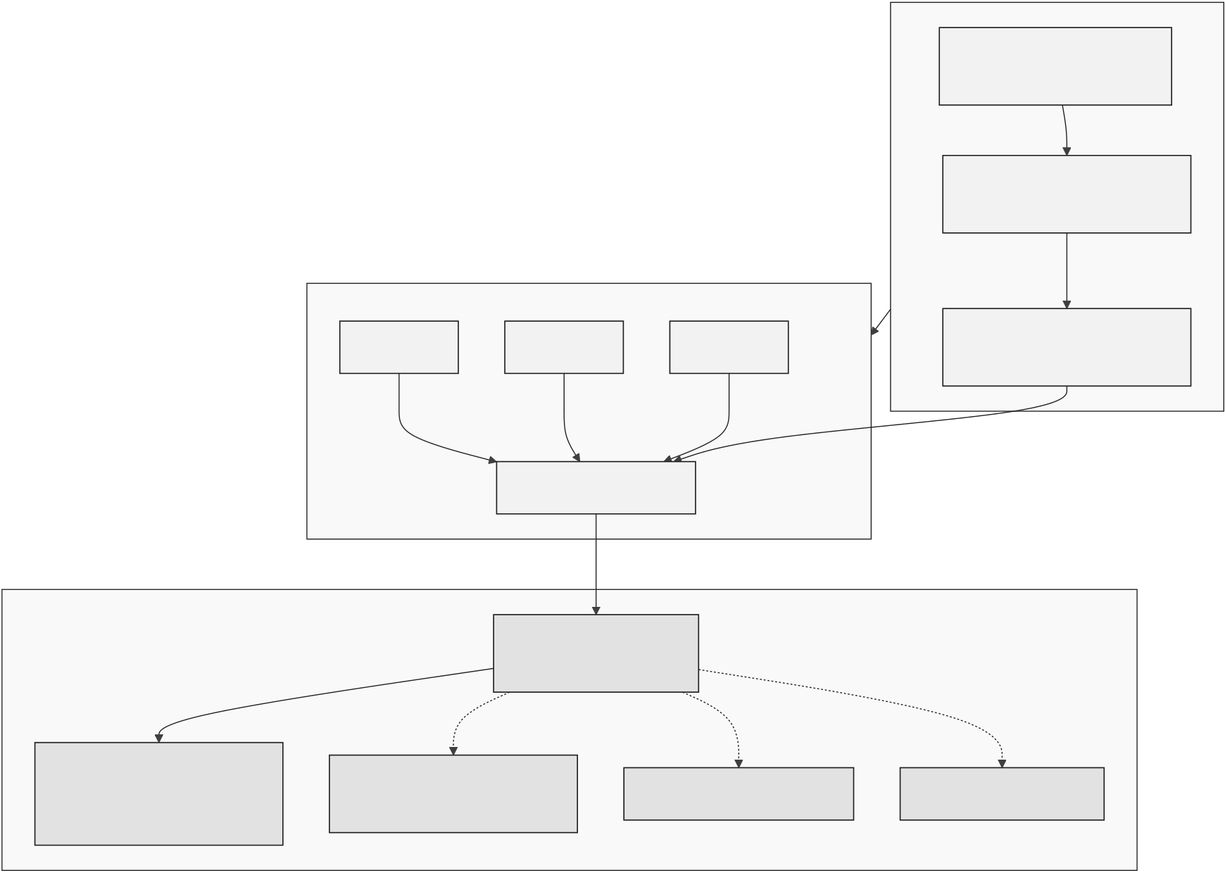
Figure 3.5: Chainlink oracle architecture
18

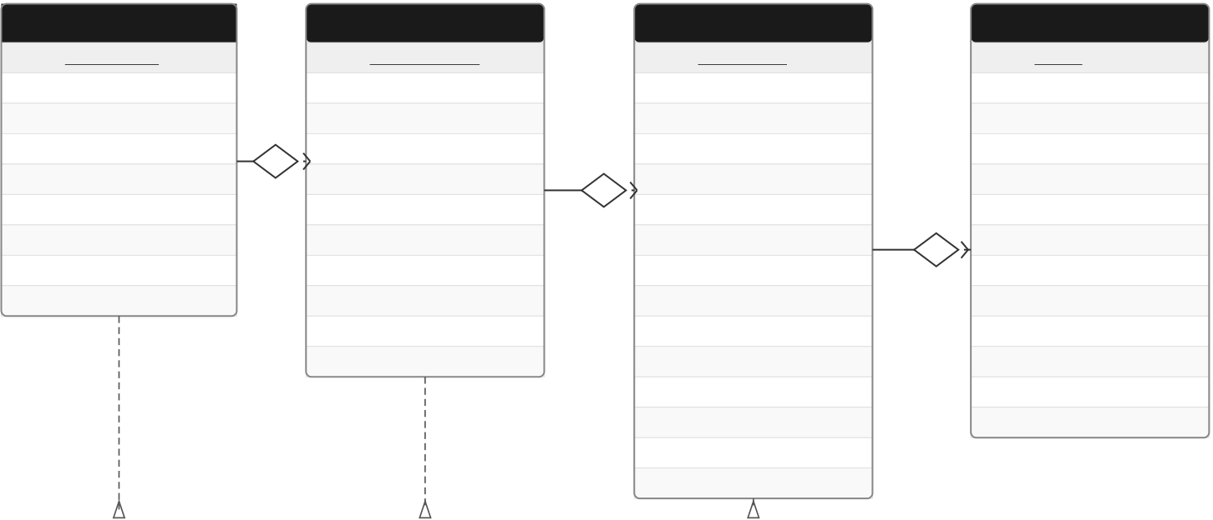
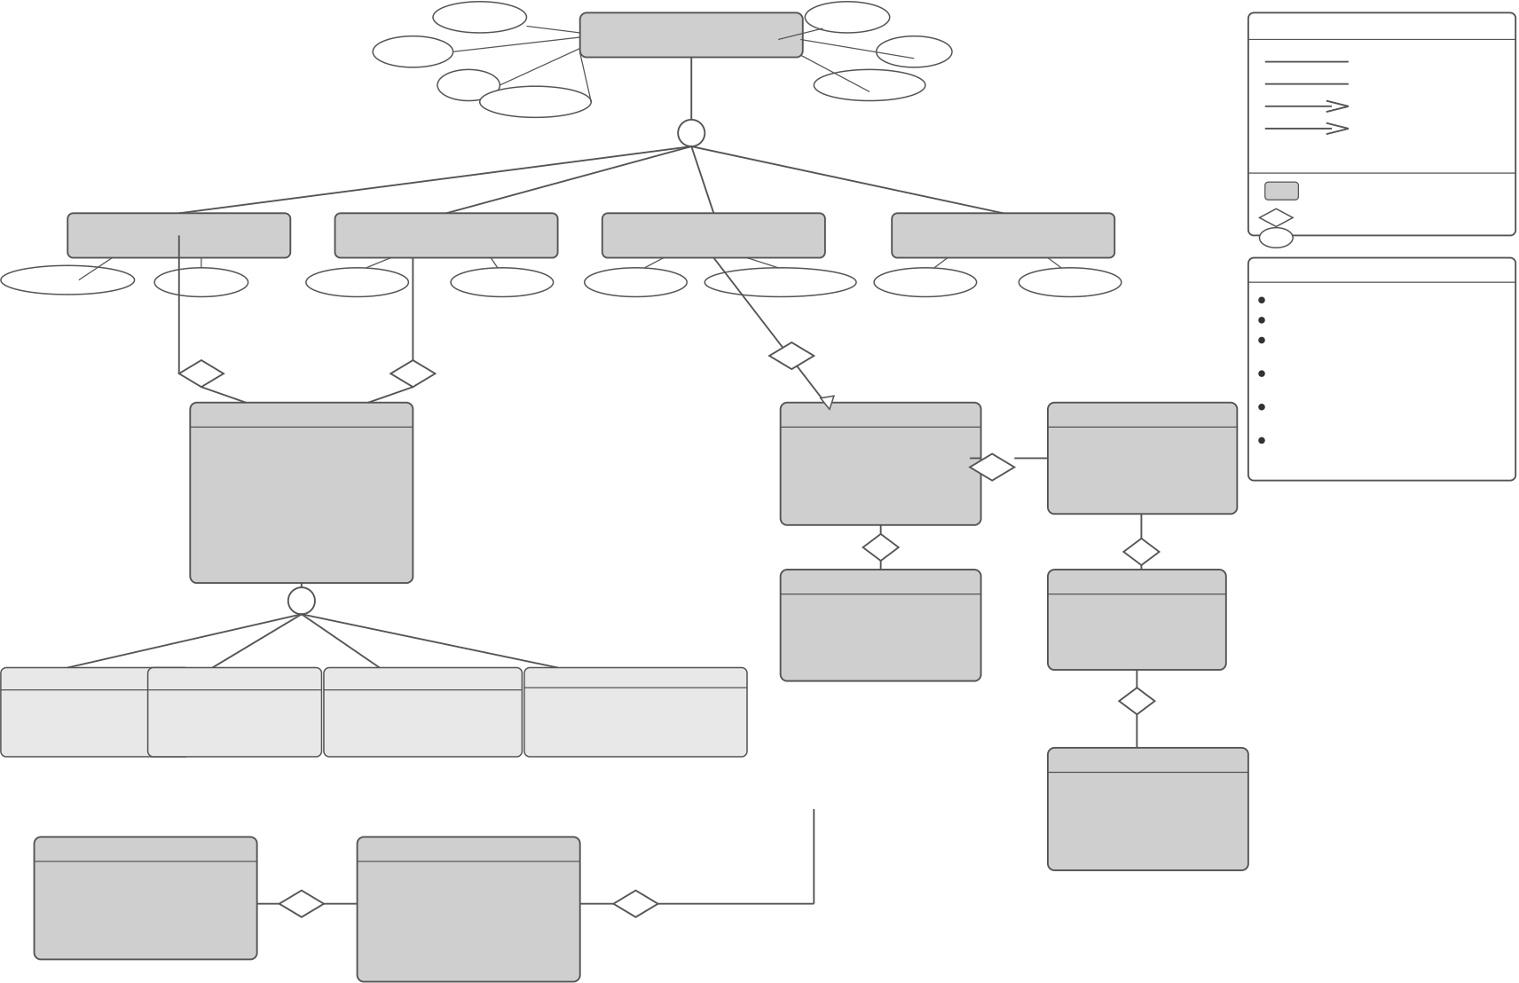
Crypto World Bank — Heavily Compressed | BRAC University
CoreSystemGraph:EntityRelationshipsAcrosstheFour-TierBankingHierarchy (WORLD_BANK→NATIONAL_BANK→LOCAL_BANK→BANK_USER)
PK | TIER1 | 1 | HAS | PK | TIER2 | 1 | HAS | PK | TIER3 | 1 | HAS | 1..* | PK | TIER4
 | WORLDBANK |  |  |  | NATIONALBANK |  |  |  | LOCALBANK |  |  |  |  | BANKUSER
 | WORLD_BANK |  |  |  | NATIONAL_BANK |  |  |  | LOCAL_BANK |  |  |  |  | BANK_USER
 | world_bank_id |  |  |  | national_bank_id |  |  |  | local_bank_id |  |  |  |  | user_id
 | name(UQ) |  |  | FK | world_bank_id |  |  | FK | national_bank_id |  |  |  | FK | local_bank_id
 | code(UQ) |  |  | 1..* | name(UQ) |  |  | 1..* | name(UQ) |  |  |  |  | username(UQ)
 | description |  |  |  | code(UQ) |  |  |  | code(UQ) |  |  |  |  | email(UQ)
 | headquarters_address |  |  |  | country_code |  |  |  | type |  |  |  |  | password_hash
 | established_date |  |  |  | central_bank_code |  |  |  | branch_code(UQ) |  |  |  |  | first_name
 | status |  |  |  | regulator_reference |  |  |  | address |  |  |  |  | last_name
 | created_at |  |  |  | established_date |  |  |  | city |  |  |  |  | role
 | updated_at |  |  |  | status |  |  |  | region |  |  |  |  | phone_number
 |  |  |  |  | created_at |  |  |  | country_code |  |  |  |  | is_active
 |  |  |  |  | updated_at |  |  |  | swift_code(UQ) |  |  |  |  | last_login_at
 |  |  |  |  |  |  |  |  | established_date |  |  |  |  | created_at
 |  |  |  |  |  |  |  |  | status |  |  |  |  | updated_at
created_at
updated_at
Referencedby |  |  | Referencedby | Referencedby
NATIONAL_BANK.world_bank_id |  |  | LOCAL_BANK.national_bank_id | BANK_USER.local_bank_id
LEGEND |  |  | RELATIONSHIPSUMMARY  Relationship From To Cardinality  HAS WORLD_BANKNATIONAL_BANK 1toMany(1..*)  HAS NATIONAL_BANKLOCAL_BANK 1toMany(1..*)  HAS LOCAL_BANK BANK_USER 1toMany(1..*) |  | NOTES
PK | PrimaryKey |  |  |  | •Themodelenforcesastrictfour-tierhierarchy.
FK | ForeignKey |  |  |  | •Eachchildentitymustbelongtoexactlyone
UQ | UniqueConstraint |  |  |  | parentinthetierabove.
 |  | OnetoOne
 |  |  |  |  | •Deletionofaparentisrestrictedifdependent
 |  | Many(OnetoMany) |  |  | childrenexist.
ForeignKeyReference |  |  |  |  | •UQ=businesskeyuniquenesswithinscope.
Figure 3.6: Core system entity graph
name | bank_id | country_code | BANK | region | status | CARDINALITYLEGEND
 | tier |  |  | created_at |  | 1—One
 |  |  |  |  |  | 0..1—ZeroorOne
 |  |  | o
 |  |  |  |  |  | 1..*—OneorMany
 |  |  |  |  |  | 0..*—ZeroorMany
SYMBOLLEGEND
Entity
WORLD_BANK_RESERVE |  | license_no | NATIONAL_BANK |  | branch_code | LOCAL_BANK | kyc_status | RETAIL_USER | Relationship
(Tier1) |  |  | (Tier2) |  |  | (Tier3) |  | (Tier4) | Attribute
 |  |  |  |  |  |  |  |  | NOTES
authorized_capital | currency |  | 1 | swift_code |  | parent_bank_id(FK) |  | risk_rating
PK=PrimaryKey
SAVINGS_ACCOUNT | 1 | owns | INSURANCE_FUND_ACCOUNT | 1 | 1 | requests | 1..* | LOAN_REQUEST | FK=ForeignKey
 |  |  |  |  | 1..* |  |  |  | Overlap(o):Entitycanbelong
 | maintains |  |  |  | requests |  |  |  | tomorethanonesubtype.
 |  |  |  |  |  |  |  |  | Allrelationshipsfollow
 | 1..* | 1..* |  |  | LOAN_GROUP |  |  |  | referentialintegrityconstraints.
 |  |  |  |  |  |  |  |  | Modulesrepresentfunctional
 | ACCOUNT
 |  |  |  |  |  |  |  |  | contextsinPhaseI–IV.
 | account_id | CURRENT_ACCOUNT |  |  | group_id |  |  | loan_id | Specialization:circlewith'o'
 | owner_id(FK) |  |  |  | name |  |  | purpose | denotespartial/overlap.
 | account_type |  |  |  | status |  |  | amount
 | currency |  |  |  | created_at |  |  | status
 | balance |  |  |  | updated_at |  |  | created_at
 | status |  |  |  | 1 |  |  | 1..*
 | created_at |  |  |  | includes |  |  | approved_by  1
 | updated_at
 |  |  |  |  | 1..*
 | o |  |  |  | GROUP_MEMBER |  |  | LOCAL_BANK
 |  |  |  |  | member_id |  |  | lb_id
 |  |  |  |  | user_id(FK) |  |  | name
 |  |  |  |  | role |  |  | region
 | FIXED_DEPOSIT |  |  |  | joined_at |  |  | status
 |  |  |  |  |  |  |  | 1
interest_rate | term_months | overdraft_limit | coverage_type |  |  |  |  | generates
yield_accrued | maturity_date | transaction_limit | premium_due |  |  |  |  | 1..*
withdraw_limit | interest_rate | branch_id | claim_status
INSTALLMENT
installment_id
GROUP_LENDING_POOL | 1 | funds | 1..* | LOAN_REQUEST | 1 | repaid_by | 1..* | (installment_id, | loan_id(FK)
 |  |  |  |  |  |  |  | loan_idFK,due_date, | due_date
 |  |  |  |  |  |  |  | amount_due,paid_status) | amount_due
 |  |  |  |  |  |  |  |  | paid_status
pool_id |  |  |  | loan_id
lb_id(FK) |  |  |  | lb_id(FK)
loan_id |  |  |  | pool_id(FK)
total_funds |  |  |  | amount
utilization |  |  |  | status
status |  |  |  | created_at
Figure 3.7: Enhanced EER model
19

Crypto World Bank — Heavily Compressed | BRAC University
ExtendedERD-BankingProductsandMulti-EntityOperations
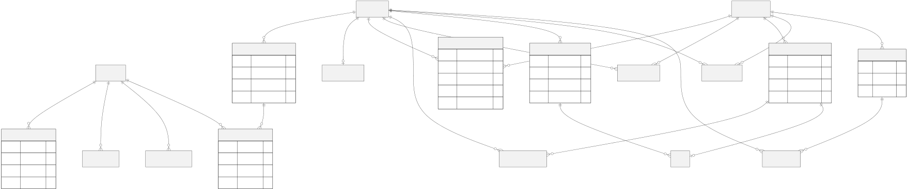
Figure 3.8: Extended ERD entities
On-ChainvsOff-ChainDataPartitioning
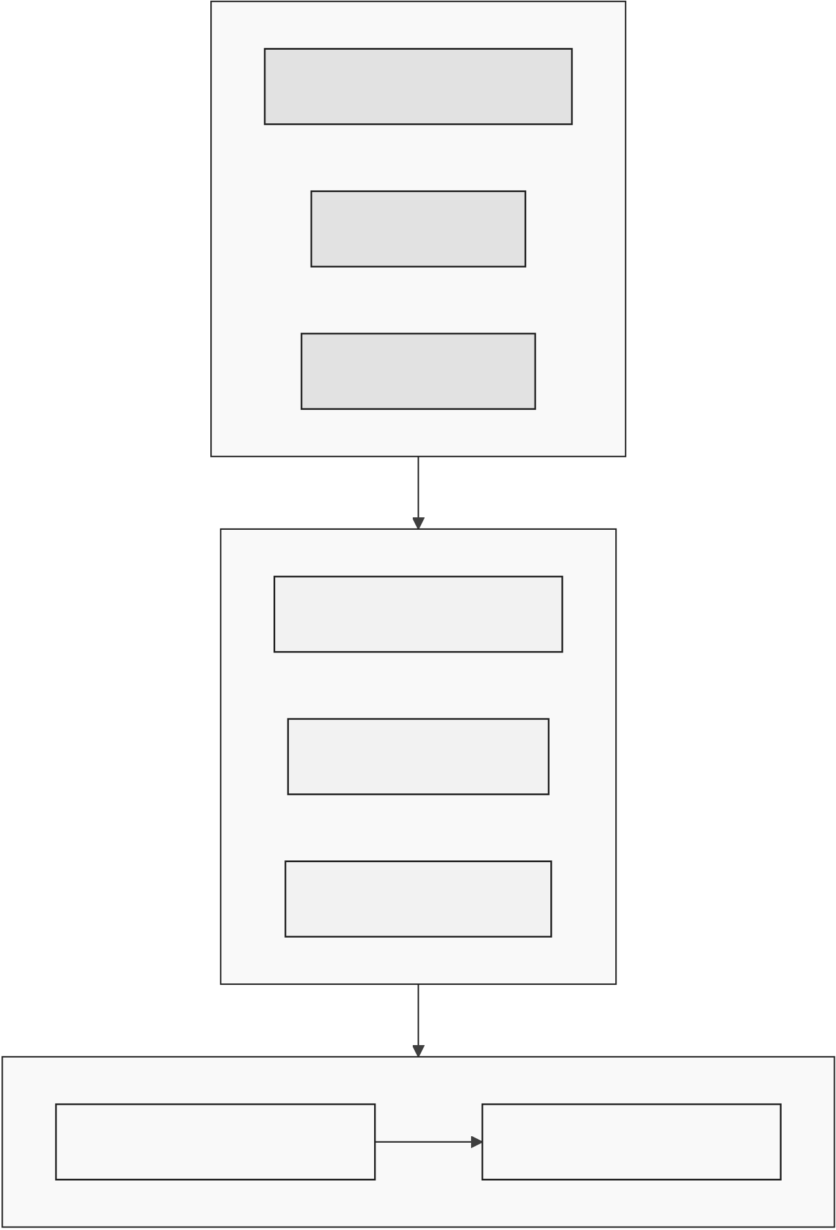
Figure 3.9: On-chain versus off-chain data partitioning
20


Crypto World Bank — Heavily Compressed | BRAC University
ComplianceandIdentityStack
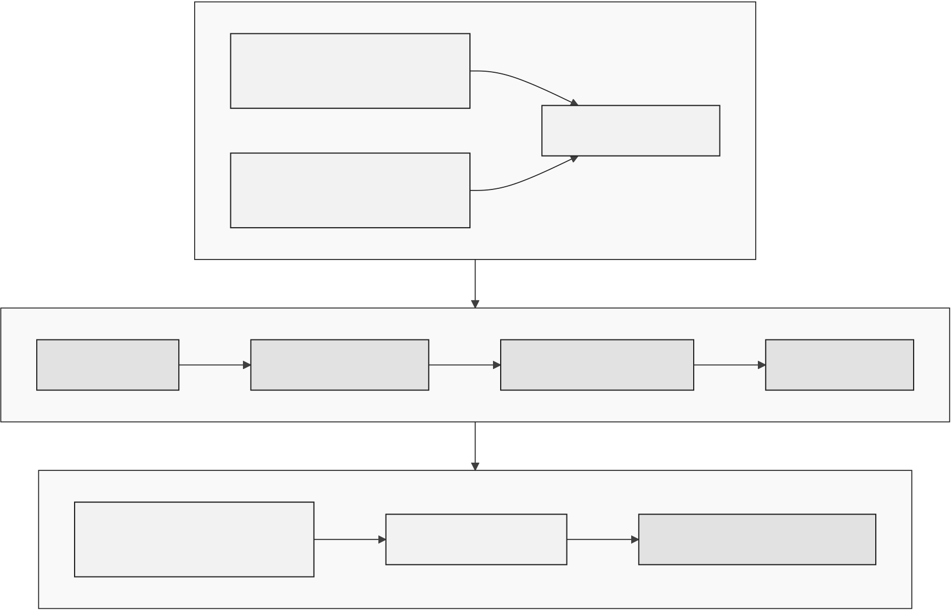
Figure 3.10: Compliance and identity stack
 |  |  |  | 
Client | LocalBank | NationalBank | WorldBank | AIAgent
 |  |  | Reserve
(ReactUI/ | (Tier3) | (Tier2) |  | (Optional)
MCPAgent) |  |  | (Tier1)
Action/Tool
Submitloanrequest
Payinstallment |  |  | 
Approveloan
Approveaccount |  |  |  |  | 
Freezeaccounts
Viewallrates |  |  |  |  | 
Writetools(humansonly) |  |  |  | 
Allowed | Notallowed |  | Fullaccess(asperrole) |  | Optional/limited(AIAgent)
Figure 3.11: Actor permission matrix (primary actions)
21

Crypto World Bank — Heavily Compressed | BRAC University
ClientEntry,KYCLimits,andBank-LevelSyndication(USDC-first)
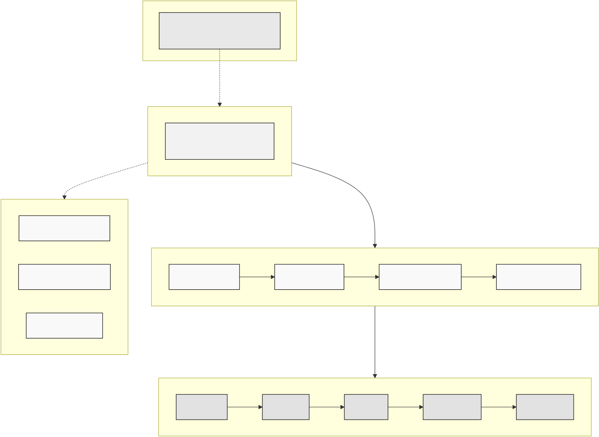
Figure 3.12: Client limits and bank-level syndication
22

Crypto World Bank — Heavily Compressed | BRAC University
Five-StageRetailConversionFunnel
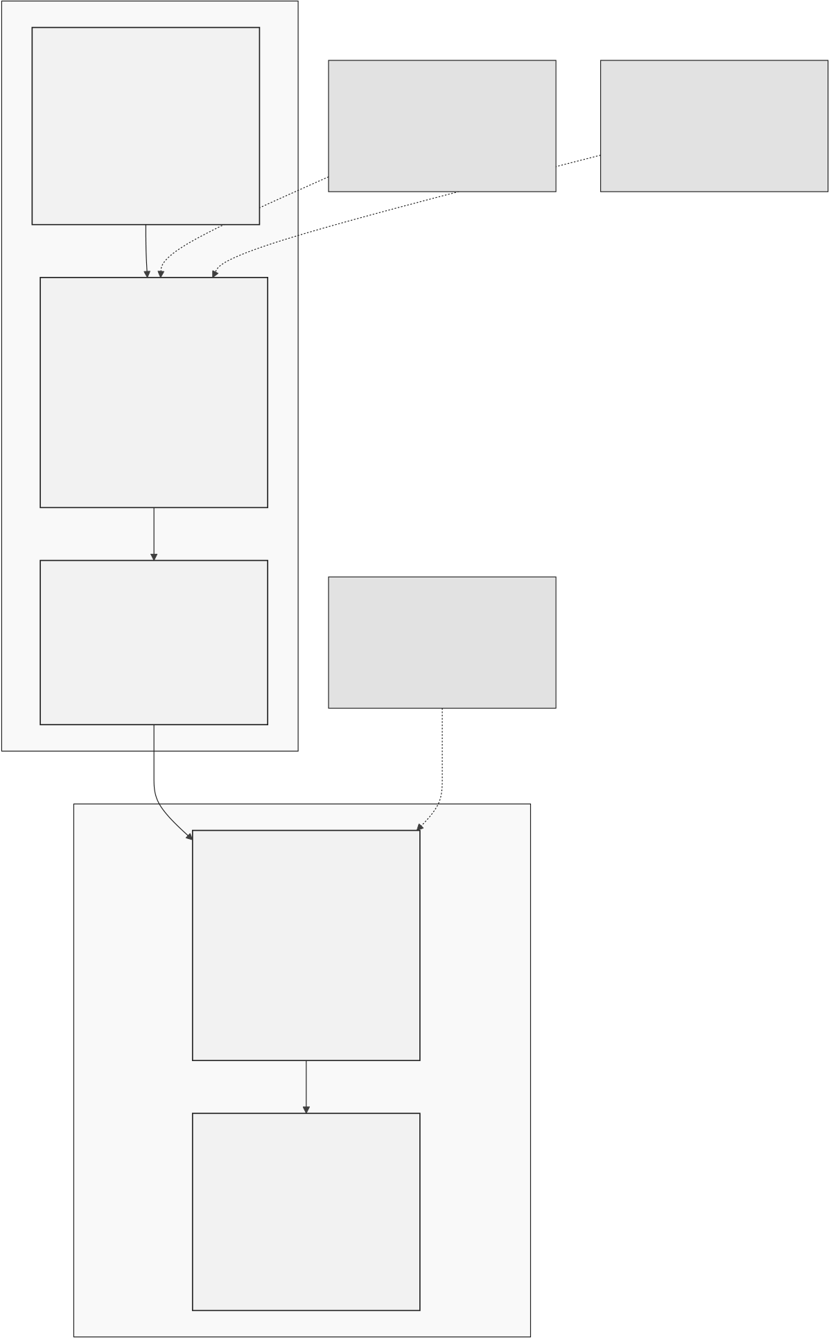
Figure 3.13: Five-stage retail onboarding funnel
23

Crypto World Bank — Heavily Compressed | BRAC University
OptionalAIAgentAdd-On—Six-StepPipeline(PhaseIII–IV)
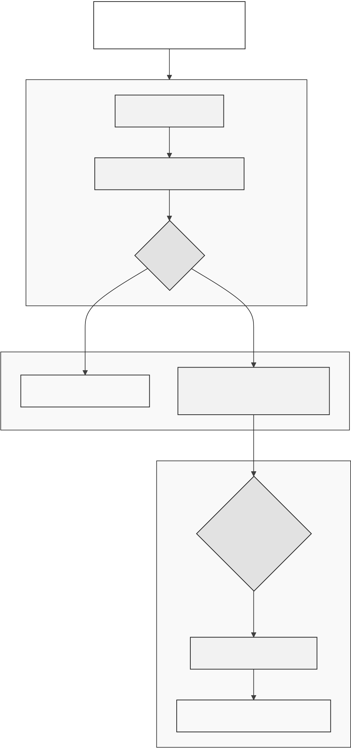
Figure 3.14: Optional AI agent add-on (Phase III–IV, excluded from MVT)
24

Crypto World Bank — Heavily Compressed | BRAC University
LiquidationEngine—Tier-SpecificHealthFactorandLifecycle
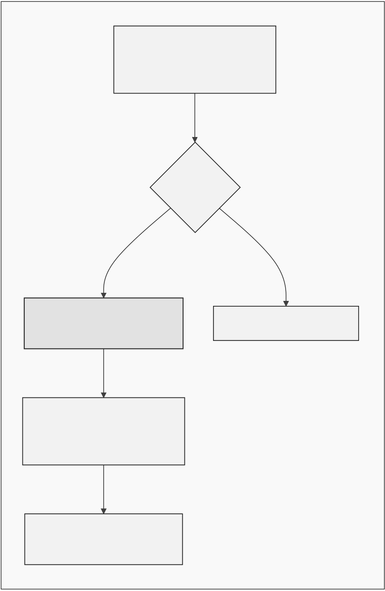
Figure 3.15: LiquidationEngine tier models and lifecycle
SavingsVaultandFixedDeposit—Closed-LoopDepositMobilization
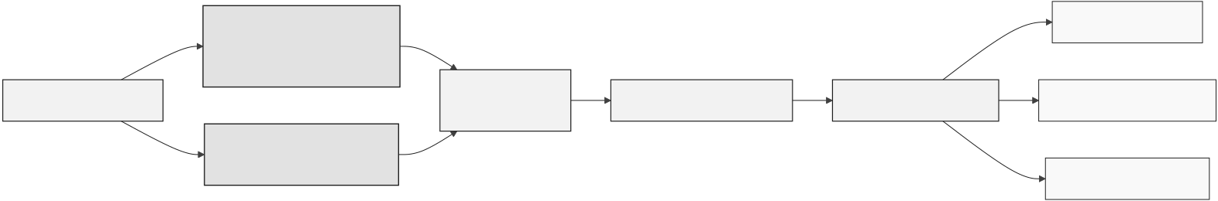
Figure 3.16: SavingsVault and FixedDeposit closed loop
25

Crypto World Bank — Heavily Compressed | BRAC University
On-ChainCreditPassport(SoulboundToken)
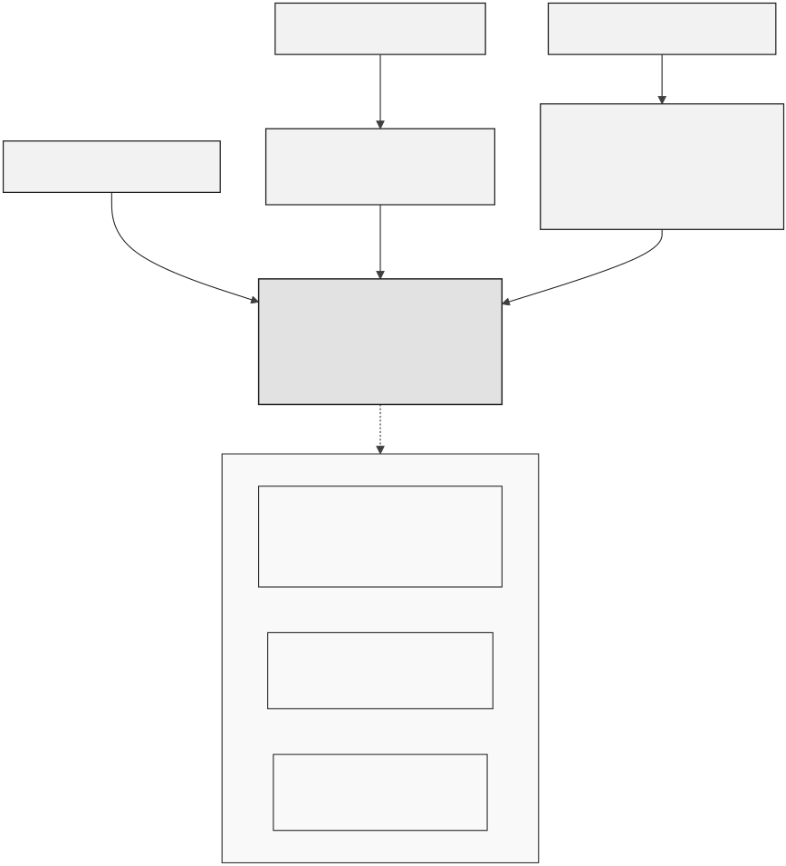
Figure 3.17: On-chain Credit Passport SBT lifecycle
26

Crypto World Bank — Heavily Compressed | BRAC University
Cross-ChainBridge—ChainlinkCCIPandHierarchyInvariant
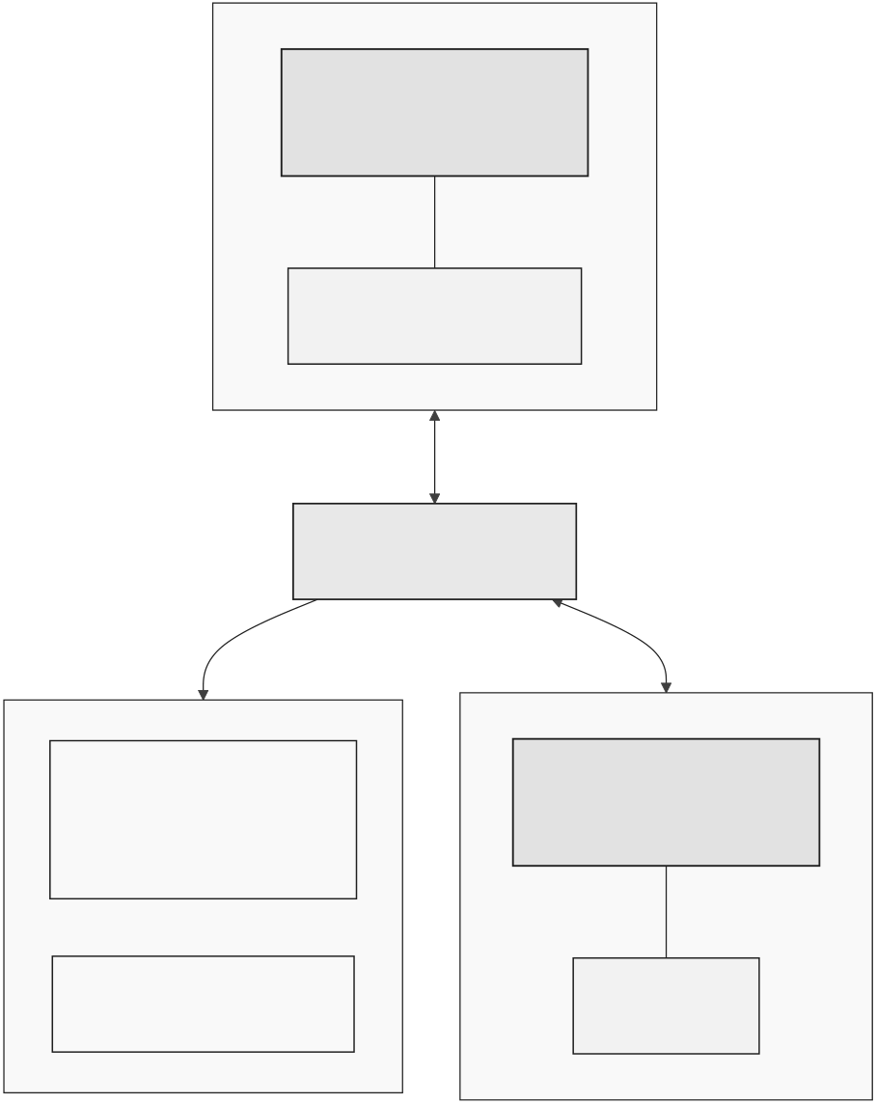

Figure 3.18: Chainlink CCIP cross-chain hierarchy invariant
27


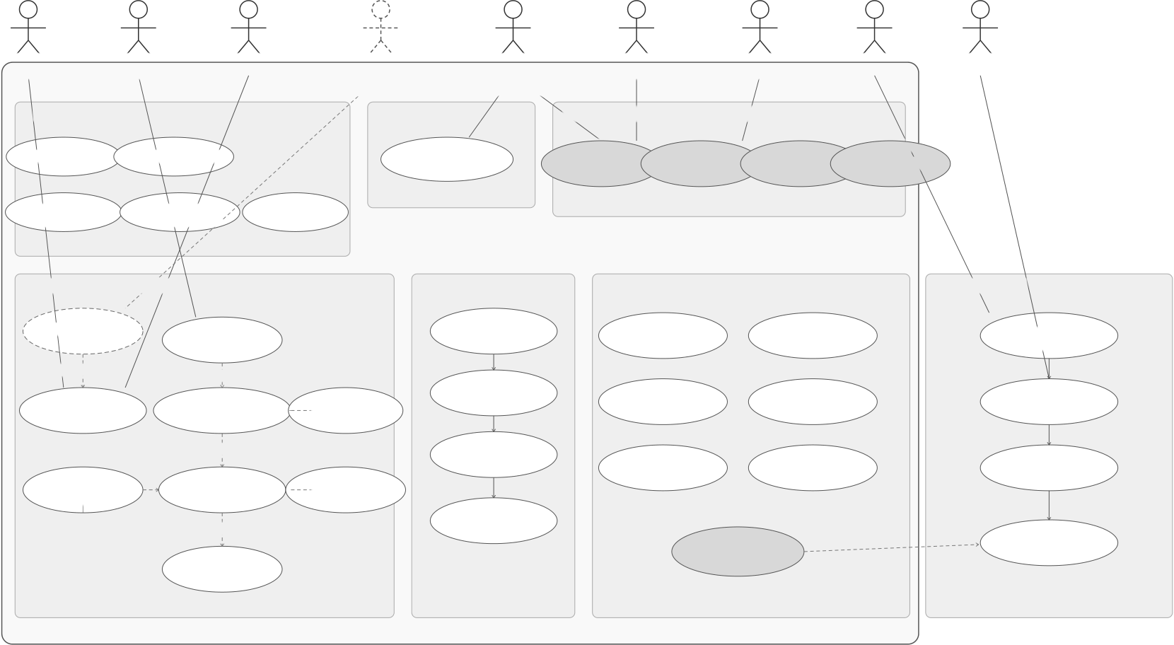
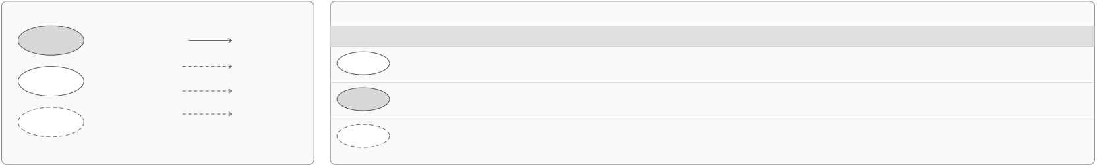
Crypto World Bank — Heavily Compressed | BRAC University
Multi-EntityCo-FundingMechanisms
FourCo-FundingPatternsEnablingCapitalatScaleAcrosstheCryptoWorldBankEcosystem
1 | SyndicatedLoan | 2 | SolidarityGroupLoan |  | Group | 3 | TranchedPool | SeniorTranche | 4 | UpwardDepositFacility
 | InstitutionalCo-Lending |  | RetailCo-Borrowing |  |  |  | Senior/JuniorCo-Funding |  |  | SurplusRepatriation
 | LeadArranger |  | Group | Group |  |  | JuniorTranche |  |  | Surplus | Surplus
 | Bank |  | Member1 | Member2 | Member3 |  | (First-Loss) | (Protected) |  | LocalBankA | LocalBankB
structure+fee
SyndicatedLoan | collateral | collateral | collateral | juniorcapital | seniorcapital
Contract
Co-LenderA | Co-LenderB | GroupLendingPool | TranchedPool | UpwardDepositFacility
 |  | (MutualLiability) | Contract | Contract
consolidatedsurplus
deposits
capitalshare | capitalshare | grouploan | cover | funding | senior-priority | Parent
 |  |  |  |  | repayment
 |  |  | shortfall |  | (interest&
 |  | (disbursement) | (mutual |  | principal)
 |  |  | liability) |  |  | NationalBank
Corporate/Project
Borrower furtherrepatriation (toWorldBankReserve
pro-ratainterest | LocalBank | LoanPool | ifapplicable)
 |  | (Borrowers)
&principalrepayment
WorldBankReserve
(Tier1)
LEGEND
 | CapitalCommitment/Disbursement(FlowofFunds) |  | Entities(DarkGray)
 | Repayment/Yield/MutualLiabilityCover(ReturnFlow) |  | SmartContracts/Pools(LightGray)
Figure 3.19: Multi-entity and cross-tier capital operations
«Optional»
A9:ExternalAuditor | A4:Borrower | A7:PolygonzkEVML2 | A5:AIAgent | A1:WorldBank | A2:NationalBank | A3:LocalBank | A6:ChainlinkOracle | A8:FastAPIMLService
(PoR/Indexer) | (Client) |  | (OptionalAdd-on) | (Tier1) | (Tier2) | (Tier3)
CryptoWorldBankSystemBoundary
1.Onboarding&Setup |  |  | UC15:Configure | 2.CapitalAllocation | 3.FundingOperations(Multi-EntityUseCases) |  |  | «MultiEntity» | 7.AI&RiskScoring
 |  |  |  |  | «MultiEntity» | «MultiEntity» | «MultiEntity»
UC4:ProcessInstallment | UC12:RegisterInstitution |  |  | UC1:Allocate | UC5:Inter-Bank | UC6:Upward | UC7:Syndicated | UC8:Multilateral
UC13:KYC/ | UC14:Manage |  |  | HierarchicalCapital | Lending | DepositFacility | y Co-lending | Netting
IdentityVerification | Roles&Permissions |  | RiskParameters | 5.Repayment&Servicing | 6.Monitoring,Risk&Compliance
4.LoanOrigination&Processing
UC10:Conversational |  |  | «include»  UC17:Collateral | UC21:Repayment | UC25:Monitor |  | UC26:TrackCapital |  | UC32:FetchOn-chain
Interface | UC2:Request |  |  | (Installment) | Exposure&Limits |  | Utilization |  | &Off-chainData
Loan
«interacts» | «include»
 |  |  |  | UC22:InterestAccrual | UC27:AML/CFT |  | UC28:Sanctions |  | UC33:ComputeML
UC11:VerifyProof | UC16:CreditScoring
 |  |  |  |  | Screening |  | Screening |  | RiskScore
ofReserve | &RiskAssessment |  | Management | UC23:Payment | UC29:Regulatory |  | UC30:AuditTrail |  | UC34:RiskScore
«include»
 |  |  |  | Reconciliation
UC18:Loan | «include» | UC3:Evaluate& | «include»  UC19:Generate |  | Reporting |  | &Logs |  | Feedback
Structuring | ApproveLoan |  | LoanAgreement
UC24:LoanClosure
«include» | &Settlement | «MultiEntity» | UC9:Assess
 |  | UC31:NetExposure | MLRiskScore
Calculation
UC20:DisburseLoan
Legend | Multi-EntityUseCase | Association | Status | PrototypeScope&ImplementationStatus(Pre-ThesisDesignRecordOnly;NoLivePublicDeployment) |  |  |  | Notes
 |  |  |  | Definition |  | AppliesTo
 | (involvesmultipleentities) |  | Specified | (FormalDesign) | Requirementsanddesignspecifiedin | AllUseCases&Actorsdefinedabove |  | Notimplementedyet.
 |  | «include»Mandatory
 | StandardUseCase(singleentity) |  |  | thisdocument.Basisforevaluation. |  |  |  | Implementationpendingthesisphases.
 |  | «extend»Optional
 |  |  | Planned | (Implementation) | ) Plannedforimplementationinlater | AllUseCases&Actorsdefinedabove
 | OptionalUseCase(add-on) | «interacts»Optional | Optional | phasesofthefinalthesis. |  |  |  | Maybeimplementeddependingon
 |  |  |  | (Add-on) | Optionalconversationalagentinterface |  | UC10andA5(AIAgent)only
 |  |  |  | (UC10andA5only).Notpartofcore. |  |  |  | scopeandfeasibility.
Note:Nothinginthepre-thesissubmissionisdeployedtoapublicnetwork;thisdiagramrecordsdesignstatusonly.
Figure 3.20: Use-case diagram (nine-actor taxonomy)
28

Crypto World Bank — Heavily Compressed | BRAC University
USDCLoanLifecycle—End-to-EndActivityFlow
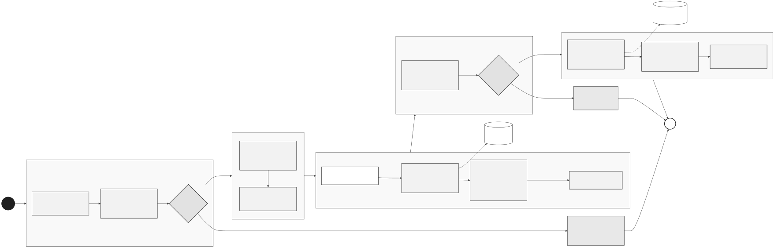
Figure 3.21: USDC loan lifecycle activity flow
RetailOnboardingandTieredIdentity—ActivityFlow
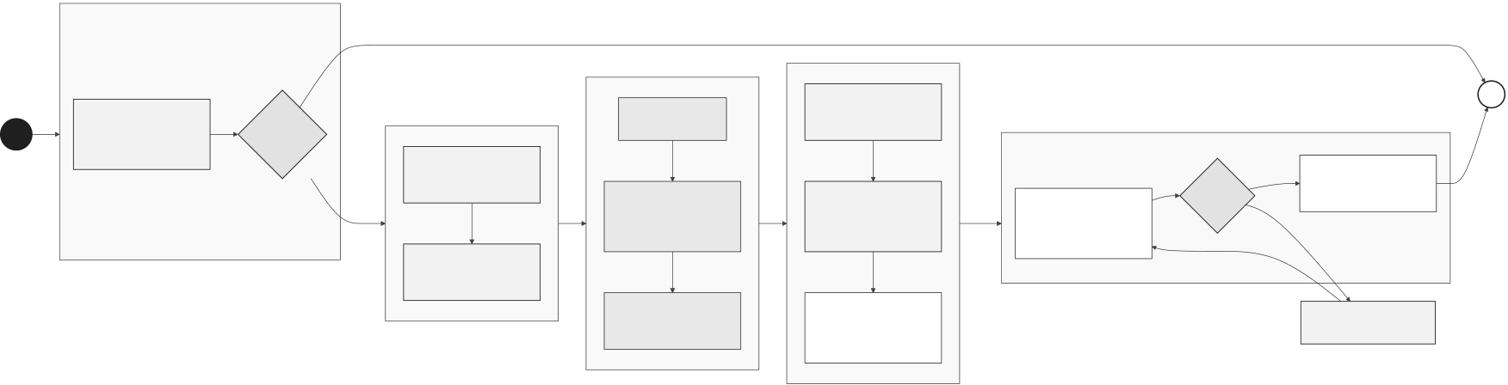
Figure 3.22: Retail onboarding and identity activity flow
ClientBankingSession—Chat,Dashboard,andOptionalAgent
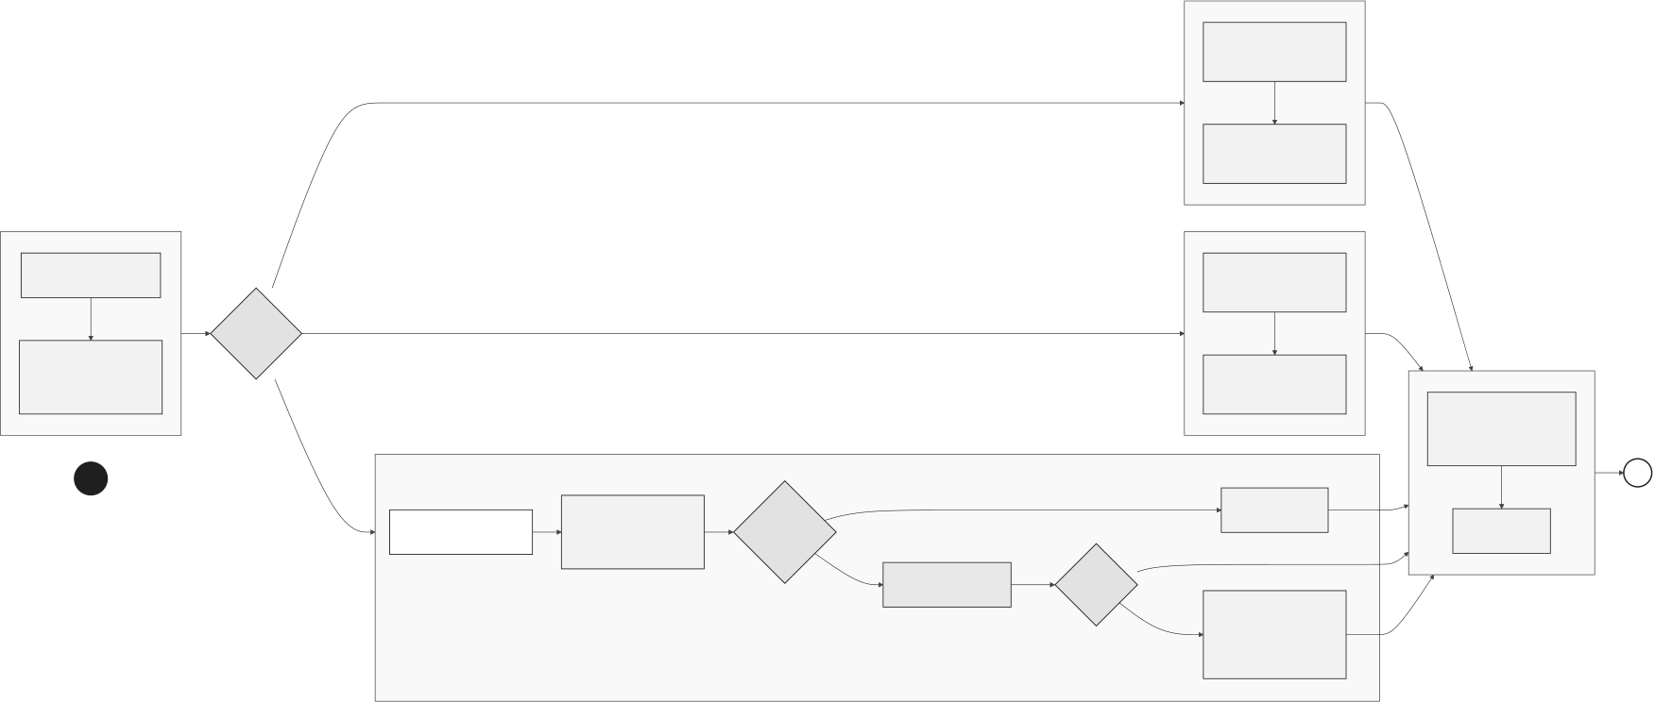
Figure 3.23: Client banking session activity flow
29

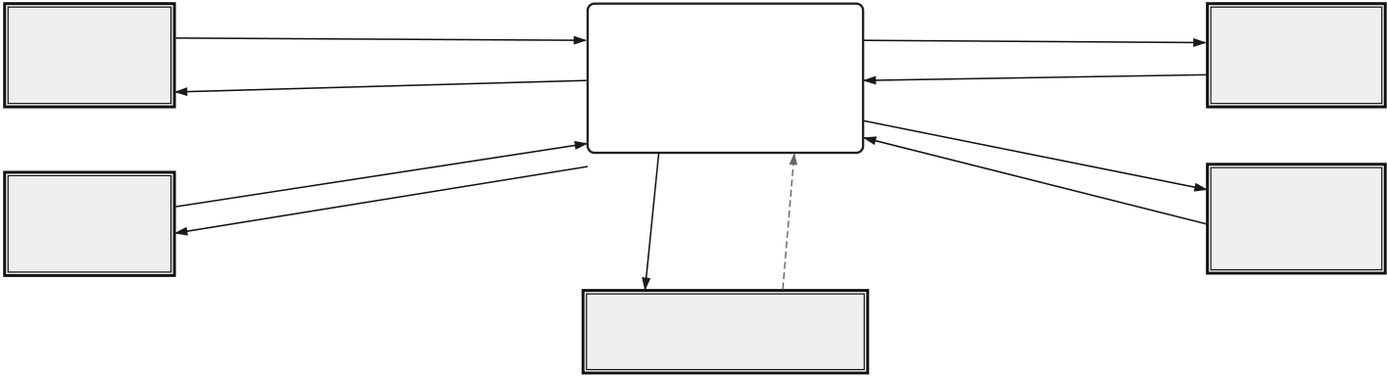
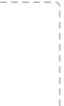
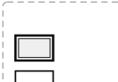

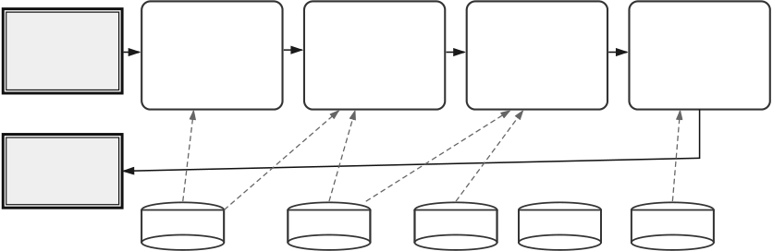
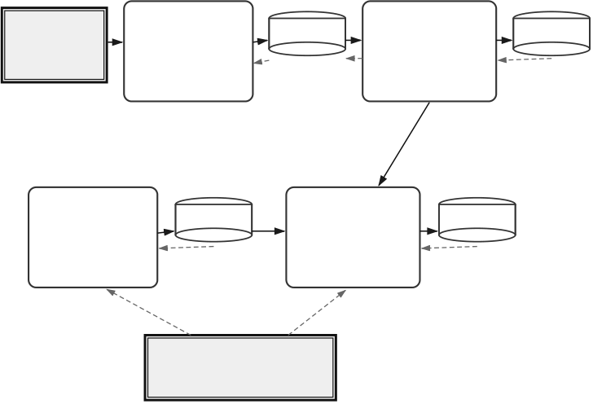
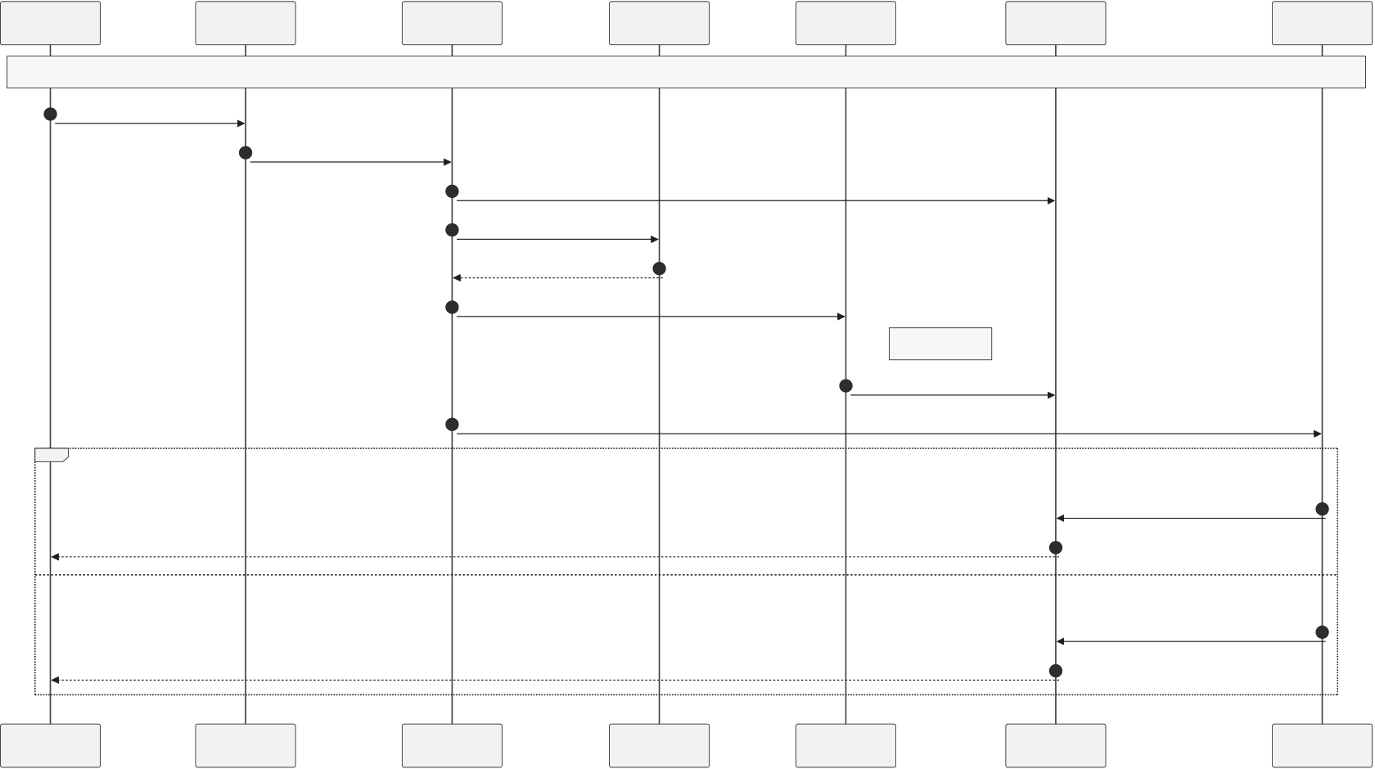
Crypto World Bank — Heavily Compressed | BRAC University

E1 | Registration,KYCData,LoanRequests, | (A)Level-0(ContextDiagram)–CryptoWorldBankPlatform |  |  | E3 | DFDLegend(NotationUsed)     1D ExternalEntity Process DataStore DataFlow Control/FeedbackFlow DataStore(Named)
 |  | 0  CryptoWorldBank | Transactions,Events,  SmartContractCalls
Users/Customers | Deposits,Repayments,Queries |  |  |  | Blockchain
(Tier4Borrowers |  | Platform |  |  | Network
&Depositors) |  |  |  |  | (PolygonzkEVM)
 | Approvals,LoanTerms, | (Four-TierDecentralised  Lending&TreasurySystem) |  | TransactionReceipts,  EventLogs,BlockData | E4
ExternalEntity
 | Balances,Statements,Notifications  LoanRequests,Repayments, | Process
 |  | DataRequests
 |  | ExternalData
E2 | CollateralData,Reports | (Prices,Rates,KYC,etc.) |  |  | Oracle&External
Banks(Tier1–3) |  | Reports,AuditTrails, | Policies,Rules, |  | Services
(National& | LoanDecisions,Disbursements, | Risk&ComplianceData | ComplianceRequests |  | (Chainlink,PriceFeeds,
LocalBanks) | Limits,Statements |  |  |  | KYC,Sanctions,FXRates)

ExternalEntity

E5
Regulators/Compliance
 |  | (B)Level-1DFD–CoreLendingSubsystem |  |  |  |  |  |  | (Authorities,Auditors) |  | (C)Level-1DFD–Treasury&LiquiditySubsystems
E1,E2 | Application |  |  |  |  |  |  | Installment | 1.4 | E1,E2
 |  | 1.1 | 1.2 |  |  | 1.3 |  |  |  |  | 2.1 | 2.2
Banks(Tier1–3) |  | Origination | Score& | MLScoring |  | Disbursement | Disbursement |  | Installment | Customers& | Deposit | DepositRecords | D6 | PoolContributions |  | InterBank | PoolTransactions | D7
&Customers | Data | Service | RiskGrade |  | Service | Transaction | Service | Schedules | Engine | Banks | Mobilization | LendingPoolService
(Tier4) |  | •Validaterequest | •Featureextraction |  |  | •Creditapproval |  |  | •ScheduleEMIs | (Tier1–4) | Service | DepositAccounts  AccountUpdates (On-Chain) PoolUpdates  s |  |  | •Same-tierP2Plending |  | g InterBankPool  PoolUpdates Ledger(On-Chain)
 |  | •Captureterms | •MLriskscoring |  |  | •Smartcontractcall |  |  | •Generatedueevents |  | •Acceptdeposits |  |  |  | •Manageliquiditypool
 |  | •Createloanapplication | •Decisionsupport |  |  | •Funddisbursement |  |  | •Trackpayments |  | •Manageproducts |  |  |  | •Calculatepeerrates

E1,E2 | CustomerData, | InstallmentSchedules&Dues |  |  | Schedules, | 2.3 | •Updatebalances |  | 2.4 | Exposure&
 |  | CustomerData, | Models,Features
Banks(Tier1–3) | KYCStatus  ) | Requisites |  |  | PaymentStatus |  |  |  |  | Obligations
&Customers(Tier4) |  | LoanAccount  Update
 | D1 |  |  |  | D5
 |  | D2 | D3 | D4
 | Customer&KYC | MLModels& | LoanAccounts | RepaymentSchedule | PaymentLedger | TreasurySwap | SwapTrades | D8 | NettingEngine | NettingResults | D9
 | Repository | FeatureStore | e (On-Chain) | Repository | (On-Chain) | Service | SwapPositions |  | Service | Netting&Settlement
 |  |  |  |  |  | •FX&rateswaps |  |  | •Multilateralnetting
 |  |  |  |  |  | •Treasuryoperations | PositionUpdates (On-Chain) |  | •Offsetpositions | SettlementUpdates Ledger(On-Chain)
 |  | Events,LoanStatusUpdates,Notifications |  |  |  | •Hedgemanagement |  |  | •Settleobligations

E4
Oracles&ExternalServices
(Chainlink,PriceFeeds,KYC,FXRates,etc.)
Figure 3.24: Data-flow diagrams
LoanApprovalSequence-ChainlinkFunctions+AuthorityBrief
Client | Frontend | ExpressAPI | FastAPIML | ChainlinkDON | LocalBank | Approver
ML+oraclepath(PhaseIII,afterpre-thesis2)
1 Submitloan(USDC)  2 | 2 POST/loans(EIP-712) | 5 |  | applyLoan()
 |  | 6 oraclescorerequest
MLAPIconsensus
alt | 8  Disbursed | [Approve] | 7 | commitscoreon-chain | 10 | approveLoan(SCORE_REVEALED) | 9
 |  |  | AuthorityBrief(SHAPtop-3)
[Reject]
Client | Frontend | Rejected+explanation |  | ChainlinkDON | 12 | rejectLoan(reason) | 11
 |  | ExpressAPI | FastAPIML |  | LocalBank |  | Approver
Figure 3.25: Loan approval sequence diagram
30

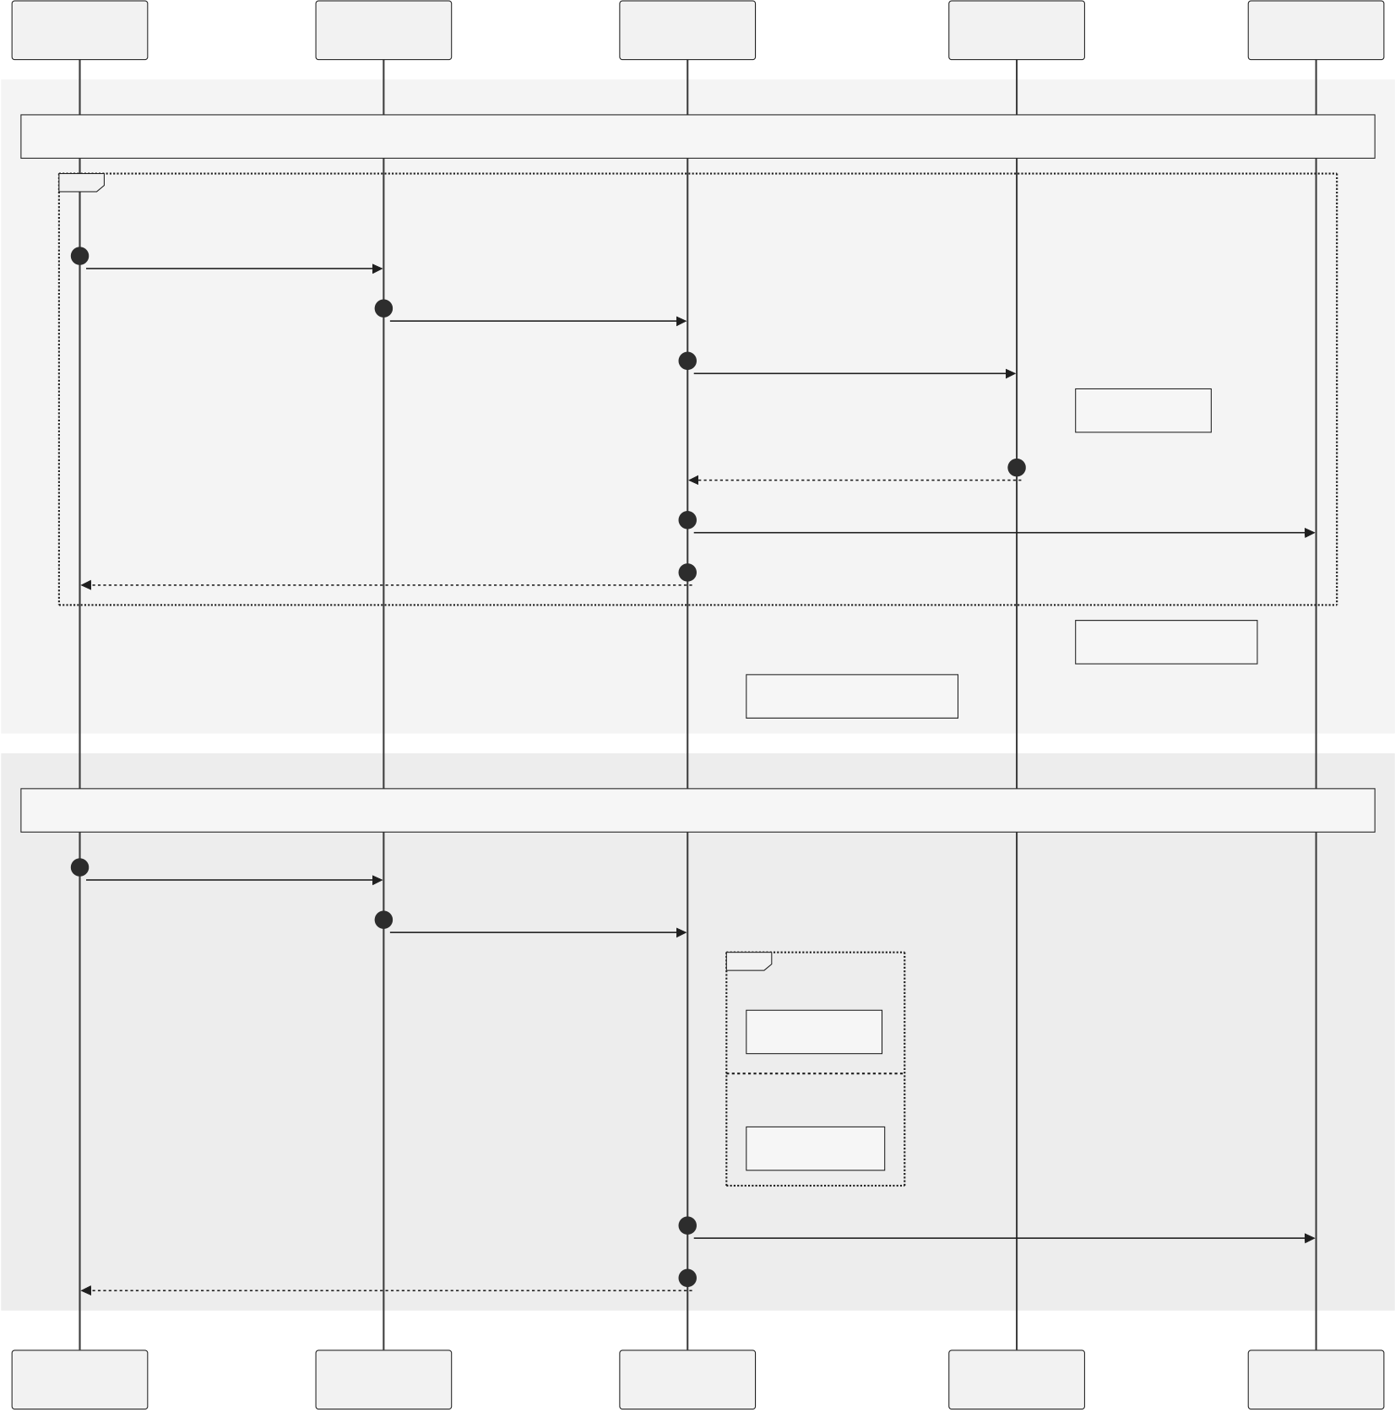
Crypto World Bank — Heavily Compressed | BRAC University
SequenceDiagrams-(a)InstallmentPaymentLoop,(b)IncomeVerification
Borrower | Frontend | BackendAPI | LocalBank | PostgreSQL
(a)Installmentpaymentloop
loop | PayinstallmentN | 2 | [Foreachscheduledinstallment]
1 |  |  | POST/installments/N/pay
 |  |  | 3 | processInstallment(loanId,N)
CEIpattern
receipt+nextduedate | 5 | emitInstallmentPaid | 4
 |  | UPDATEstatus=PAID
 | 6
LoanClosed+SBTbump
overdueviaAutomation(PhII)
(b)Incomeverification
7 | Uploadincomedocument | 8 | POST/income | alt | [APIpull]
fetchtransactions
[Manual]
queueforoperator
Borrower | verified+SBTscorebump | 9 | INSERTincome_proof | PostgreSQL
 |  | 10
 | Frontend | BackendAPI | LocalBank
Figure 3.26: Sequence diagrams
31

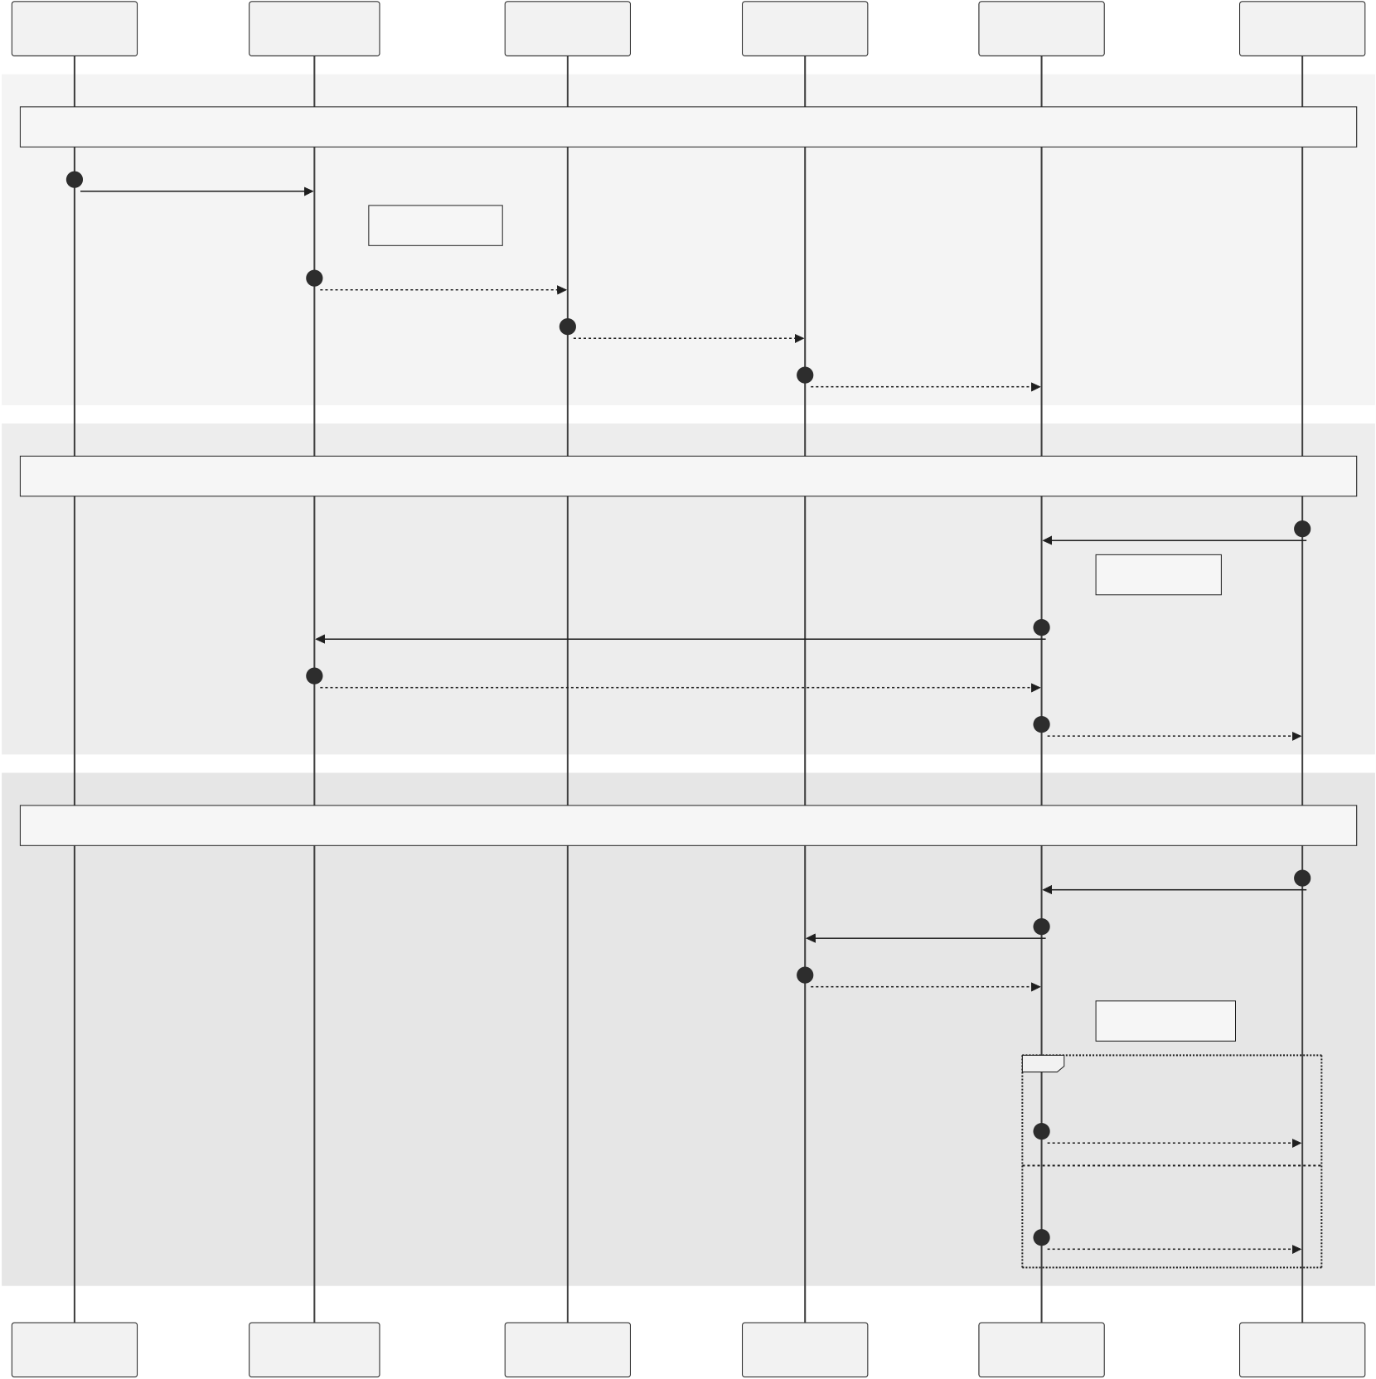
Crypto World Bank — Heavily Compressed | BRAC University
SequenceDiagrams-(a)HierarchicalBanking,(b)MarketData,(c)Borrowing-LimitCalculation
WBAdmin | WorldBankReserve | NationalBank | LocalBank | Backend | Borrower
(a)Hierarchicalcapitalflow
1 allocateCapital(NB)
requireratio>=min
2 | emitCapitalAllocated | 3 allocateCapital(LB) | 4 | poolfunded
(b)Market-dataretrieval
GET/market 5
cachemiss?
7 | Chainlinkpricefeeds | 6  8 prices(cached10s)
 | ETH/USD,fiatpairs
(c)Borrowing-limitcalculation
11 | readSBT+tier | 10 | POST/loans | 9
 | tiercap+loancap
ceiling+capchecks
alt [Pass]
12 proceedtoMLscoring
[Fail]
WBAdmin | WorldBankReserve | NationalBank | LocalBank | 13 | limitexceeded | Borrower
 |  |  |  | Backend
Figure 3.27: Sequence diagrams
32

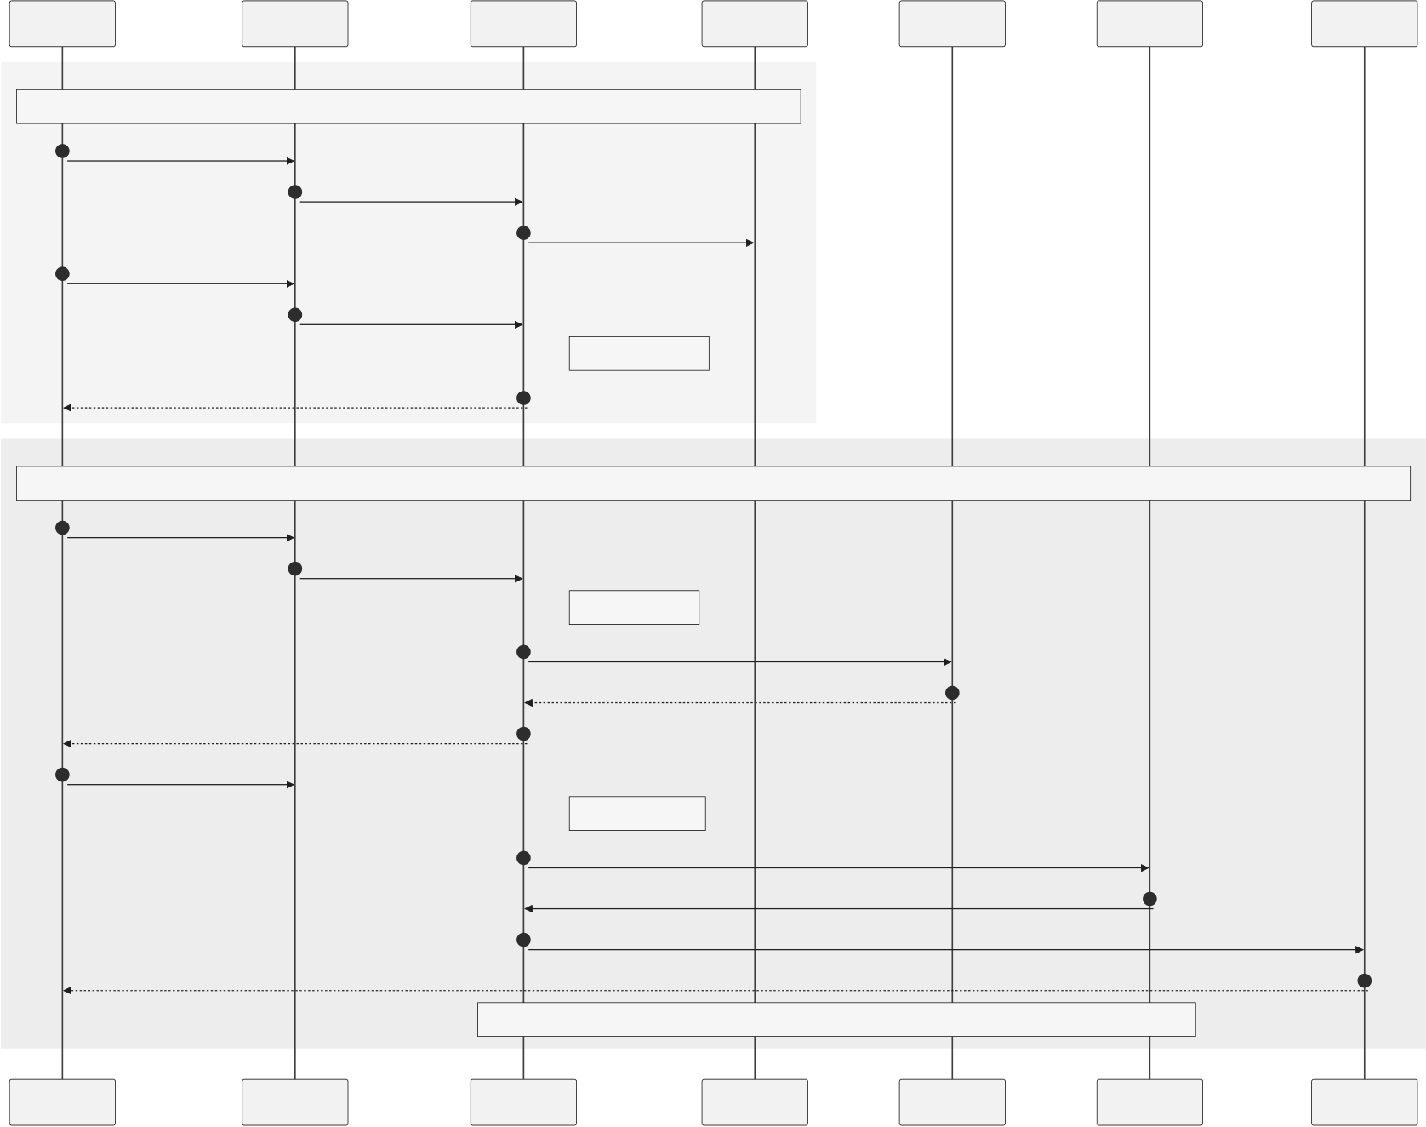
Crypto World Bank — Heavily Compressed | BRAC University
SequenceDiagrams-(a)BankChat,(b)OptionalAgentAdd-On
Client | Frontend | ExpressAPI | WebSocket | Qwen3-8B | MCPTools | Contract
(a)Client-bankchat(corepath)
1 Opensupportthread | 2 | Authenticate+openWS | 3 | Subscribethread
4 Messagetoapprover | 5 | POST/chat
persistCHAT_MESSAGE
DeliverviaWebSocket 6
(b)OptionalMCPagent(PhaseIII-IV,notMVT)
7 Applyfor150USDCloan | 8 | Streammessage(SSE)
injecton-chaincontext
12 | Proceed?EMI26.25USDC | 9 | /v1/chat/completions | 10
 |  | 11 | Confirmationsummary
 | Yes,proceed
logconfirmation_turn_id
13 | submit_loan_application | 14 | 16
15 | POST/api/loan/apply
 | applyLoan(walletorsessionkey)
 | LoansubmittedL-4821
HTTP403withoutconfirmation
Client | Frontend | ExpressAPI | WebSocket | Qwen3-8B | MCPTools | Contract
Figure 3.28: Sequence diagrams
33

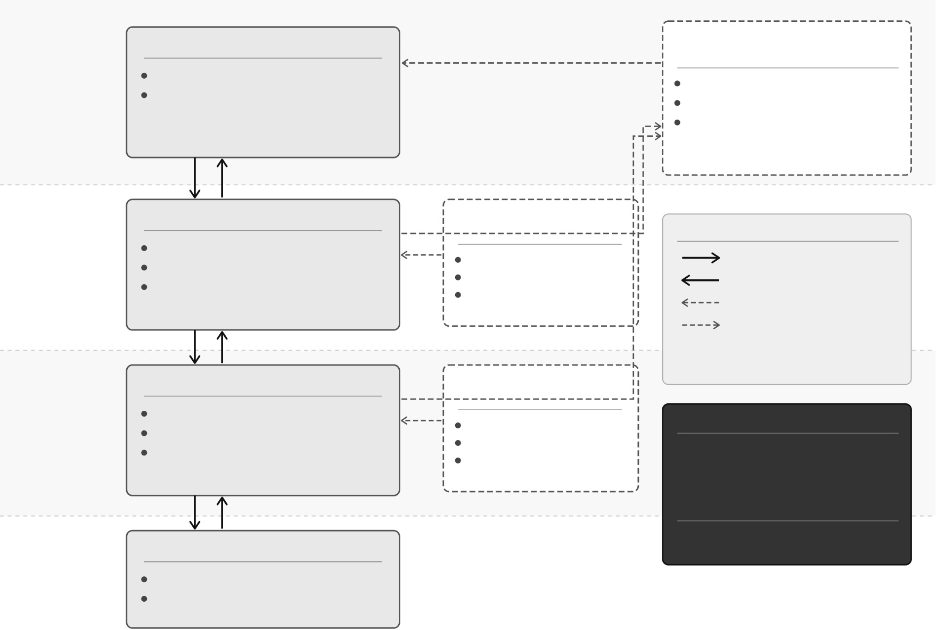
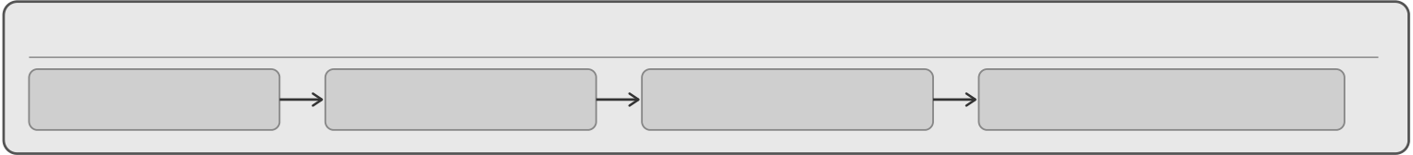
Crypto World Bank — Heavily Compressed |  |  | BRAC University
WorldBankReserve(Tier1) |  | UpwardSurplus | UpwardDepositFacility
Tier1 | Holdsglobalreservesandcapital | Repatriation(r_up) | (Surplusfromlowertiers)
WorldBank  Reserve | LendstoNationalBanks(Tier2) |  | Holdsupwardsurplus
 |  |  | Paysr_uptodepositors
Repatriatestohighertier
ondemand/trigger
Tier2 | Capital | Repayment | InterBankLendingPool | Legend
 | Disbursement | +Interest
 | ($) | (r_down)
 |  | NationalBanks(Tier2)
 |  |  | (Tier2)
 |  | AggregatecapitalfromTier1
 |  |  | Peer-to-peerlending | CapitalDisbursement(Downward)
National | Capital | LendtoLocalBanks(Tier3) |  | Repayment+Interest(Upward)
 |  |  | Collateralized
Banks |  | InterbanklendingwithinTier2
 |  |  | Rate:r_peer(same-tier)
 |  |  |  | Same-TierInterbankLending
 |  | Repayment |  | UpwardSurplusFlow
 | Disbursement | +Interest | InterBankLendingPool
 | ($) | (r_down)
 |  | LocalBanks(Tier3)
(Tier3)
Tier3 | AggregatecapitalfromTier2 | Peer-to-peerlending | AsymmetricRateStructure(On-Chain)
Local | LendtoCustomers(Tier4) |  | r_up=Upwardsurplusdepositrate
 |  | Collateralized
Banks | InterbanklendingwithinTier3 | Rate:r_peer(same-tier)
 |  |  | (paidbyhighertier)
r_down=Downwardlendingrate
Tier4 | Capital | Repayment | (chargedtolower-tier)
 | Disbursement | +Interest | δ=Spread/ComplianceBuffer
 | ($) | (r_down) | EnforcedConstraint:
 |  | Customers(Tier4) | r_up<r_down−δ
 |  | BorrowfromLocalBanks
Customers |  | Repayprincipal+interest
CascadingRepayment(UpwardFlow)
Customers | LocalBanks | NationalBanks | WorldBankReserve
RepayLocalBanks | RepayNationalBanks | RepayWorldBankReserve | FinalSettlement
Figure 3.29: Four-tier hierarchical capital flow
GovernanceDual-Path-TimeLockStandardvsSecurityCouncilEmergency
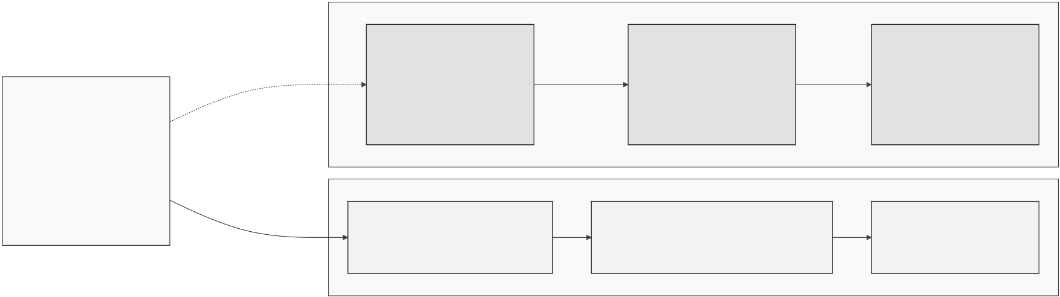
Figure 3.30: Governance dual-path
34

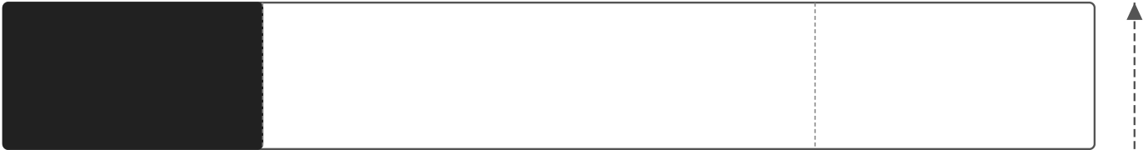
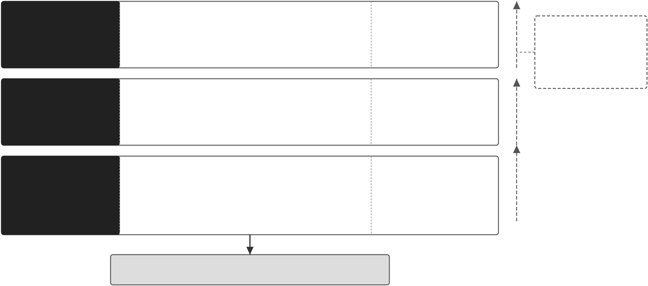
Crypto World Bank — Heavily Compressed | BRAC University
SARandAMLComplianceWorkflow
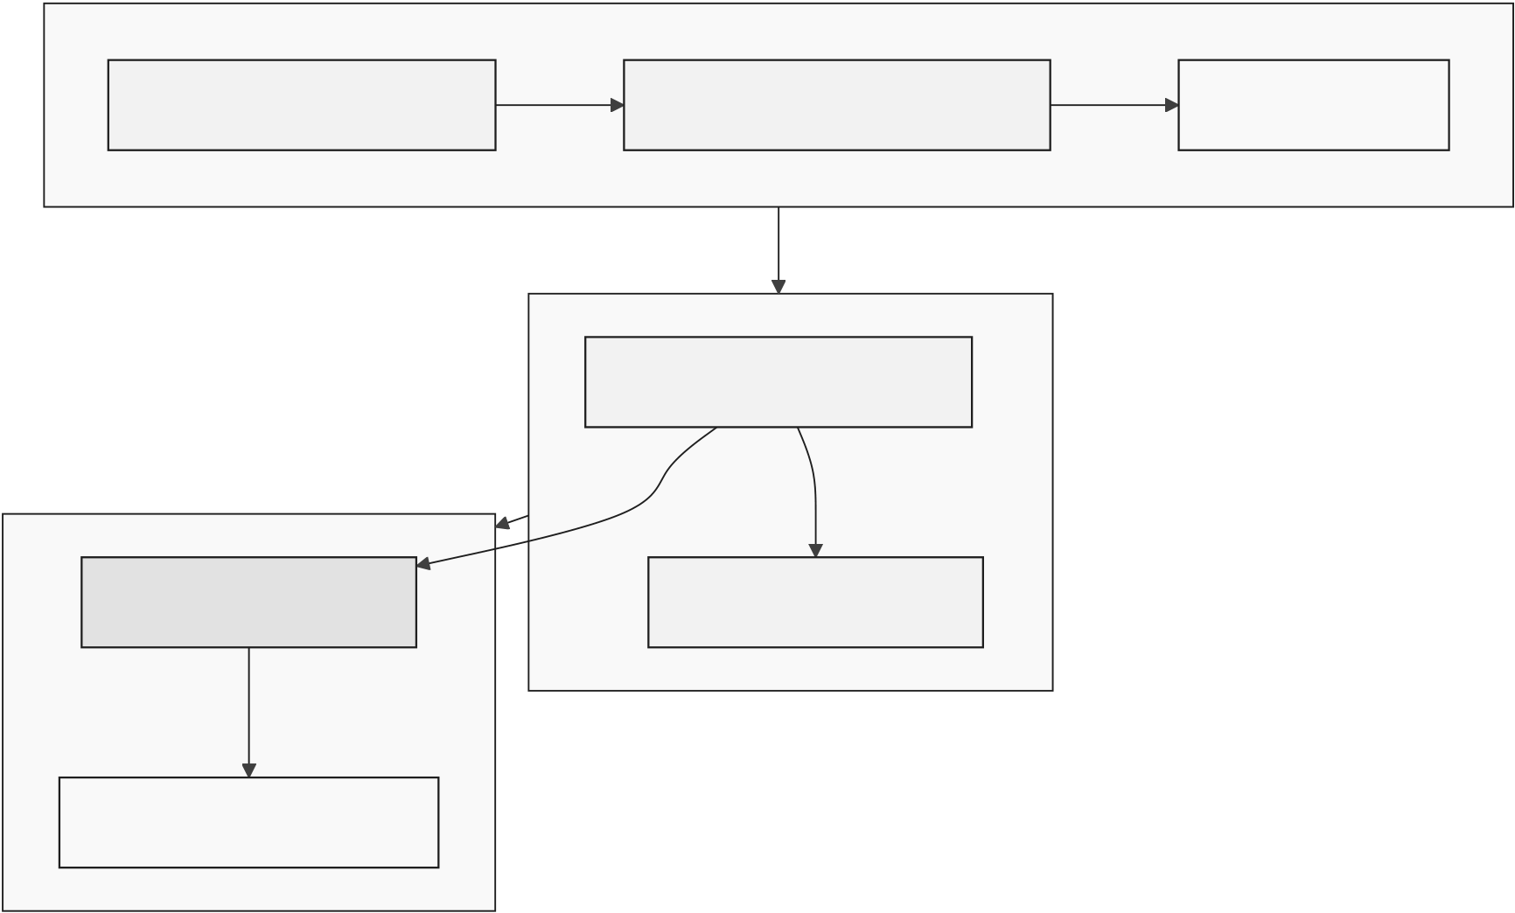
Figure 3.31: SAR and AML compliance workflow
Layer4 | KeyControls | Real-timevisibilityandanomaly | Tobreachthe
 | •Tenderlyreal-timemonitoringandsimulation
RuntimeLayer | •TheGraphindexingforon-chaindataandalerts | detectionacrossthesystem
 | •WebSocketdashboardforlivesystemvisibility | toidentifyandrespondto
(Monitoring&
 | •Anomalydetectionandalertingoncriticalevents | threatsquickly.
Observability)
 | KeyControls | EnsurestrustworthyAI/ML
Layer3
 | •ChainlinkFunctionsoracleforsecureoff-chainexecution
AI/MLLayer | •Modelregistryandversioncontrol | decisionswithverifiablemodels
 | •SHAP-basedexplainabilityforallmodeldecisions | andexplainable,validated | SmartContract
(ModelIntegrity&
Explainability) | •Hallucinationguardandoutputvalidation | outputs. | Layer(Layer1),
 |  |  | anattackermust
compromise
everylayeraboveit.
Layer2  ApplicationLayer (API&Application  Security)  Layer1  SmartContractLayer (On-ChainSecurity&  Correctness) | KeyControls
 | •EIP-712typeddatasign-intopreventreplay/phishing | Protectsapplicationendpoints
 | •JWT-basedauthenticationandsessionmanagement | andusersessionsfromabuse,
 | •RatelimitingandthrottlingonallAPIendpoints | impersonation,andoverload.
•Inputvalidationandserver-sideauthorization
KeyControls
•OpenZeppelinv5librariesforsecureprimitives•RBACforrole-basedaccesscontrol Secure,upgradeable,and•UUPSupgradeableproxypattern •ReentrancyGuardandchecks-effects-interactions auditedsmartcontractsform•TimeLockforprivilegedoperations
•Comprehensiveauditsuite(Slither,Echidna, theultimatetrustboundary Foundry,MythX) forassetsandstate.
ON-CHAINASSETS&STATE
BlockchainNetwork(e.g.,PolygonzkEVM)
Figure 3.32: Five-layer defense-in-depth security architecture
35

Crypto World Bank — Heavily Compressed | BRAC University
Smart-ContractSecurityControls-UUPS,EIP-712,GranularPause
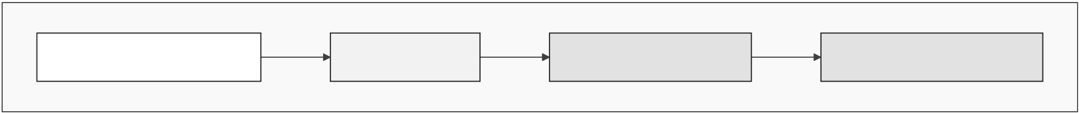

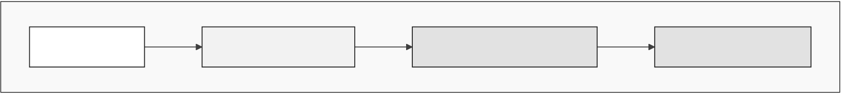
Figure 3.33: Smart-contract security controls
36

Chapter 4
Methodology
LightweightAgile/Scrumacrossfourimplementationphases.Corethesis=on-chain
banking + oracle ML; conversational agent is optional (Could-have).
4.1MVT Checklist and Phase Plan
Graded pass line:(C1) four-tier contracts on testnet; (C2) GroupLendingPool spec + PoC;
(C3)RF/IF/SHAP+AuthorityBriefafterpre-thesis2.Pre-thesis1deliversspecification
only—no trained models or live deploy.
Table 4.1: Four-phase implementation summary
Phase | Focus | Weeks | Key deliverables
I | Foundation | 1–4 | Contract hierarchy, DB schema, React

 |  |  | shell
II | Core banking | 5–9 | LoanE2E,savings,grouppool,au-
tomation
III | ML + oracle | 10–13 | ChainlinkFunctions,AuthorityBrief,

IV | Verification | 14–16 | dashboard
 |  |  | Foundrysim,Certorastretch,testnet
manifest
Table 4.2: Core vs. optional capabilities
Capability |  | Priority | Phase / interface
Four-tier | smart | Must (I–II) | React + wallet; Foundry tests

contracts
On-chain loan life- | Must (II) | LoanController state machine
cycle
Chainlink | Func- | Must (III) | FastAPI →DON →on-chain score

tions oracle |  | Must (III) |  | Authority Brief; audit log
RF + IF + SHAP
MCP | conversa- | Could | (III– | Alternate API path only
tional agent |  | IV)
37

Crypto World Bank — Heavily Compressed | BRAC University
4.2Design Decisions
Table 4.3: Design decisions (selected)
Area | Choice |  | Alternative | Criterion
Network | Polygon | zkEVM | Amoy PoS | ZK validity proofs, low gas

 | Cardona
Contracts | Solidity EVM | Solana | Tooling, testnet cost
Fraud ML | RandomForest+ | XGBoost | SHAP compatibility

Oracle | IF | Func- | Commit-reveal | Decentralised trust
 | Chainlink
 | tions |  | only
Database | PostgreSQL |  | SQLite | 3NF, async API
38

Crypto World Bank — Heavily Compressed | BRAC University
4.3Methodology Diagrams (Full Set)
Agile/ScrumProcesswithSprintSubmissionCycle
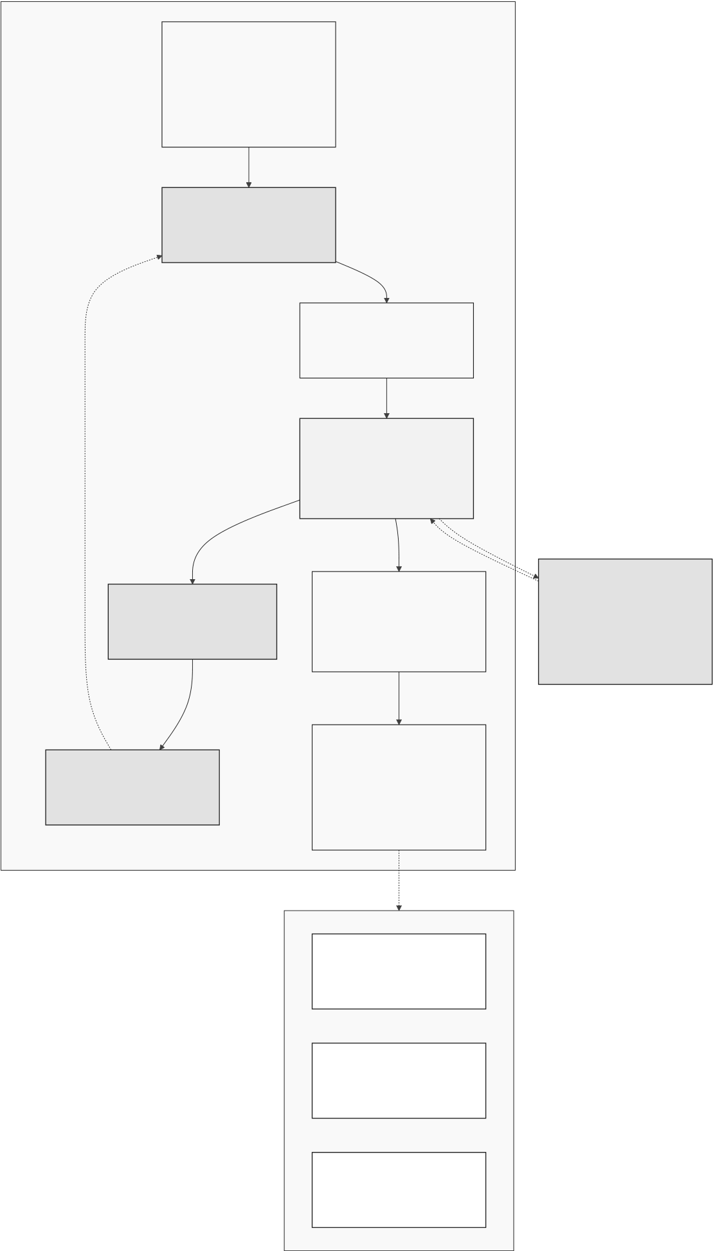
Figure 4.1: Agile / Scrum development process
39

Crypto World Bank — Heavily Compressed | BRAC University
AI/MLPipeline-Training,Oracle,GNN,FederatedLearning
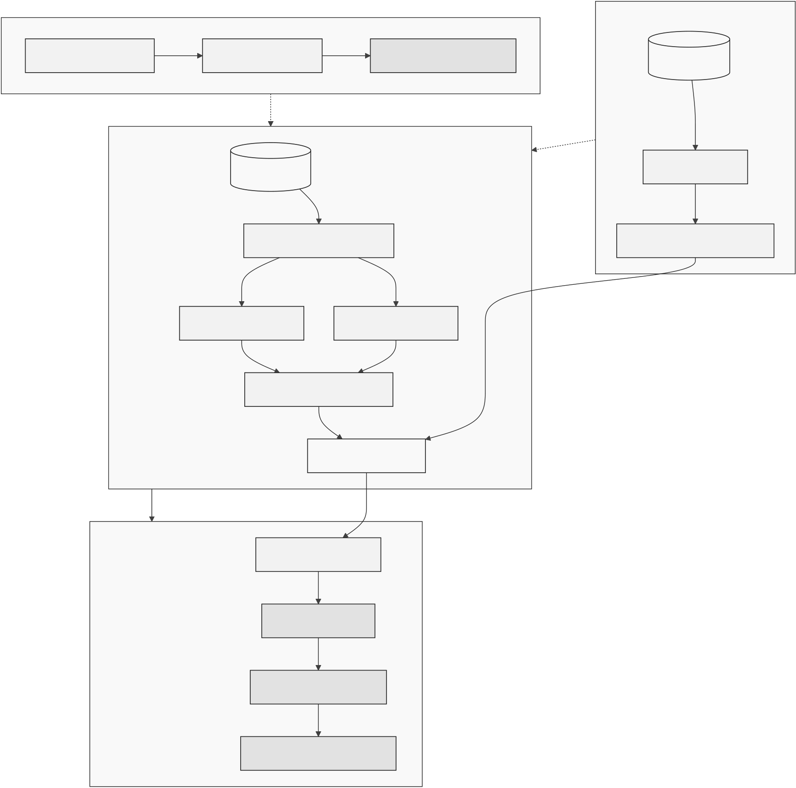
Figure 4.2: AI/ML pipeline wiring
40

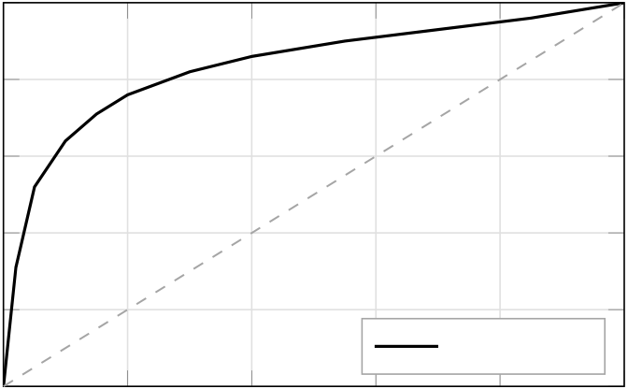
Crypto World Bank — Heavily Compressed |  |  |  |  |  |  |  | BRAC University
Random Forest ROC (BCCC held-out) |  |  |  |  |  |  |  | Confusion matrix (normalised counts, n = 154,030 test rows) |  |  |  |  |  |  |  |  | ·105 | 1 | Count
1 |  |  |  |  |  |  |  | Actual class | Legit.
True positive rate | 0.8  0.6  0.4  0.2 |  |  |  |  |  |  |  |  |  |  |  |  |  |  |  |  | 0.8
 |  |  |  |  |  |  |  |  | Fraud |  |  |  |  |  |  |  |  | 0.6
 |  |  |  |  |  |  |  |  |  |  |  |  |  |  |  |  |  | 0.4
 |  |  |  |  |  |  |  |  |  |  |  |  |  |  |  |  |  | 0.2
AUC = 0.89 |  |  |  |  |  |  |  |  |  |  |  |  |  |  |  |  |  | 0
0 |  | 0 | 0.2 | 0.4 | 0.6 | 0.8 | 1
 |  |  |  |  |  |  |  | Legit. |  |  |  |  | Fraud
False positive rate |  |  |  |  |  |  |  | Predicted class
Score | 1 | 0. 89  . 0. 76  0. 71
 |  |  |  |  |  |  |  | SHAP waterfall — sample declined loan (s = 0.74)
 | 0.8 |  |  |  |  |  |  | Tx velocity Graph dist.  Tx interval Req. amount  KYC level |  |  | 18  −0.04
 | 0.6
 | 0.4
 | 0.2
 | 0
Precision |  |  |  | Recall | F1 | AUC
 |  |  |  |  |  |  |  | −5 · 10−2 |  |  |  | 0 | 5 · 10−2 | 0.1 | 0.15 | 0.2
SHAP impact on pf
Figure 4.3: Planned ML evaluation layout (post pre-thesis 2)
41

Crypto World Bank — Heavily Compressed | BRAC University
MLExplainabilityandAnomalyDetectionFlow
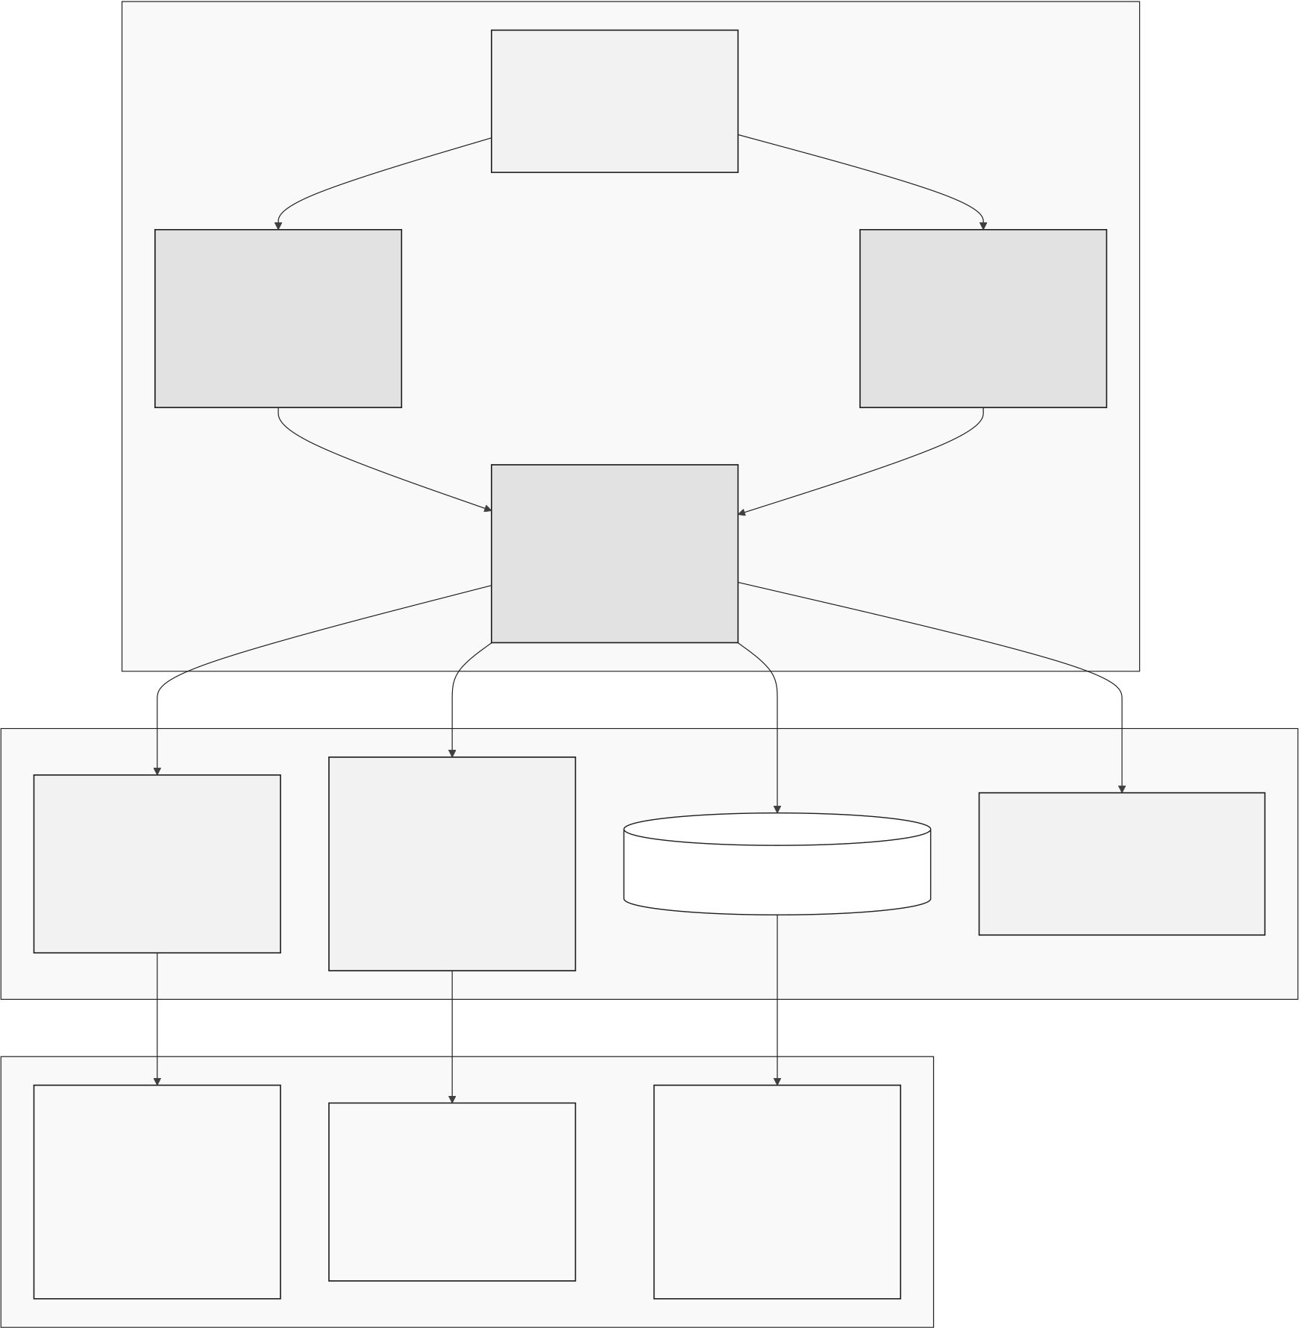
Figure 4.4: Explainability and anomaly-detection flow
42

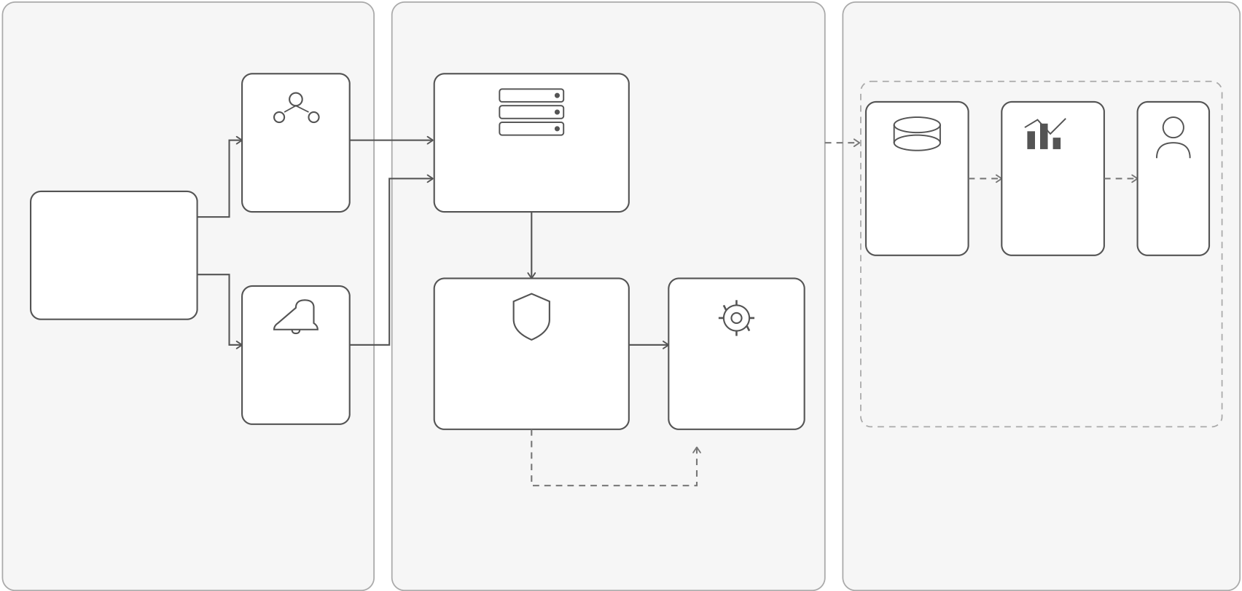
Crypto World Bank — Heavily Compressed | BRAC University
Real-TimeDashboardandRuntimeMonitoringPipeline
1)INGESTION&INDEXING | 2)PROCESSING&DETECTION | 3)REAL-TIMEDASHBOARD&MONITORING
ConsumerViews
</> | TheGraph | WebSocketServer | RedisCache | ReactDashboard | Read-only
 | Subgraph
 | (Indexer) | (Node.js20)
 | Indexesevents | Receivesindexeddata | (LatestSnapshot) | Charts+Alerts
 |  | andruntimealerts | Storeslateststate | VisualizesKPIs, | Regulator
 | andstores |  |  |  | View
 |  |  | andmetricsfor | trends,and | Audit-friendly
 |  |  | fastretrieval | real-timealerts | read-only
Smart
 |  |  |  |  | interface
Contracts
EmitTyped
Events
Tenderly | ! | alert | OpsRunbook
 | AnomalyDetector |  | Function
(RuntimeAlerts) | (IsolationForest)
 |  |  | (AutoActions)
Monitorstxns | Analyzesincomingdata |  | Triggersresponses
andemits | anddetectsanomalous |  | andremediation
runtimealerts | patterns |  | workflows
incidentwebhook
LEGEND
 | DataFlow |  | Alert/ |  | SystemComponent
 |  |  | WebhookFlow
 |  |  |  |  | ExternalService
Figure 4.5: Real-time dashboard and runtime monitoring pipeline
43

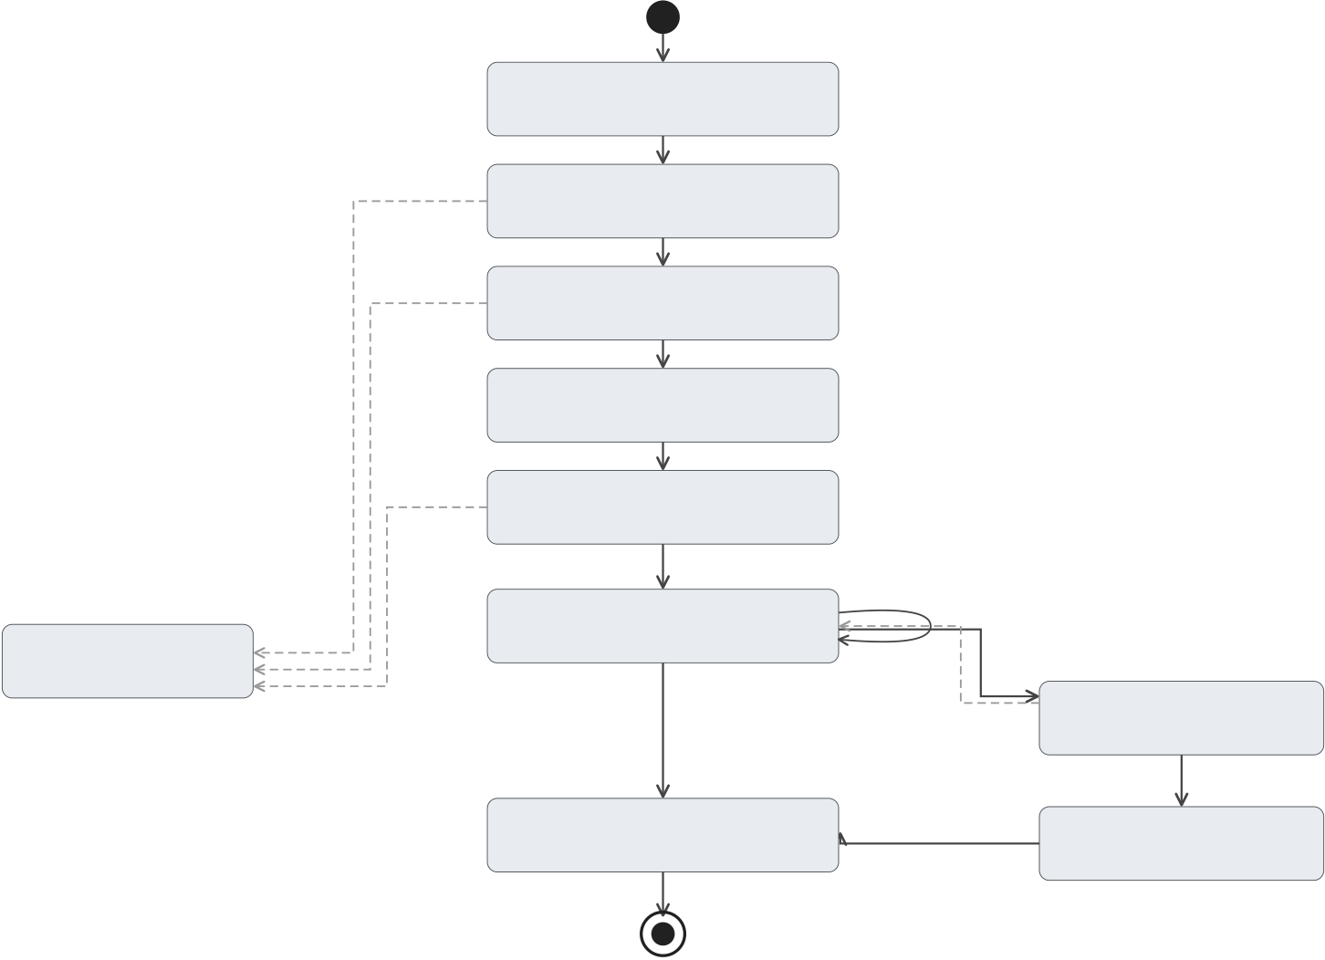
Crypto World Bank — Heavily Compressed | BRAC University
TransactionStateMachine(LoanLifecycle)
DRAFT
Borrowersubmits
KYCfails | PENDING_KYC
KYCok
Borrowing-limitfail | PENDING_LIMIT
Limitok
PENDING_SCORE
MLcommitted
Approverrejects | PENDING_APPROVAL
Approverapproves
+reveal
ACTIVE | processInstallment(N)
REJECTED
Finalinstallmentpaid | Missedbeyondgrace | DEFAULTED
Curewithinwindow
LiquidationEngineseizes
CLOSED LIQUIDATED
Recoverydistributed
Legend |  |  | Designprinciples  •AllstatetransitionsareguardedbyCEI-ordered  contractfunctions.  •Everytransitionemitsanindexedevent  forauditability.
 | Initialstate
 | State
 |  | Successfultransition
 |  | Failure/alternatetransition
 | Finalstate
Figure 4.6: Transaction state machine of the loan lifecycle
44


Crypto World Bank — Heavily Compressed |  |  |  |  |  | BRAC University
Pre-thesis  (Planning–Design) |  |  | PhaseI  Weeks1–4 | PhaseII | PhaseIII | PhaseIV
 |  |  |  | Weeks5–8 | Weeks9–12 | Weeks13–16
SDLCStage | Planning–Design |  | Development | Development | Verification–Validation | Maintenance
Mapping |  |  |  | LendingLifecycle, | Testing,Security, | DeploymentHardening,
Requirements,Architecture, |  |  | CoreContracts&
PrimaryFocus | System&SmartContract |  | Infrastructure | Oracle&MLIntegration, | Validation,Simulation, | Monitoring,Optimization,
Design,Dataset&MLPipeline |  |  | Development | Front-end&API | Documentation | Handover
Primary | •SRS&UseCases |  | •Four-tierCoreContracts | •Lending&DepositModules | •Integration&SystemTests | •TestnetDeployment
 | •4-tierArchitectureDesign |  | (WB,NB,LB,WalletAuth) | (SavingsVault,FixedDeposit, | •SecurityTesting(Slither, | •Monitoring&Alerting
 |  |  | •Role&AccessControl | GroupLendingPool,IBLP, | Mythril) | •BugFixes&Optimization
 | •SmartContractSpec |  |  | UpwardDeposit)
 | •DBSchema&APIDesign |  | •WalletIntegration |  | •Simulation(300clients) | •Backup&Recovery
 |  |  | •BasicFrontendShell | •OracleIntegration | •FormalMethods(Invariants) | •FinalReport&Handover
 | •MLPipelineDesign |  | •DBSchema&Migrations | •MLScoringAPI(RF+IF) | •Documentation(Tech+User) | •FutureWorkRoadmap
 | •ProjectPlan&RiskRegister |  |  | •AuthorityBrief(SHAP) | •Performance&GasAnalysis
Deliverables |  |  | •UnitTests(Core)
 |  |  |  | •FrontendFlows(End-to-End)
 |  |  |  |  | ConversationalAgent(MCP)– | AgentIntegration&
OptionalAgent |  | — | —
(dashed) |  |  |  | — | PrototypeDevelopment | Evaluation
 |  |  |  | End-to-EndLoanFlow | Validated&Tested | Deployed,Monitored&
KeyMilestone/ | DesignComplete |  | CorePlatform
Outcome | (SpecBaseline) |  | Operational | withMLScoring | System(MVTReady) | HandoverComplete

Pre-thesisSpecificationCompleteness(Target) |  | Architecture&Design |  | DetailedSpecification |  | Review&Freeze
InitialScoping
0% | 25% |  | 50% |  | 75% |  | 100%

MVTImplementationTargets(Across16Weeks) |  |  | Verification&Validation(Weeks9–12) |  | Deployment&Maintenance(Weeks13–16)
Development(Weeks1–8)
0% | 25% | 50% |  | 75% |  | 100%
Figure 4.7: Four-phase roadmap with SDLC mapping and progress
Estimateddevelopmenteffortbyphase(person-days)
Person-days | 70
 | 65
 | 60
 | 55
 | 50
 | 45
 | 40
 | 35
 | 30
 | 25
 | 20
 | 15
 | 10
 | 5
 | 0
 |  | PhaseI | PhaseII | PhaseIII | PhaseIV
Figure 4.8: Development effort by implementation phase
45

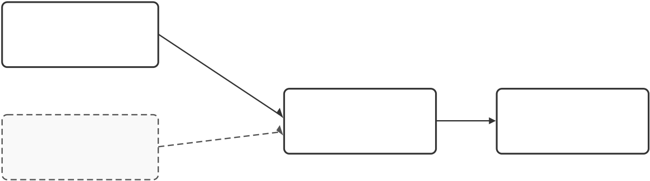
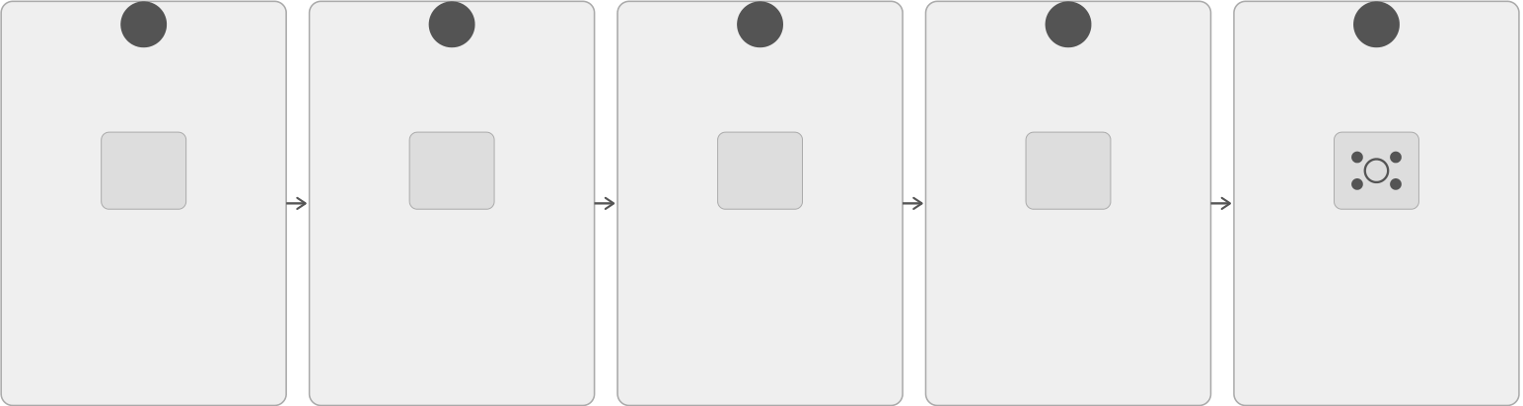

Crypto World Bank — Heavily Compressed | BRAC University
OptionalConversationalAgentAdd-on
RealUI
(PrimaryPath)
Same
Express.jsAPI
MCPAgent | Same | Express.jsAPI | SmartContracts
 |  | (Backend) | (On-chain)
(AlternatePath)
 | Express.jsAPI

Note:

Bothpaths(RealUIandMCPAgent)usethesameExpress.jsAPIandinteractwiththesame

smartcontracts.Theagentdoesnotgatecorebankingoperations.
Figure 4.9: Optional conversational agent add-on
PlannedDevelopmentandVerificationToolchain
VerificationPipeline
1 |  |  | 2 |  |  | 3 |  | 4 |  |  |  | 5  TestnetDeployment (PhaseIV)  •Deployverifiedcontracts  •PolygonzkEVMCardona  •Integration&end-to-end  testing
SmartContract |  |  | Foundry |  |  | Certora |  | CIPipeline
Development&Deploy |  |  | Fuzz/InvariantTests |  |  | CVLReserveProofs |  |  | (10kFuzzRuns)
</> |  |  | ✓ |  |  | CVL |  | CI
•Soliditysmartcontracts |  |  | •Foundryfuzztesting |  |  | •FormalspecinCVL |  | •AutomatedCIpipeline
•DeployusingHardhat |  |  | •Invarianttestsuitefor |  |  | •Provereserveand |  | •~10,000fuzzruns
(local/testnet) |  |  | criticalproperties |  |  | safetyproperties |  | •Regression&invariant
 |  |  |  |  |  |  |  | checks
•Proofchecks
PipelineFlow: |  | 1 | Development | 2 | Fuzz/Invariants | 3 | FormalProofs(CVL)4 | CIAutomation |  | 5 | TestnetDeployment
Note: | Verificationisprogressivelystrengthenedfromtestingtoformalproofs,thencontinuouslyenforcedinCI
beforefinaldeploymenttoPolygonzkEVMCardonatestnetinPhaseIV.
Figure 4.10: Planned development and verification toolchain
46

Crypto World Bank — Heavily Compressed | BRAC University

1)DesignDecisions
Smart-ContractPlatform | ChainChoice |  | Upgradeability
/Solana EVM) Hyb Mult Only etL1) Sing (Non-E  EVM (EthereumCompatible) Cosmos/Solana (Non-EVM) Hyb rid/ Multi-VM Polygon–Sepolia (L2with EVM&LowCost) L1-Only (MainnetL1) Sing leL2 (Non-EVML2) |  |  |  | UUPS (Upgradeable ProxyStandard) TransparentProxy (StandardProxy) Immutable (NoUpgrade
Identity |  | 2)Security&PrivacyDecisions
 |  | MLOracleApproach
in-Only Public) Off-Cha KYC(Pri  DID/VC+zkKYC (Privacy-Preserving Identity) On-Chain-Only KYC(Public) Off-Cha in-Only KYC(PrivateDB) |  | Backend inInfer.) On-Ch (FullOn  Commit-Reveal (On-ChainVerify) Trusted-Backend (Off-ChainInfer.) On-Ch ainML (FullOn-Chain) |  |  | (Updatable)

3)Interoperability&Cross-ChainDecisions
Cross-ChainCommunication | DataAvailability |  | ExecutionModel
rZero aging ocol) Ax (Inter Netw  ChainlinkCCIP (Standardized Interoperability) LayerZero (Messaging Protocol) Ax elar (Inter chain Network) |  | On-Chain (FullyOn-Chain) Off-Chain+Hash (AnchoredData) Hybrid (SelectiveData) | (Deterministic)  On-Chain Off-ChainCompute (On-ChainVerify) Hybrid (Selective Execute)
Bold-borderedboxes=chosendesignoption
Figure 4.11: Key design decisions and alternatives considered
47

Chapter 5
Evaluation and Discussion
5.1Performance Evaluation
Ourpre-thesis1showsspecificationsandplansandcreatescheckboxes,notanykindof live benchmarks, since the project has not been deployed or tested yet.Project influential elementsandfinancialfeasibilityarefurtherelaboratedinSection5.4.OurplannedRQ-level evaluation will be executed after pre-thesis 2.Our plan is for projected gas per loan to stay below interest achieved on L2; the result of default stress is given in Table 5.7.
5.2Analysis of Design Solutions
Our choices of technology stack were chosen based on ecosystem maturity, as per our goal to create a system with zero-cost prototype constraints and more transparent auditability (visible in Table 4.3, Section 4.2). The chosen stack for off-chain pairs EVM Solidity on Post-greSQL + FastAPI, zkEVM for L2 execution, and to connect to on-chain we use Chainlink Functions attached with ML scores.The optional conversational MCP agent and EIP-7702 session keys remain Phase III–IV extensions outside the MVT.
5.3Final Design Adjustment
The final pre-thesis 1 outlook locks in four adjustments before implementation.These are stablecoins, which is the first retail lending path and is used to avoid ETH liability volatility (USDC/USDT, Section 1.7).After that,L2 deployment for micro-loan gas economics.The third one is ML as decision support only, meaning human approvers and on-chain gates, no auto-disbursement.Last but not least is MVT scope.It is limited to the three-tier lending core, database schema, and dashboard;syndicated modules, full regulatory filing, and the conversational agent are deferred.
5.4Feasibility Analysis
5.4.1Technical Feasibility
Each layer is specified against mature tooling; nothing requires bespoke infrastructure be-yond standard testnets and open-source stacks (Table 5.1).
48

Crypto World Bank — Heavily Compressed | BRAC University
Table 5.1: Technical feasibility assessment
Component | Assessment |  | Evidence
Smart contracts | Feasible | (speci- | Solidity;Hardhat;OpenZeppelin;Phases I–
 | fied) |  | II
Frontend DApp | Feasible | (speci- | React 18 + Wagmi/RainbowKit
fied)
Blockchain |  | de- | Feasible |  | Polygon zkEVM Cardona + Sepolia
ployment |  |  | (planned)
AI/ML | integra- |  | Feasible with con- |  | RF+IF+SHAP;ChainlinkFunctions
tion |  |  | straints |  | Phase III
Optional agent |  |  | Feasible | (de- | MCP+Qwen3-8B;PhaseIII–IV;outside
 |  |  | ferred) |  | MVT
Database | back- |  | Feasible |  | PostgreSQL | 20-entity | schema | (3NF);
end |  |  |  |  | FastAPI
5.4.2Economic Feasibility
Table 5.2: Economic feasibility — zero-cost prototype
Cost Category |  | Estimate | Notes
Blockchain | deploy- | $0 | Public testnets

ment
Frontend | / | backend | $0 | Vercel / Render free tiers or localhost
hosting
AI/ML training | $0 | Local machine or Colab free tier
Development tools | $0 | Hardhat, VS Code, Git (open-source)
Total prototype | $0 | Pilot ops ≈$500–$2,000/month at scale
5.4.3Risk Feasibility
Main delivery risks and mitigations are summarised in Table 5.3; smart-contract and regu-latory items dominate severity.
49

Crypto World Bank — Heavily Compressed | BRAC University
Table 5.3: Risk taxonomy and mitigation
Risk Category |  |  | Description | Severity | Mitigation
Partner | non- |  | Key partners decline to | Medium | Testnetpilots;open-source
cooperation |  |  | join |  | replication
Smart | contract |  | Logic exploit | High | OpenZeppelin;audits;pause
vulnerability |  |  |  |  | mechanism
Regulatory |  | ad- | Jurisdictionblocksre- | Medium | Testnet-only prototype; sand-
versity |  |  | tail crypto |  | box path
AI/ML | model |  | Fraud model drift | Low | Retraining; | human-in-the-
degradation |  |  |  |  | loop; SHAP review
5.4.4Regulatory Feasibility
The CWB platform uses basic compliance measures for retail stablecoin lending like MiCA, GENIUSAct,andEUAIAct,usingauthorizedstablecoinandkeepingPIIoff-chain(Ta-ble5.4).Butforfuturework,fullconformityfilesandnationallicensingarekept.This thesis only focuses on testnet.
Table 5.4: Regulatory design controls (selected)
Statute / Article | Requirement | CWB Control
MiCA Art. 16 | Authorised EMT issuer | Uses USDC/USDT; does not issue
MiCA Art. 36 | 1:1 reserve backing | Issuer attestations before pool ac-
ceptance
EUAIAct(credit | High-risk | AI | from | Human approver gate; SHAP + au-
scoring) | Aug. 2026 |  |  | dit log
GDPR Art. 17 | Right to erasure |  |  | PIIoff-chainonly; | hasheson-
chain
5.5Statistical Analysis
Based on planning assumption rather than platform data, the table below presents spread revenue,ETH-pricesensitivity,anddefaultstressatdeploymentscale.AsshowninFig-ure 5.2, the interest structure follows the lending hierarchy of 3%, 5%, and 8%.
50

Crypto World Bank — Heavily Compressed | BRAC University
Table 5.5: Revenue projection assumptions
Parameter | Value
Reference ETH price | $2,500 (planning mid-point, Feb 2026)
World Bank →National Bank | 3% APR
National Bank →Local Bank | 5% APR
Local Bank →Client | 8% APR
Average loan term | 12 months
Default rate provision (base) | 8%
Origination fee | 0.25% per disbursement
Table 5.6: ETH-price sensitivity of spread revenue
ETH Price | Loan Base | Spread Revenue | Incl. Fees (est.)
$2,000 | $1.376B | $110.1M | $120–128M
$2,500 (base) | $1.720B | $137.6M | $150–159M
$3,000 | $2.064B | $165.1M | $180–191M
Table 5.7: Default-rate sensitivity
Scenario | Default rate | Annual loss | Basis
Optimistic | 3.7% | $7.4M | Mature MFI benchmarks
Base case | 8% | $16M | Newplatform,limitedhis-

Stress | 15% | $30M | tory
 |  |  | Thincredithistory,volatile

collateral
Annualspreadrevenuebytier(USDmillions,basecase)
160
80
60
40
20
0
140
120
Revenue(USDm)
100
World Bank National Banks Local Banks Total
Figure 5.1: Annual revenue projection (10-year maturity)
51

Crypto World Bank — Heavily Compressed |  |  |  | BRAC University
10
9
8
7
6
APR(%)
5
4
3
2
1
0
 | WB to NB | NB to LB | LB to Borrow
Figure 5.2: Hierarchical interest-rate spread (APR)
5.6Comparisons and Relationships
Table 5.8: Market segments with supporting data
Segment | Description |  | Estimated Scale
TAM | GlobalDeFilending; | remittances; | $55B – 5T+

 | MSME gap [8, 11, 16]
SAM | Institutional | hierarchical | lending; | $5B – 15B
emerging-market credit
SOM | Testnet pilots; sandbox partnerships | $50 – 200M
Table 5.9: Target customer segment profile
Characteristic | Description
Primary users | Tier 1–3 bank operators; Tier 4 retail via Local Banks
Loan range | Micro/SME at Local Bank tier; larger exposures via syndi-
cation
Key pain points | Opaque reserves; flat DeFi pools; weak explainability in on-

chain lending
Table 5.10: Partner categories and roles
Partner Category | Role |  | Incentive
Financial regulators | Sandbox oversight |  | On-chain audit trails
Banking institutions | National/Local | Bank | Reserveaccess; | lowersettle-
 | nodes |  | ment friction
Oracle providers | Chainlink DON, indexing |  | Unified oracle stack
Academic partners | ML/formal-verification |  | Datasets; co-publication
review
52

Crypto World Bank — Heavily Compressed | BRAC University
5.7Discussion
Thispre-thesisonlyshowsarchitectureandevaluationplans. Thedeploymentresult, trained model and formal proof will be evaluated on pre-thesis 2. Five key limitations are:
•Novelty is compound, not absolute:this thesis uniquely represents the combina-tion of a four-tier reserve system, explainable oracle ML and group liability lending within a single open framework while Maple, Goldfinch, and Morpho cover parts of institutional credit.
•BCCC is a baseline only: without testnet retraining, flat-pool fraud labels will not be transferred to hierarchical CWB flows.
•Testnet scope: to be accepted as strong research, the project needs performance tests withothersystemsandpubliclyavailablereportswhichpeoplecanrunandverify. MVT deployment will help this real-world evidence.
•Group lending: BRAC and Grameen Bank statistical data is only used for designing purposes.Thedigitalloansystemoron-chaincosigningontheblockchainisnot fully replaceable like real social support by humans.
•Oracle and economics—when credit scores are assigned, there are still chances of collusion or AI might drift.The Certora proof clearly specifies the assumptions and states that it might not give correctness under every possible scenario.
The prototype only works on testing environments. It is not ready for global release. It will be in the future.
53

Chapter 6
Conclusion
TheCryptoWorldBankaddressesthecoordinationandtrustchallengesoftraditionalde-velopment finance through a decentralized four-tier lending architecture.Unlike existing DeFilendingprotocols,theproposedsystemsupportshierarchicalcapitalflowsbetween institutions, banks, lenders, and borrowers while enforcing reserve requirements at every tier.
The thesis introduces four key contributions:
•A four-tier DeFi lending architecture.
•Programmable group lending with over-indebtedness controls.
•Explainable AI-based fraud detection and credit scoring.
•Privacy-preserving identity and compliance using decentralized identifiers and zero- knowledge proofs.
AnalysisofexistingDeFiandbankingsolutionsindicatesthatnocurrentplatformcom-bines hierarchical lending, interbank operations, and tiered borrower access within a single decentralizedsystem.Theprojectprovidesacompletearchitecturaldesign,governance framework,andimplementationroadmapforablockchain-baseddevelopment-finance ecosystem.
6.1Future Work
Complete end-to-endhierarchicallending,includingcross-tier fund transfers,repayment mechanisms, and interest accrual.Deploy stablecoin-based financial services and develop savings,deposit,andlendingproducts.AlsointegrateexplainableAIanalyticsintolive loan approval and fraud detection workflows.
We want to expand the platform with remittance services, merchant payments, fiat on/off ramps, and consumer protection features.
Lastly, for more advanced sections, this project can explore advanced research areas such as graph-based fraud detection, federated learning, privacy-preserving compliance, and for-mal verification of financial operations.
54

References
[1]S. M. Werner, D. Perez, L. Gudgeon, A. Klages-Mundt, D. Harz, and W. J. Knottenbelt, “SoK: DecentralizedFinance(DeFi),”arXivpreprintarXiv:2101.08778,2022.[Online].Available:
[2]M. Bastankhah, V. Nadkarni, C. Jin, S. Kulkarni, and P. Viswanath, “Thinking Fast and Slow: Data-Driven Adaptive DeFi Borrow-Lending Protocol,” in Proc.6th Conf.Advances in Finan-cialTechnologies(AFT),LIPIcs,vol.316,pp.27:1–27:23,2024.DOI:.

[3]G. Palaiokrassas, S. Scherrers, I. Ofeidis, and L. Tassiulas, “Leveraging Machine Learning for MultichainDeFiFraudDetection,”inProc.IEEEInt.Conf.BlockchainandCryptocurrency (ICBC), 2024. DOI:
[4]I.T.Adom,C.O.Julius,S.Akuma,andS.U.Otor,“ComparativeAnalysisofExplainable AIFrameworks(LIMEandSHAP)inLoanApprovalSystems,”InternationalJournalofIn-formationEngineeringandElectronicBusiness,vol.17,no.6,pp.60–70,2025.DOI:
[5]B.W.Tan,“CentralBankDigitalCurrencyandFinancialInclusion,”IMFWorkingPaper
WP/23/69,2023. | [Online]. | Available:
. Accessed: June 9, 2026.
[6]F. T. Liu, K. M. Ting, and Z.-H. Zhou, “Isolation Forest,” in Proc.IEEE Int.Conf.Data Mining (ICDM), pp. 413–422, 2008. DOI:
[7]N.Atzei,M.Bartoletti,andT.Cimoli,“ASurveyofAttacksonEthereumSmartContracts (SoK),”inProc.Int.Conf.PrinciplesofSecurityandTrust(POST),pp.164–186,2017.DOI:
[8]DefiLlama,“LendingProtocols—DeFiTVLandProtocolRankings,”2024–2026.[Online]. Available: Accessed: June 9, 2026.
[9]World Bank,“TheGlobal Findex Database 2021:FinancialInclusion,DigitalPayments,and Resilience,”2021.[Online].Available:. Accessed: June 9, 2026.
[10]Aave, “Aave Protocol Documentation,” 2024.[Online].Available:. Accessed: June 9, 2026.
[11]International Finance Corporation (IFC), “MSME Finance Gap:Assessment of the Shortfalls andOpportunitiesinFinancingMicro,Small,andMediumEnterprisesinEmergingMar-kets,”WorldBank,2017.[Online].Available:Accessed:June9, 2026.
[12]G. Cornelli, L. Gambacorta, R. Garratt, and A. Reghezza, “Why DeFi lending? Evidence from Aave V2,” BIS Working Paper No. 1183, 2024.[Online].Available:. Accessed: June 9, 2026.
55

Crypto World Bank — Heavily Compressed | BRAC University
[13]Y. Wang, Q. Zhang, K. Li, Y. Tang, J. Chen, X. Luo, and T. Chen, “iBatch: Saving Ethereum Fees via Secure and Cost-Effective Batching of Smart-Contract Invocations,” in Proc. ACM Joint Eur. Software Engineering Conf.and Symp.Foundations of Software Engineering (ESEC/FSE), 2021, pp. 777–789. DOI:
[14]Committee on Payments and Market Infrastructures and Bank for International Settlements,“Correspondent Banking — Technical Report,” CPMI Papers No. 147, 2016. [Online]. Available: Accessed: June 9, 2026.
[15]McKinsey&Company,“GlobalPayments2018: ADynamicIndustryContinuesto DefyPredictions,”McKinseyGlobalPaymentsMap,2018. [Online]. Available: Accessed:June9, 2026.
[16]WorldBank,“RemittancesSlowedin2023,ExpectedtoGrowFasterin2024,”Migration andDevelopmentBrief40,June2024.[Online].Available:. Accessed: June 9, 2026.
[17]DefiLlama, “Aave V3 TVL, Fees, Revenue & Income Statement,” March 2026.[Online].Avail- able: Accessed: June 9, 2026.
[18]WorldInequalityLab,“ExorbitantPrivilege,”WorldInequalityReport2026,2026.[Online]. Available:Accessed: June 9, 2026.
[19]DefiLlama, “Compound V3 TVL, Fees, Revenue & Income Statement,” March 2026.[Online]. Available: Accessed: June 9, 2026.
[20]Fensory, “Sky Protocol Projects $611M Revenue in 2026 as USDS Supply Targets $20.6 Billion,”
February2026. | [Online]. | Available:
Accessed: June 9, 2026.
[21]Financial Stability Board, “Enhancing Cross-border Payments:Stage 3 Roadmap,” 2020.[On-line]. Available: . Accessed: June 9, 2026.
[22]I.CerçilandG.Aksaray,“MonetaryPolicyandInequality:DistributionalEffectsofAsset Purchase Programs,” Journal of International Money and Finance, vol. 157, 2025.DOI:
[23]FederalReserveBoard,“MonetaryPolicyandtheDistributionofIncome: Evidence fromU.S.MetropolitanAreas,”FEDSNotes,March2025. [Online]. Available: . Accessed: June 9, 2026.
[24]R. Cantillon, Essai sur la Nature du Commerce en Général (Essay on the Nature of Commerce in General), 1755 (posthumous).
[25]GlobeNewswire,“R3’sCordaLeadsTokenizedRWAMarketwithOver$10Billionin
On-chainAssets,”February2025. | [Online]. | Available:
. Accessed: June 9, 2026.
56

Crypto World Bank — Heavily Compressed | BRAC University
[26]Centrifuge,“Real-WorldAssetTokenization:KeyTrendsfrom2025,”2025.[Online].Avail-able: Accessed: June 9, 2026.
[27]WorldBank,“WorldBankGroupTracksProjectFundswithNewBlockchainTool,”Press Release,September2025.[Online].Available:. Accessed: June 9, 2026.
[28]JPMorgan,“Kinexys Digital Payments:Real-Time Multicurrency Payments,”2025.[Online]. Available: Accessed: June 9, 2026.
[29]Morpho,“NetworkData,”March2026.[Online].Available:. Accessed: June 9, 2026.
[30]Y.Chen,S.Bin,andH.He,“DesignandImplementationofaMulti-ChainLendingModel inBlockchain,”inProc.3rdInt.Conf.ArtificialIntelligenceandComputerInformationTech-nology(AICIT),2024,pp.97–102.[Online].Available:. Accessed: June 9, 2026.
[31]S.YangandW.Cui,“AnEvaluationSystemforDeFiLendingProtocols,”arXivpreprint arXiv:2303.01022, 2023. [Online]. Available:
[32]J.HartmannandO.Hasan,“ASocial-CapitalBasedApproachtoBlockchain-EnabledPeer-to-PeerLending,”inProc.IEEEInt.Conf.BlockchainComputingandApplications(BCCA), pp.105–110,2021.[Online].Available:Accessed: June 9, 2026.
[33]P. T. Hasan, H. K. T. Akhter, M. R. Tahsinur, A. B. Haque, A. K. M. N. Islam, and R. M. Rahman, “Blockchain and Machine Learning for Fraud Detection:A Privacy-Preserving and Adaptive Incentive Based Approach,” IEEE Access, vol. 10, pp. 87115–87131, 2022.[Online].Available: Accessed: June 9, 2026.
[34]Y.Wang,J.Liu,andZ.Chen,“ContractWard:AutomatedVulnerabilityDetectionModels forEthereumSmartContracts,”IEEETrans.NetworkScienceandEngineering,vol.8,no.2, pp. 1133–1144, 2020. DOI:
[35]J.-W.Liao,T.-T.Tsai,C.-K.He,andC.-W.Tien,“SoliAudit:SmartContractVulnerability AssessmentBasedonMachineLearningandFuzzTesting,”inProc.6thInt.Conf.Inter-net of Things:Systems,Management and Security (IOTSMS), pp. 458–465,2019.DOI:
[36]S. So, M. Lee, J. Park, H. Lee, and H. Oh, “VERISMART: A Highly Precise Safety Verifier for EthereumSmartContracts,”inProc.IEEESymp.SecurityandPrivacy(S&P),pp.1678–1694, 2020. DOI:
[37]BankforInternationalSettlementsetal.,“CentralBankDigitalCurrencies:Foundational Principles and Core Features,” BIS and Central Banks Joint Report, 2020.[Online].Available: Accessed: June 9, 2026.
[38]M. Asaduzzaman, F. Hasib, and Z. B. Hafiz, “Towards Using Blockchain Technology for Micro-credit Industry in Bangladesh,” in Proc.23rd Int.Conf.Computer and Information Technology (ICCIT), pp. 1–6, 2020. DOI:
[39]H.KimandD.Kim,“OptimalGasFeeMinimizationinDeFi:EnhancingEfficiencyandSe-curity on the Ethereum Blockchain,” IEEE Access, vol. 12, pp. 173810–173823, 2024.[Online]. Available: Accessed: June 9, 2026.
57

Crypto World Bank — Heavily Compressed | BRAC University
[40]X.Yuan,“SHAP-basedInterpretableModelsforCreditDefaultAssessmentUsingMachine Learning,” in Proc.14th Int.Conf.Software Technology and Engineering (ICSTE), pp. 213–217, 2024. DOI:
[41]G. Wood, “Ethereum: A Secure Decentralised Generalised Transaction Ledger” (Yellow Paper), Ethereum Foundation, 2014 (revised 2023). [Online]. Available: . Accessed: June 9, 2026.
[42]Aave,“AaveProtocolV3TechnicalPaper,”2022.[Online].Available:. Accessed: June 9, 2026.
[43]T. Dao, T. Trinh, and V. Pham, “Optimizing Credit Scoring Models for Decentralized Financial Applications,”inInformationandCommunicationTechnology,Springer,2025.DOI:
[44]G.-L. Gücük, S. Leible, and J. Edinger, “Blockchain-Based Microlending for Financial Inclusiv-ity:A Literature Review of Its Privacy and Trust,” Springer, 2024.DOI:
[45]A.Pasdar,Y.C.Lee,andZ.Dong,“ConnectAPIwithBlockchain:ASurveyonBlockchain Oracle Implementation,” ACM Computing Surveys, vol. 55, no. 10, 2023.DOI: .

[46]L. Gudgeon, S. M. Werner, D. Perez, and W. J. Knottenbelt, “DeFi Protocols for Loanable Funds: Interest Rates, Liquidity and Market Efficiency,” in Proc. 2nd ACM Conf. Advances in Financial Technologies (AFT), pp. 92–112, 2020. DOI:
[47]F.Piper,K.Wolf,andJ.Heiss,“Privacy-PreservingOn-chainPermissioningforKYC-CompliantDecentralizedApplications,”TUBerlin,arXivpreprintarXiv:2510.05807,2025.
[Online]. Available: Accessed: June 9, 2026.
[48]A.Carstensetal.,“Stablecoins: Risks,PotentialandRegulation,”BISWorkingPa- persNo.905,BankforInternationalSettlements,2021. [Online]. Available: Accessed: June 9, 2026.
[49]B. Eichengreen, M. T. Nguyen, and G. Viswanath-Natraj, “Stablecoin Devaluation Risk,” The EuropeanJournalofFinance,vol.31,no.11,pp.1469–1496,2025.DOI:
[50]F.A.Aponte-Novoa,A.L.S.Orozco,R.Villanueva-Polanco,andP.Wightman,“The51% AttackonBlockchains:AMiningBehaviorStudy,”IEEEAccess,vol.9,pp.140549–140564, 2021. DOI:
[51]SygnumBank,“InstitutionalDeFiin2025:TheDisconnectbetweenInfrastructureand Allocation,”SygnumBankBlog,May2025.[Online].Available:.
. Accessed: June 9, 2026.
[52]M.J.Page,J.E.McKenzie,P.M.Bossuyt,I.Boutron,T.C.Hoffmann,C.D.Mulrow,etal.,“The PRISMA 2020 statement:an updated guideline for reporting systematic reviews,” BMJ, vol. 372, n71, 2021. DOI:
[53]D.Wang,B.Wu,X.Yuan,L.Wu,Y.Zhou,andH.Cui,“DeFiGuard:APriceManipulation DetectionServiceinDeFiUsingGraphNeuralNetworks,”arXivpreprintarXiv:2406.11157, 2024. [Online]. Available:
58

Crypto World Bank — Heavily Compressed | BRAC University
[54]B. McMahan, E. Moore, D. Ramage, S. Hampson, and B. A. y Arcas, “Communication-Efficient Learning of Deep Networks from Decentralized Data,” in Proc. Int. Conf. Artificial Intelligence and Statistics (AISTATS), 2017.[Online].Available:Accessed: June 9, 2026.
[55]V.Buterin,P.Hitzig,andE.G.Weyl,“DecentralizedSociety:FindingWeb3’sSoul,”SSRN Working Paper No. 4105763, May 2022. DOI:
[56]MicroSaveConsulting,“ShapingaSustainableMicrofinanceSectorinBangladesh,”MSC
SignatureProject,September2025. | [Online]. | Available: | .
Accessed:June9, 2026.
[57]BankforInternationalSettlements,“EmbracingDiversity,AdvancingTogether—Resultsof the2023BISSurveyonCentralBankDigitalCurrenciesandCrypto,”BISPapersNo.147, June 2024.[Online].Available:Ac-cessed: June 9, 2026.
[58]Morgan Stanley, “Key Milestone in Innovation Journey with OpenAI,” Press Release, March
2023. | [Online]. | Available:
Accessed: June 9, 2026.
[59]McKinsey&Company,“TheEconomicPotentialofGenerativeAI:TheNextProductivity Frontier(BankingSectorUpdate),”McKinseyGlobalInstitute,June2024.[Online].Avail- able: Ac- cessed: June 9, 2026.
[60]G.Chengetal.,“UncoveringtheVulnerabilityofLargeLanguageModelsintheFinancial DomainviaRiskConcealment,”arXivpreprintarXiv:2509.10546,2025.[Online].Available:
[61]EuropeanParliamentandCounciloftheEuropeanUnion,“Regulation(EU)2023/1114of 31May2023onMarketsinCrypto-Assets(MiCA),”OfficialJournaloftheEuropeanUnion, L150/40,June2023;fullyapplicablefrom30December2024.[Online].Available: Accessed: June 9, 2026.
[62]EuropeanBankingAuthority,“GuidelinesontheMinimumContentoftheGovernance ArrangementsforIssuersofAsset-ReferencedTokensunderMiCAR,”EBA/GL/2024/06,
June2024. | [Online]. | Available:
. Accessed: June 9, 2026.
[63]United States Congress,“Guiding and Establishing National Innovation for U.S. Stablecoins (GENIUS)Act,”Pub.L.No.119-27,S.1582,119thCong.,July18,2025.[Online].Available: Accessed: June 9, 2026.
[64]Bank for International Settlements Innovation Hub, “Project mBridge: Connecting Economies through CBDC — Reaches Minimum Viable Product,” BIS Innovation Hub Report, June 2024. [Online].Available:. Accessed: June 9, 2026.
59

Crypto World Bank — Heavily Compressed | BRAC University
[65]BankforInternationalSettlementsandCentralBanksofFrance,Japan,Korea,Mexico, Switzerland,theUK,andtheUS,“ProjectAgora:TokenizationofCross-BorderPayments using Unified Ledgers,” BIS Innovation Hub Working Paper, April 2024.[Online].Available: Accessed: June 9, 2026.
[66]Bangladesh Bank,“Financial Inclusion and Central Banking:Bridging Gaps in Bangladesh,”SpecialPublicationSP2025-02,June2025.[Online].Available: Accessed: June 9, 2026.
[67]Ethereum Foundation, “EIP-4626: Tokenized Vault Standard,” April 2022. [Online]. Available: Accessed: June 9, 2026.
[68]EthereumFoundation,“EIP-7540:AsynchronousERC-4626TokenizedVaults,”September
2023. | [Online]. | Available: | Accessed:
June 9, 2026.
[69]Ethereum Foundation, “EIP-3643:T-REX—Token for Regulated EXchanges,” May 2021.[On- line]. Available: Accessed: June 9, 2026.
[70]Qwen Team (Alibaba Cloud), “Qwen3 Technical Report,” arXiv preprint arXiv:2505.09388, 2025. [Online]. Available: Accessed: June 9, 2026.
[71]Behaviour-Centric Cybersecurity Center, York University, “DeFi Fraud Transac- tionsDataset(BCCC-DeFiFraudTrans-2025),” 2025. [Online]. Available:
 | Accessed: | June9,
2026.
[72]M. Weber, G. Domeniconi, J. Chen, D. K. I. Weidele, C. Bellei, T. Robinson, and C. E. Leiserson, “Anti-Money Laundering in Bitcoin: Experimenting with Graph Convolutional Networks for Financial Forensics,” arXiv preprint arXiv:1908.02591, KDD Workshop on Anomaly Detection in Finance, 2019. [Online]. Available:
[73]G. Aspris and J. Svec, “Institutionalizing Risk Curation in Decentralized Credit,” arXiv preprint arXiv:2512.11976, 2025. [Online]. Available:
[74]Z.Chang,Y.Cai,X.F.Liu,Z.Xie,Y.Liu,andQ.Zhan,“AnomalousNodeDetectionin Blockchain Networks Based on Graph Neural Networks,”Sensors,vol. 25,no. 1,art. 1,2025.
DOI:
[75]B. Luo, Z. Zhang, Q. Wang, A. Ke, S. Lu, and B. He, “AI-powered Fraud Detection in Decen-tralized Finance:A Project Life Cycle Perspective,” ACM Comput.Surv., vol. 57, no. 4, art. 96, 2024. DOI:
[76]G.Caldarelli,“CanArtificialIntelligenceSolvetheBlockchainOracleProblem?Unpack-ing the Challenges and Possibilities,”Frontiers in Blockchain,vol. 8,art. 1682623,2025.DOI:
[77]H. Fazliani, A. Pasdar, and Y. C. Lee, “Ensemble-Based Semi-Supervised Learning for Illicit Ac-count Detection in Ethereum DeFi Transactions,” arXiv preprint arXiv:2412.02408, rev. October 2025. [Online]. Available:
[78]H.Alhasawi,A.Almutairi,andS.Alharbi,“FedFraud:AFederatedApproachtoScalable and Trustworthy Financial Fraud Detection,” Security and Privacy, Wiley, 2025.DOI:
60

Crypto World Bank — Heavily Compressed | BRAC University
[79]Federal Reserve Bank of New York and Bank for International Settlements Innovation Hub, “Project Pine:Central Bank Open Market Operations with Smart Contracts,” BIS Innovation Hub/NYFedJointReport,May2025.[Online].Available: . Accessed: June 9, 2026.
[80]L.Dong,Y.Qiu,andF.Xu,“Blockchain-EnabledDeep-TierSupplyChainFinance,”Manu-facturing & Service Operations Management, vol. 25, no. 6, pp. 2021–2037, 2023.DOI:
[81]U.Bindseil,“TieredCBDCandtheFinancialSystem,”ECBWorkingPaperSeries,no.2351, January2020.[Online].Available:. Accessed: June 9, 2026.
[82]J.Kiff,J.Alwazir,S.Davidovic,A.Farias,A.Khan,T.Khiaonarong,M.Malaika,H.Mon- roe,N.Sugimoto,H.Tourpe,andP.Zhou,“ASurveyofResearchonRetailCentral
BankDigitalCurrency,”IMFWorkingPaperWP/20/104,June2020. | [Online]. | Available:

 | Accessed: | June9,
2026.
[83]R. Auer and R. Böhme, “The Technology of Retail Central Bank Digital Currency,” BIS Quar-terly Review,March 2020;see also BIS Working Paper No. 948.[Online].Available: Accessed: June 9, 2026.
[84]L. Ante,“From Adoption to Continuance:Stablecoins in Cross-Border Remittances and the Role of Digital and Financial Literacy,”Telematics and Informatics,vol. 97,art. 102230,2025.
DOI:
[85]Y. Li, Y. Xiang, Q. Wang, T. H. Yuen, A. Deppeler, and J. Yu, “SoK: Stablecoins in Retail Pay-ments,”arXivpreprintarXiv:2601.00196,2026.[Online].Available:
[86]W.Du,C.Huang,andD.Scharfstein,“CompetingRailsforCross-BorderPayments:Banks, Fintechs, and Stablecoins,” Harvard Business School Working Paper, February 2026. [Online].
Available: |  | Accessed:
June 9, 2026.
[87]M. Fröhlich,J. A. Vega Vermehren,F. Alt,and A. Schmidt,“Implementation and Evaluation ofaPoint-Of-SalePaymentSystemUsingBitcoinLightning,”inProc. NordiCHI,2022. [Online]. Available: Accessed: June 9, 2026.
[88]K. Zhang, T.-M. Choi, S.-H. Chung, Y. Dai, and X. Wen, “Blockchain Adoption in Retail Oper-ations: Stablecoins and Traceability,” European Journal of Operational Research, vol. 315, no. 1, pp. 147–160, 2024. DOI:
[89]J.Lin,M.Liu,S.Li,andX.Wang,“SecurePay:EnablingSecureandFastPaymentProcess-ingforPlatformEconomy,”inProc.IEEE/ACMInt.Symp.QualityofService(IWQoS),2025; arXiv:2505.17466.[Online].Available:Accessed: June 9, 2026.
[90]CommitteeonPaymentsandMarketInfrastructures,“ConsiderationsfortheUseofStable-coin Arrangements in Cross-Border Payments,” Bank for International Settlements, July 2023. [Online]. Available: Accessed: June 9, 2026.
61

Crypto World Bank — Heavily Compressed | BRAC University
[91]A. Kosse, J. Lisack, and N. Boakye-Agyeman, “The Impact of Stablecoins on the International MonetaryandFinancialSystem,”BISPapers,no.170,February2023.[Online].Available: Accessed: June 9, 2026.
[92]E.Cerutti,M.Firat,andH.Pérez-Saiz,“EstimatingtheImpactofDigitalMoneyon Cross-BorderFlows: ScenarioAnalysisCoveringtheIntensiveMargin,” IMFFin- techNotes,2025/002,February2025. [Online]. Available: Accessed: June 9, 2026.
[93]FinancialActionTaskForce,“UpdatedGuidanceforaRisk-BasedApproachtoVirtual Assets and Virtual Asset Service Providers,”FATF, Paris,October 2021.[Online].Available: Accessed: June 9, 2026.
[94]G.Cimaszewski,F.DaDalt,T.Moser,andA.Perrig,“SCIONandCross-BorderPayments: EnhancingSecurityandComplianceinDistributedLedgerNetworks,”SNBWorking Papers,15/2025,SwissNationalBank. [Online]. Available: Accessed: June 9, 2026.
[95]Bank for International Settlements Innovation Hub, “Project Sela:An Accessible and Secure RetailCBDCEcosystem,”BIS,2024.[Online].Available:. Accessed: June 9, 2026.
62

